B2B HR & Payroll
User Manual – 2020

Copyright © 2009 by B2B Software Technologies

Document Control
Change Record

Date | Version | Author | Change Reference

Reviewer

Date | Version | Reviewer | Organization

Approver

Date | Version | Approver | Organization

Table of Contents
Table of Contents

1. Objective 6
2. Setup 7
2.1 Main Menu 7
2.2 HR Setup 7
3. Look Ups 11
4. Lookup Types 14
4.1 Skill Sets 16
4.2 Qualifications 17
4.3 Certification 17
4.4 Departments 18
4.5 Designations 18
4.6 Interview Types 18
4.7 Interview Status 19
4.8 Performance Appraisal 19
4.9 Performance Rating Scale 19
4.10 Type of Training 20
4.11 Need for Training 20
4.12 Staff Types 20
4.13 Cause of Inactive 21
4.14 Grounds for Termination 21
4.15 PAYROLL YEARS 21
4.16 PAY CADRE 23
4.17 ADDITIONS & DEDUCTIONS 24
4.18 COMPUTATION TYPE 24
4.19 Leave Pay Cadre 25
4.20 Physical Work Location 26
4.21 Employee Status 26
5. Salary Adjustment Setup 27
6. Payroll Journal Template 27
7. Questionnaire setup 28
7.1 Questionnaires 29
7.2 Questionnaire Profile Setup 29
8. Attendance setup 30
8.1 Holidays 30
8.2 Off Days 31
8.3 Shifts 31
8.4 Leave Master 33
8.5 Leave Generation 35
8.6 Leave Approval Setup 35
8.7 Resource Indent Approval Setup 36
8.8 Tour Intimation Setup 37
9. Statutory Setup 38
9.1 Professional Tax Setup 38
9.2 Provident Fund (PF) 40
9.3 Employee State Insurance (ESI) 41
9.4 Bonus 42
10. Income Tax 43
10.1 Income Tax Chapters 43
10.2 Exemption Sections 44
10.3 Exemption/Deduction Groups 44
10.4 Exemption\Deduction Limit 45
10.5 IT Slabs (Income Tax Slabs) 46
Surcharge Slab (Surcharge Tax slab)……………………………………………………………………………………….46
10.6 HRA Setup 47
11. Posting Groups 48
11.1 Payroll Business Posting Groups 48
11.2 Payroll Product Posting Groups 48
11.3 Payroll General Posting Group 49
11.4 Employee Posting Groups 49
11.5 Statutory Posting setup 50
11.6 Loan posting setup 50
12. Locations 51
13. Employee 53
13.1 New Employee Creation 53
13.2 Employee Information Form 64
13.3 Employee Promotion 65
13.4 Employee Confirmation 68
13.5 Probation Extension 71
14. Recruitment 73
14.1 Resume Database 73
14.2 Resource Indent (Manpower Requisition) 76
14.3 Recruitment 80
15. Training 87
15.1 Employee Training Need 87
15.2 Training Schedule 88
15.3 Training 91
15.4 Training Dash Board 94
16. Employee Performance Appraisal 95
17. Job Description 101
18. Employee Separation 103
19. Attendance Management 106
19.1 HR Setup Attendance 106
19.2 Leave Year 107
19.3 Leave Pay cadres 107
19.4 Employee Shift 107
19.5 Period Start and End date 108
19.6 Manual Attendance Updating 109
19.7 Machine Attendance Updating 110
19.8 On-duty or Tour Information Updating 114
19.9 Over Time 117
19.10 Compensatory Off (Comp. Off) 121
19.11 Salary Process Check List 124
20. Payroll Processing 125
20.1 Pay Revision 126
20.2 Loan 129
20.3 VDA and FDA (Variable Dearness Allowance and Fixed Dearness Allowance) 133
20.4 Other Pay Elements 136
20.5 TDS Process (TDS under Income from salary) 138
20.6 Final Settlement 152
20.7 Monthly Attendance (Monthly Salary Processing) 156
21. Salary Adjustment (Perks) 161
22. Leave Encashment 163
22.1 Leave Encashment payment 166
23. Bonus\Ex-gratia Adjustment 167
24. Salary Payment 170
25. Leave Management 173
25.1 Leave Creation 173
25.2 Pay Cadre – Leaves 173
25.3 Leave Generation 174
25.4 New Employee Leave Generation 174
25.5 Leave Approval Setup 174
25.6 Leaves Applicability 174
25.7 Opening Leave Balance 175
25.8 Employee Leave and Detail Leave Records 175
25.9 Provisional Leaves 177
25.10 Leave Application Process 177
25.11 Leave Cancellation Process 189
26. Employee Details 193
27. List of Reports – HRMS 196

HR and Payroll

Objective
The objective of this document is to introduce B2B HRMS Add-on and the basic setups common to both HRMS sections.
By the end of the document, you will be able to gain an understanding of the following –
- Setups of B2B HRMS Add-On
- Concept of Look ups
- Payroll Years
- Questionnaire Profile Setup
- Attendance
- Locations
- Recruitment Process
- Training process
- Performance Appraisal Process
- Employee Separation
- Payroll Processing
- Leave Processing
- Loan Processing
- Income tax (TDS) Processing

Setup

Main Menu
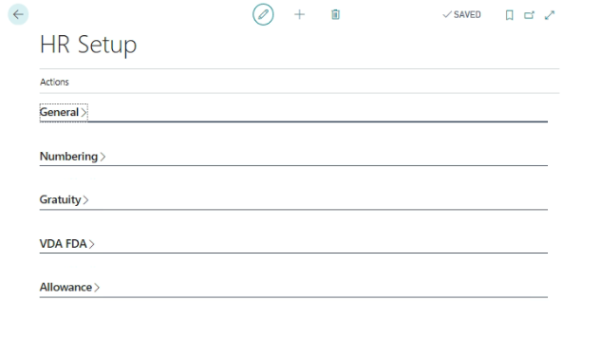

HR Setup
This is the basic setup of HRMS which will be used to define the default parameters for various processes in the system.
Path: Dynamic 365 Business Central-Actions-SetupHR Setup
General Fast Tab:
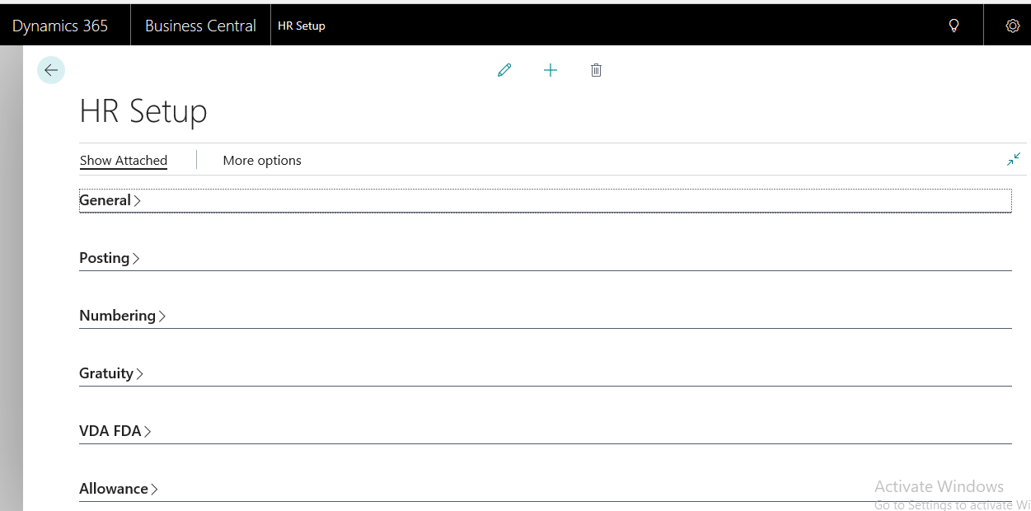

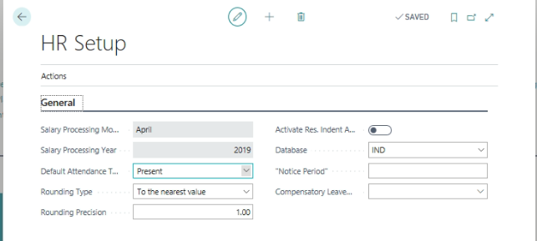
Salary processing Month & Year:
Select the Salary Processing Month and key in the Salary Processing Year. The mentioned month and year will be used as the starting point for generation of attendance, leaves, salary processing etc.

Default Attendance Type:
The default attendance can be setup either as “Present” or “Absent”. The mentioned setup will be used by system at the time of generation of attendance as a default in Daily Attendance Records.
Rounding Type & Rounding Precision:
Salary amount will be rounded based on the selection.
Attachment Storing Location:
Specify the HR related document storage location for centralized HR document storage location.
Attachment Storage Type:
Select the attachment storage location by using the following options
- Embedded
- Disk File
Attendance Storing Location:
Specify the attendance (Attendance Machine Attendance) Storing location to upload into Attendance management in HRMS.
Archive Attendance Storing Location:
Specify the Archive Attendance Storing Location, once the attendance is uploaded in Attendance management in HRMS, the same will be transferred from “Attendance Storing Location” to this location.

Numbering Tab:
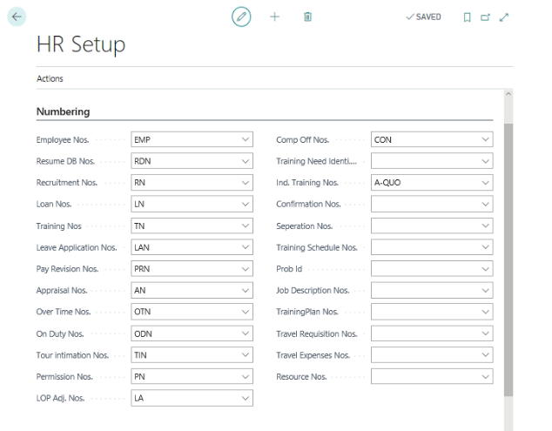
Specify the various number series that are used in generation of Employee, Resume database, Recruitment, Loan, training, leave applications, probation, pay revision, etc.,
Gratuity Tab:
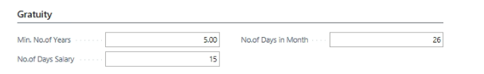
Specify the Minimum number of continuous years of service for Gratuity computation in Min. No. of Years field. Also specify the No. of days in a month and No. of Days Salary in a month to be considered for computation of Gratuity.

VDA & FDA Tab:
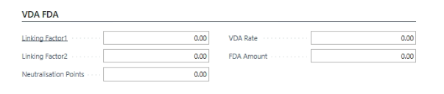
Define parameters as per applicable regulations.
Allowance:
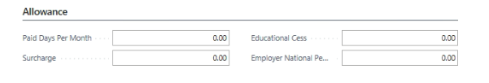
Specify the paid days per month for calculating Salary, i.e., As per Calendar days or as per fixed number of days.
Education Cess for computing Income tax under Salaries.
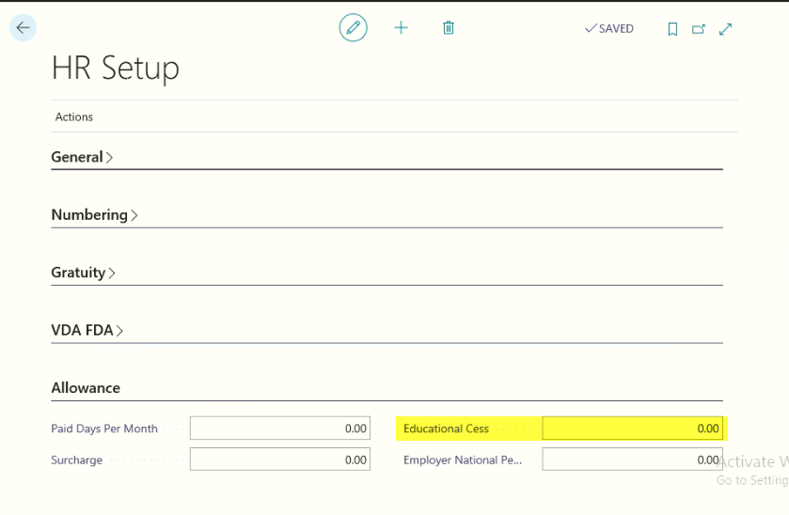
After defining of all setups go to Actions tab and then select the “Insert TDS Masters” to update the TDS related fields like Rebate, Exemption Sections, and all.
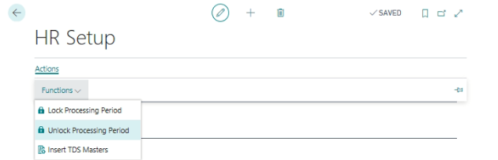

Look Ups

Look Ups is a design concept that is used in B2B HRMS module to reduce the number of tables used in development. All the similar tables will be grouped under the head of the Look Ups and each Lookup type is identified by a Lookup Id. These Lookups perform the same function as supplementary tables of NAV supporting the master tables.
All the important information related to the HRMS will be stored and tracked from the Lookup Type & Lookups.
To update the default Lookups and Lookup Types, run “Update Lookup” periodic activity, this will generate all the necessary Lookup’s that are used in the application. This is the first step in implementation of HRMS Add-on.
Lookups can be accessed from the following path –
Path: Business CentralActionsPeriodic Activates Update lookups.
Lookup Type – Lookup Types are system defined and cannot be modified. Each Lookup Type is identified by a No. internally by the system.
Lookups – Lookups store the information specific to a Lookup Type. These Lookup Types are user definable.
Example: Skill Set is the first Lookup Type in the application. In the Lookup’s, user can define Lookup values as below –
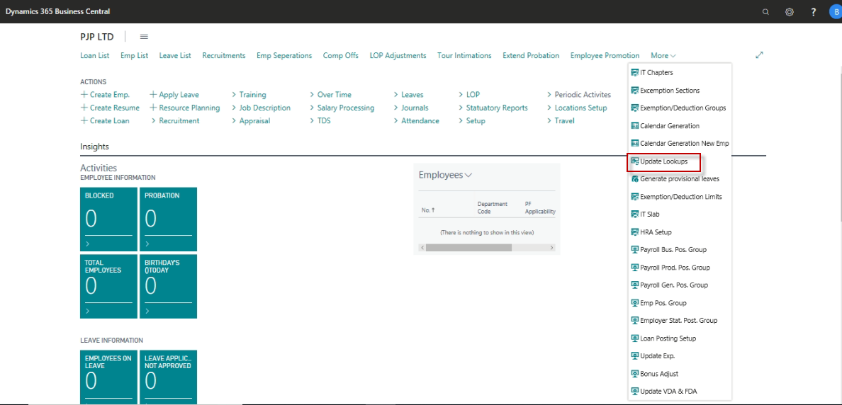

Following are the list of Lookup Types that are used in the application: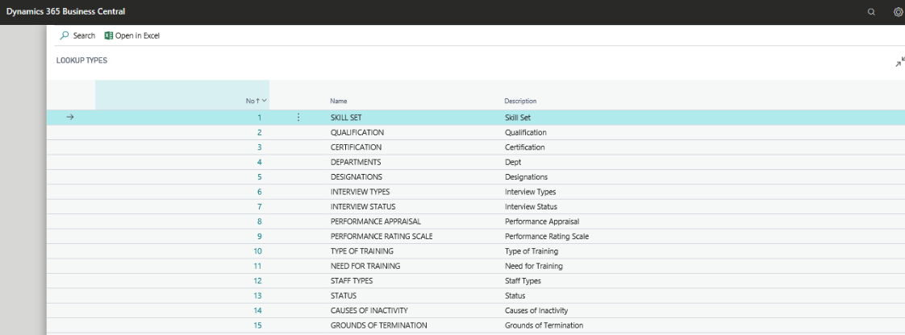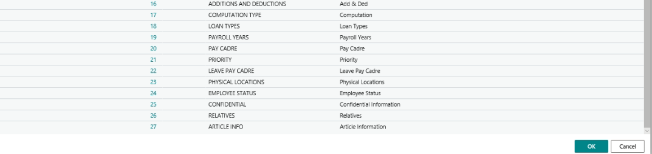

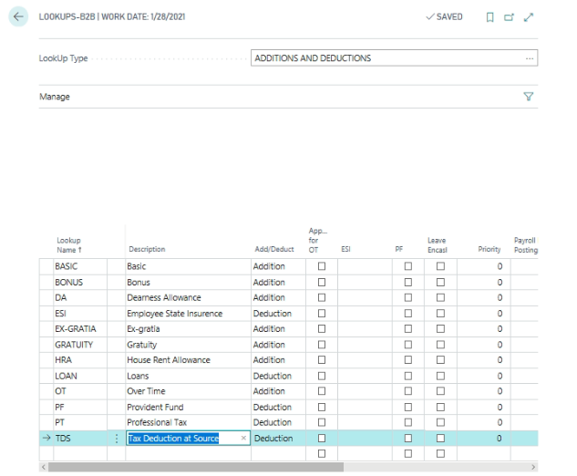

Instead of creating a separate table as Addition and Deductions (with name and Description Fields etc.), lookups concept is used to address the needs of similar functionalities.

Most of the Lookups used in the application are informative in nature and certain lookups play a vital role in payroll processing.

Lookup Types

Following are important Lookup types that are used in Processing salary, each Lookup type is explained in detail:
Lookup ID | Lookup Type Name | Remarks
1 | SKILL SET | Used for Recruitment and updating employee skill sets
2 | QUALIFICATION | Used for Recruitment and updating employee Qualifications
3 | CERTIFICATION | Used for Recruitment and updating employee certifications
4 | DEPARTMENTS | Identifying the employee working under which department and generating various reports and leaves, Resource Indent and Tour Intimation approvals.
5 | DESIGNATIONS | Identifying the employee designation
6 | INTERVIEW TYPES | Define the various types of interviews are going to be conducted based on the job profile.
7 | INTERVIEW STATUS | Define the interview status; this will be attached at the time of candidates Interview.
8 | PERFORMANCE APPRAISAL | Define the parameters to be considered for Performance appraisals.
9 | PERFORMANCE RATING SCALE | Define the Rating Scale for measuring employee performance.
10 | TYPE OF TRAINING | Define the various types of training needs to be conducted in an organization.
11 | NEED FOR TRAINING | Identify the employee training need to develop the employee skills.
12 | STAFF TYPES | Define the various types of Staff in an organization. For example – Field Staff, Admin Staff etc.,
13 | STATUS | Define the status, this can be used at the time of Recruitment process, Training Process etc.,
14 | CAUSES OF INACTIVITY | Define the employee inactive reasons.
15 | GROUNDS OF TERMINATION | Define the Reasons for terminating employee from the services.
16 | ADDITIONS AND DEDUCTIONS | Define the organization applicable pay elements and its calculation process.
17 | COMPUTATION TYPE | System will generate the computation types; this can be used for computing salary.
18 | LOAN TYPES | Define the various types of loans are provided by the organization.
19 | PAYROLL YEARS | Define the various pay roll years to run the HR and Payroll.
20 | PAY CADRE | Define the Pay Cadres and also define the pay cadre wise salary structure.
21 | PRIORITY
22 | LEAVE PAY CADRE | Define the leave pay cadres, based on leave pay cadres; system will generate various types of leaves.
23 | PHYSICAL WORK LOCATIONS | Define the physical working location under single payroll location.
24 | EMPLOYEE STATUS | Define the employee status information.
25 | CONFIDENTIAL | Confidential information of the employees
26 | RELATIVES | Relative information of the employees
27 | ARTICLE INFO | The details of the item provided to employee

Note:
Before running through these Lookup Types, run the following periodic activity – “Update Lookup”. This will update all the basic parameters.

Skill Sets
Define the applicable Skill sets master to use in Recruitment process
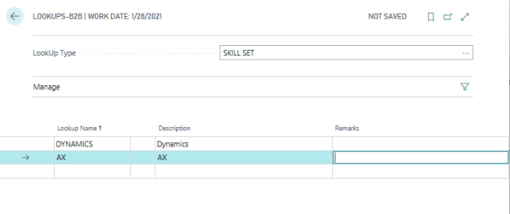

Qualifications
Define the applicable Qualifications Master to use in Recruitment process
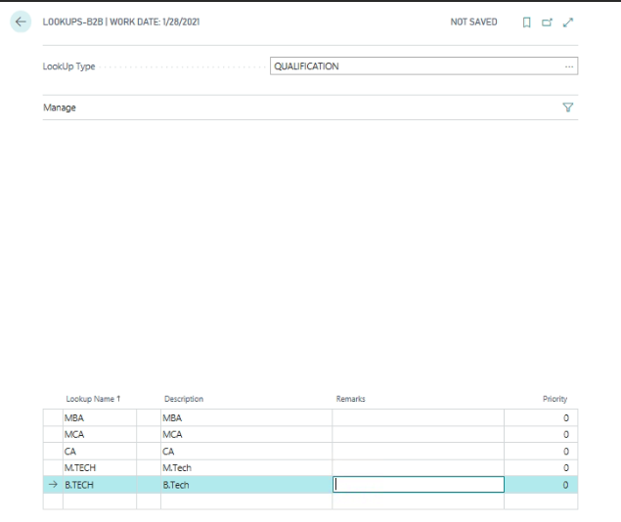

Certification
Define the Applicable Certifications Master to use in Recruitment process
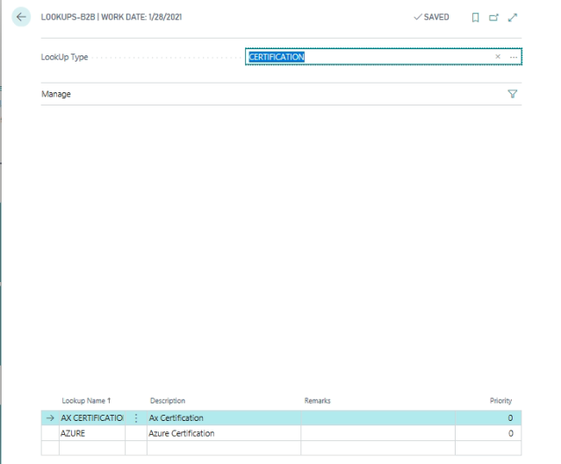

Departments
Define the Applicable Departments Master
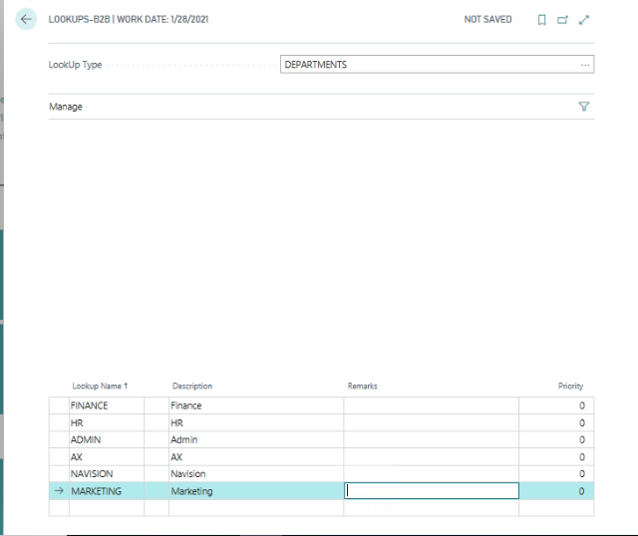

Designations
Define the Designations Master
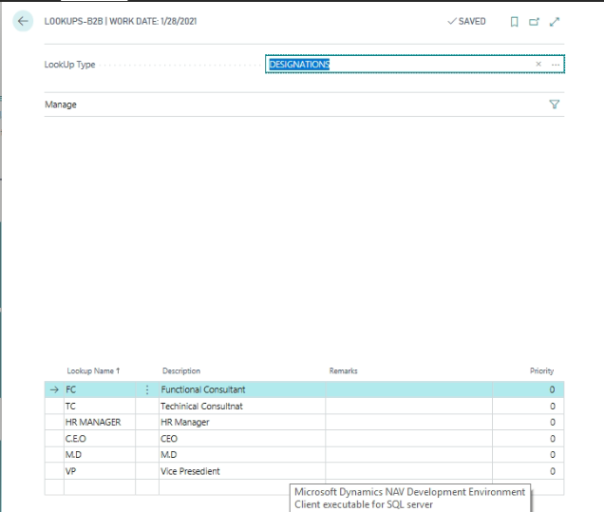

Interview Types
Define the Types of Interviews going to be conducted at the time of Recruitment.
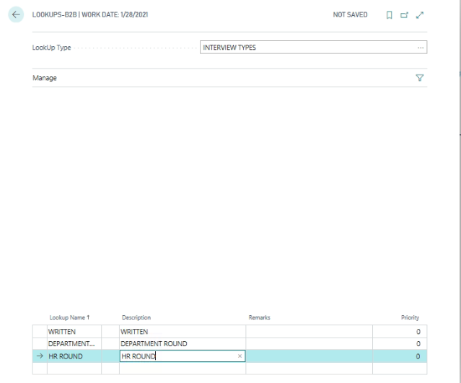

Interview Status
Define the Interview status (Results) information to attach at the time of Interviews.
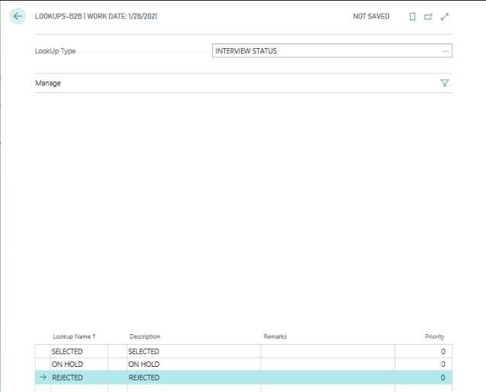

Performance Appraisal
Define the performance appraisal parameters of the organization.
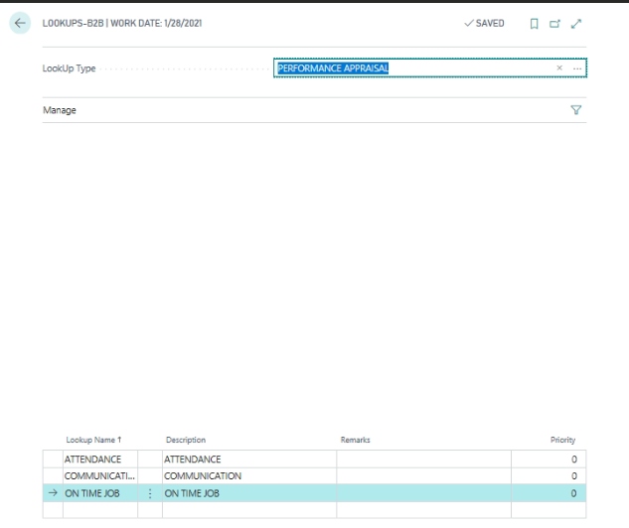

Performance Rating Scale
Define the Performance Rating Scale to compute self-Rating and HOD-Rating.
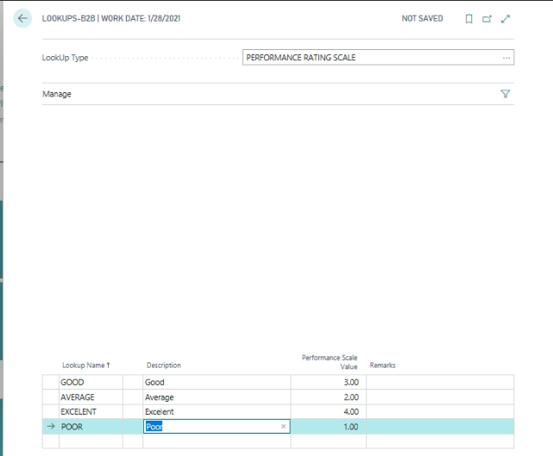

Type of Training
Define the Type of Trainings to be conducted in the Organization.
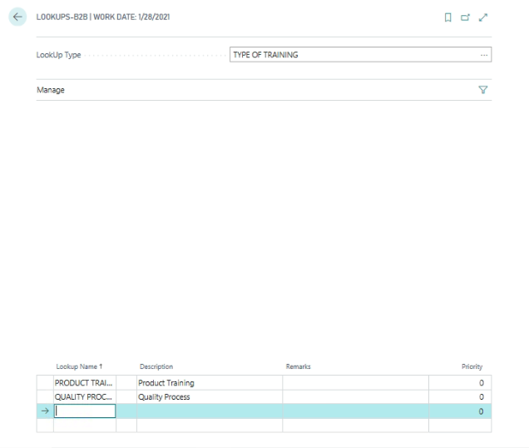

Need for Training
Define the Training need information
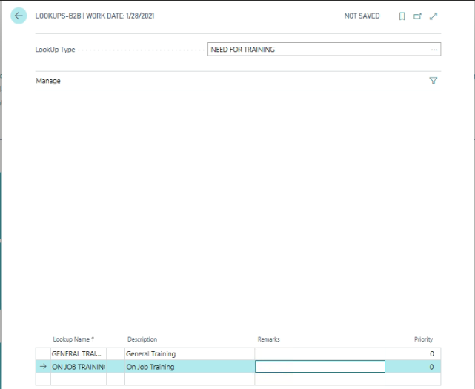

Staff Types
Define the Employee classification; this will be informative in nature.
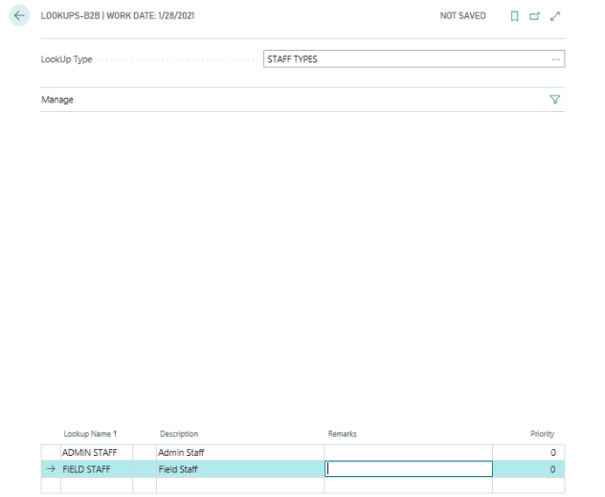

Cause of Inactive
Define the various types of Causes for inactive. This will be only informative
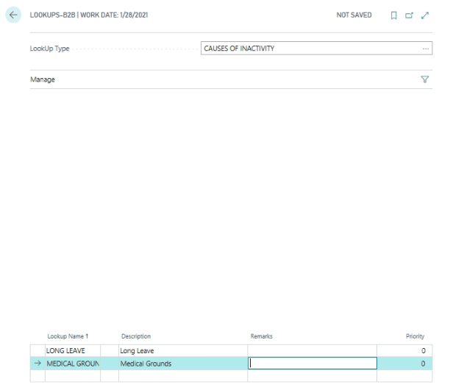

Grounds for Termination
Define the various types of Termination of Employee applicable in the Organization, based on this Grounds employee will be terminated.
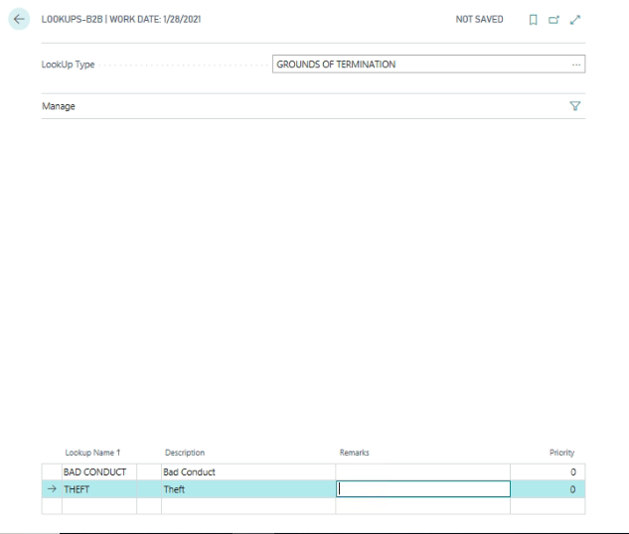

PAYROLL YEARS
Following PAYROLL Years are created when “Update Lookup” periodic activity is run –
- ESI Year
- PF Year
- Financial Year
- Leave Year
For each Payroll year, Starting and Ending dates need to be defined.
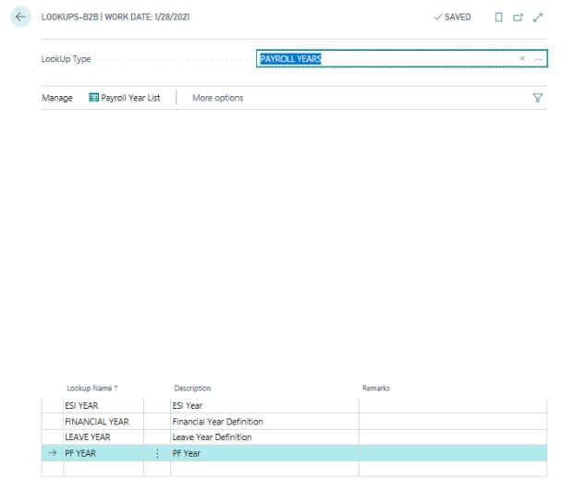
Go to action pane, Click Payroll List
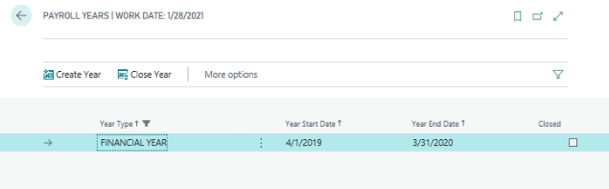
Payroll year page will be open, click action pane and clickCreate Year for creating new payroll year
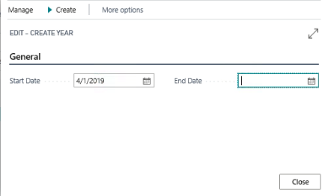
Define the Period end date and click OK in Action Pane for creating new payroll year.
Once the payroll year is completed, click the action pain for close the payroll year.
ClickClose year for closing of Payroll years.
Once the payroll year is close, system will update the filed as closed.
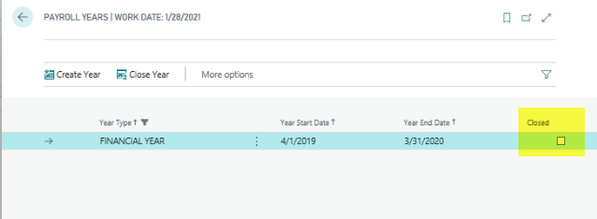
The same process needs to be run for all payroll years for creation and closing.

PAY CADRE
It is mandatory to attach a Pay Cadre to an Employee for Salary Processing. Pay Cadre can be used for filtering the employees at the time of Salary Processing and Salary Posting.
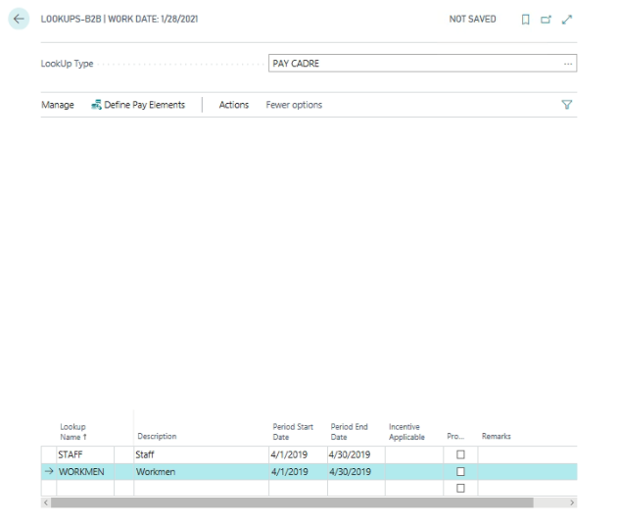
If pay cadre wise pay elements are applicable, then go to action pane and click Define pay elements.
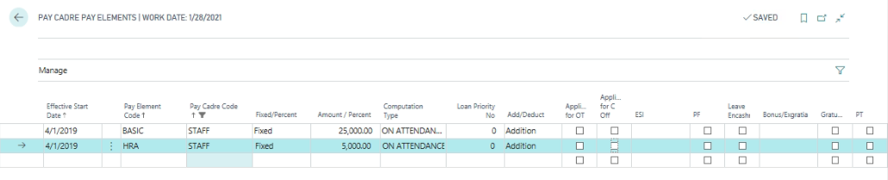
Detailed explanation is provided in the Payroll user manual

ADDITIONS & DEDUCTIONS
All the Pay Elements that are applicable for the company are defined in this Lookup. Mandatory pay elements like Basic, DA, Statutory Pay elements like PF, ESI, TDS, PT etc., are automatically generated by the system when “Update Lookup” periodic activity is run.
“Additions & Deductions” Lookup will be explained in detail in the Payroll Manual. Below is the screenshot of the system generated pay elements –
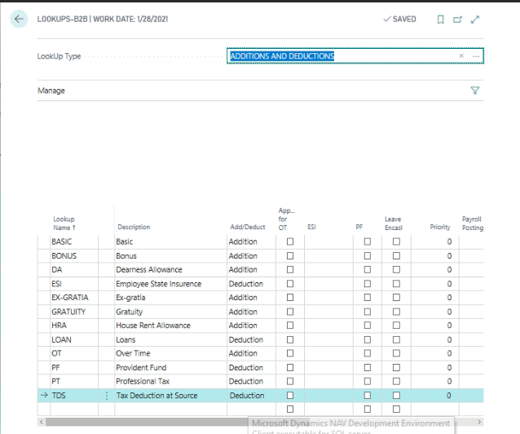

COMPUTATION TYPE
This Lookup type will be used for the calculation of the Salary. It establishes the relationship between various Pay Elements and their computation.
Following types of computations are available:
- AFTER BASIC
- AFTER BASIC AND DA
- ON ATTENDANCE
- NON-ATTENDANCE
These computation types are generated by the system when “Update Lookup” periodic activity is run.
ON ATTENDANCE:
If the Computation Type is ON ATTENDANCE basis, Salary (Pay elements) will be calculated on attendance i.e. 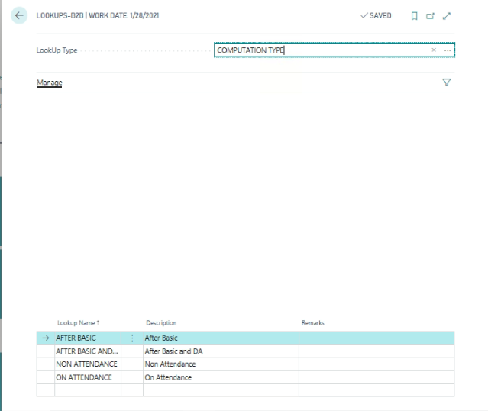
NON-ATTENDANCE:
If the Computation Type is NON-ATTENDANCE basis, Salary (Pay elements) calculation will not be linked to attendance (salary will be computed irrespective of days present or absent)
AFTER BASIC:
If the Computation Type is AFTER BASIC, pay elements calculation will be on percentage and it will be calculated on basic only.
AFTER BASIC AND DA:
If the Computation Type is AFTER BASIC AND DA, pay elements will be calculated on percentage, calculation will be done on the basic and DA amounts only.

Leave Pay Cadre
Define the Leave Pay Cadre, based on this leave pay cadres system will generate various types of leaves applicable.
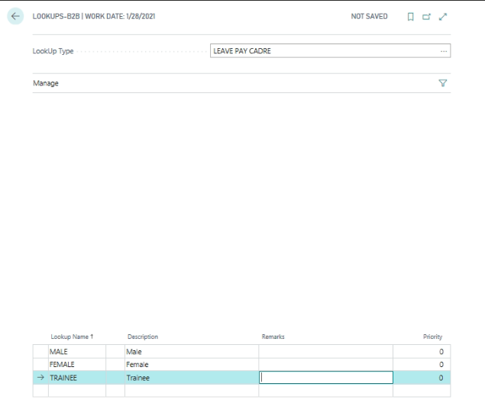

Physical Work Location
Define the Various branches or working locations under one organization.
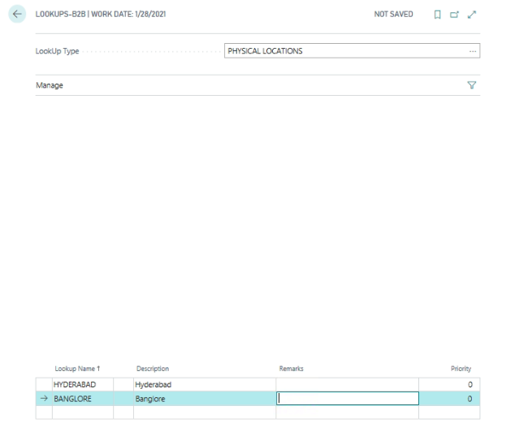

Employee Status
Define the Employee Status information in the Organization.
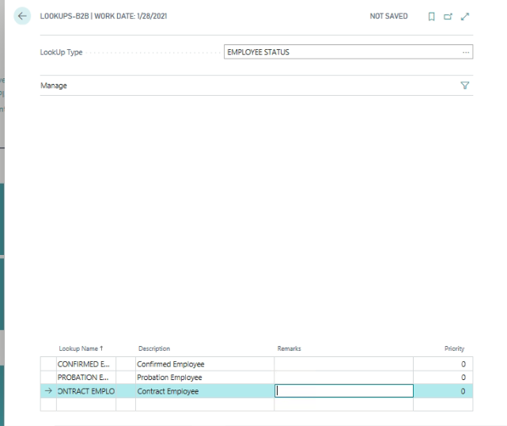

Salary Adjustment Setup

Addition benefits provided by the employer to employee by way of Perks need to be defined.
Path: Business central ActionsSetup Salary Adjustment Setup.
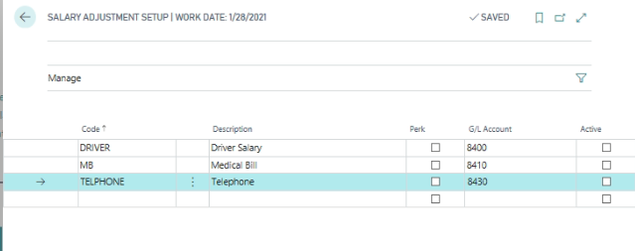
Define the Salary Adjustment code and description, place a check mark if this expense is perk and it should be consider for computing TDS.
Define the G/L accounts for respective Salary adjustment wise
Place a check mark against each perk as active, with this it will allow to make this salary adjustment applicable for the period.

Payroll Journal Template

In HR and Payroll various types of Journal Templates were used, we need to define the Journal Template Name and Batches and Document Number
Path Business CentralActionsSetup Payroll Journal Template
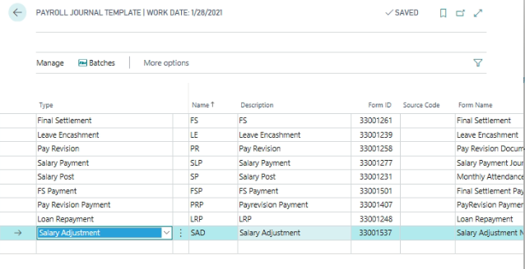
Go to Action pane
Path Business CentralActionsSetup Payroll Journal TemplateNavigateBatches
To define the Batch wise Document Number series
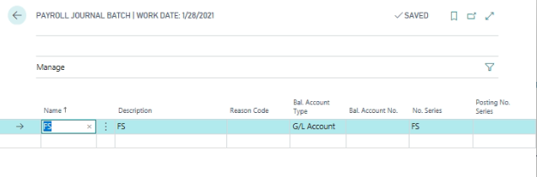

Questionnaire setup

Define the following Questionnaire Profile setups, they are:
- Joining Formalities
- Appraisals
- Induction
- Exit Interview

Questionnaires
Path: Business CentralActionsHRQuestionnaires
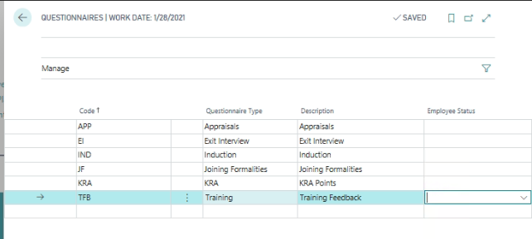
Define the Questionnaire code and description and select the Questionnaire type from the Option (Joining Formalities, Appraisals, Exit Interview, Induction, KRA and Training)

Questionnaire Profile Setup
Path: Business CentralActionsHRQuestionnaires Questionnaire Profile Setup
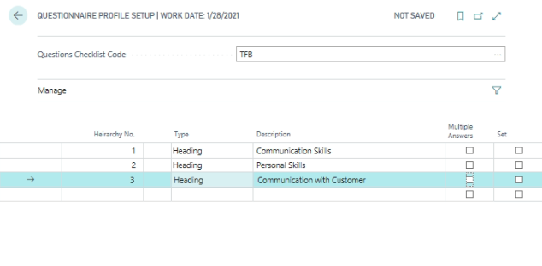
Select the current Questions check list code and update the predefined Questions
Define the Number in Hierarchy No field
Select the type as heading or Question for defining Questions
Define the next line type as Answer; user will keen the answer at various functionalities.
If the question is having multiple answers define the answer and user will select correct answer in multiple answer fields.

Attendance setup

After generation of Payroll Years as defined in the Basic Foundation user manual, following Attendance related setups needs to be updated.
Path : Business CentralActionsSetupHolidays

Holidays
Holidays applicable for the leave year need to be defined in this setup.
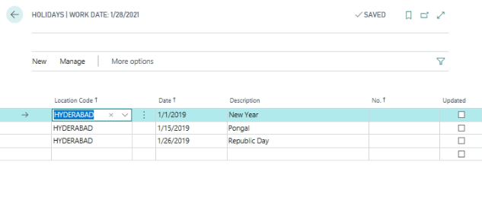
If a new Holiday has been added after Calendar Generation for the Leave Year, the same can be updated in the Attendance records by running Update Attendance from the action pane.

Off Days
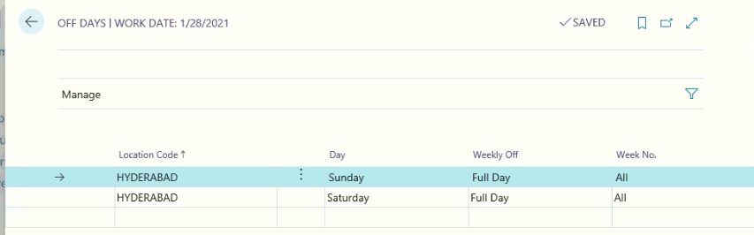

Off-days as per the company policy can be specified in the Off-days setup. Select the Day for which Off-day is applicable along with Weekly Off type either as Full Day or Half Day, also specify the Week No. as required.
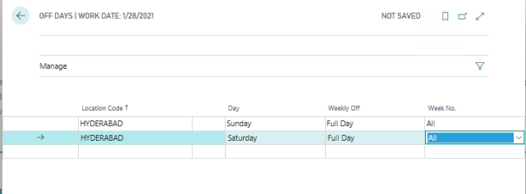
Off-days defined will be considered as Present for the purpose of Attendance and Salary processing.

Shifts
Shifts applicable can be defined in the Shift master. A minimum of one shift need to be defined and attached to the employee.
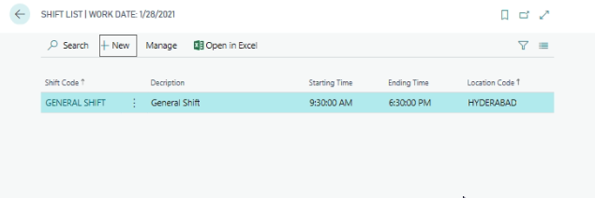
Click New from the Action pane.
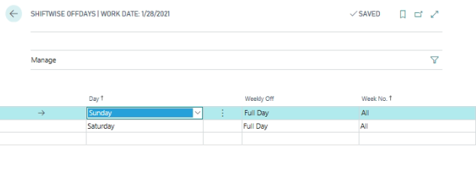
General Fast Tab:
Define the following information
- Shift code
- Description of Shift code
- Shift start time and End Time
- Break Start and End Time
- Cut off Min Start and End Time
Go to action pane and Assign Shift wise Week off Days
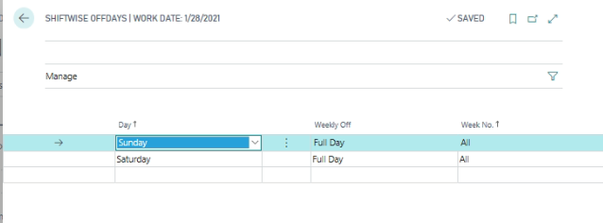
Off Days specific to the shift can be defined in the Shift master. As a default, Off-days defined in the Attendance setup will be copied into the Shift Off-Days whenever a new Shift is created. This can be modified as relevant.

Leave Master
All the applicable leaves can be defined in the Leave master. Leave master can be accessed
Path: Business CentralLeave list
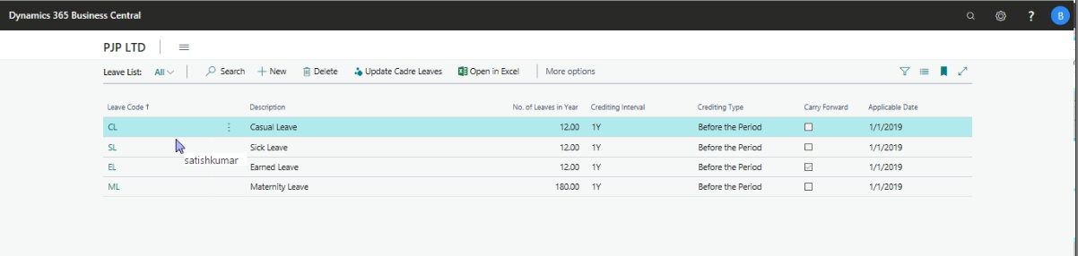
Click New from the Action pane to create new leave code
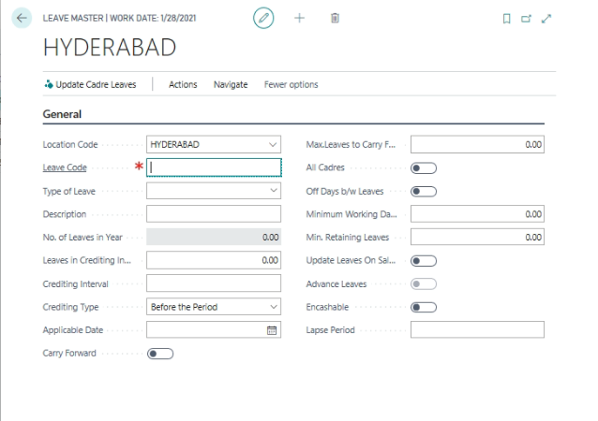
Key fields to define
Each leave should be identified by a unique Leave Code
Type of leave: - Select the leave type with following options (Casual, Sick, Earned, Maternity and Special)
Description: - Define the Description of the Leave Code
No of Leaves in year: - This field will be updated based on the Leave Crediting Interval and crediting Interval fields.
Leave Crediting Interval: - Specify the number of leaves to be credited during a leave crediting interval.
Crediting Interval: - Based on the value mentioned in this field, No. of Leaves in Year will be calculated. Example: 1M/1Y (For every one month/one year).

Crediting Type:-
Before the Period
Choose “Before the period” option when the employees are entitled for leave at the beginning of the crediting interval.
After the Period
Choose “After the period” where employees are entitled for leaves after completion of the crediting interval.
Applicable Date: - Define the date on which leave is applicable
Carry forward: - Place a check mark, if the leave is carry forward to next leave year.
Max. Leaves to carry forward: - Define the maximum leaves to be carry forward to next leave years.
All Cadres: - When the leaves are applicable for all the Pay Cadres, place a check mark in this field. After updating this field, run “Update Cadre Leaves” from Functions, this will create Pay Cadre wise Leave master setup.
Off Days between Leaves: - Place a check mark, in case off days will fall under leaves, off day will be considering as leave.
Minimum working days: - Define the minimum working days as applicable.
Min. Retaining Leaves: - Define the Minimum retaining leaves in case of paid leaves. This leaves will be paid at the time of employee leaving the organization.
Update Leaves On Salary Post: - Place a check mark, if the user needs to update the leaves on Salary posting or Not.
Advance Leave: - This field will be updated based on the leave type and crediting type
Encashable: - Place a check mark if the leave is encashable
Go to action Pane and click Grade wise leaves.
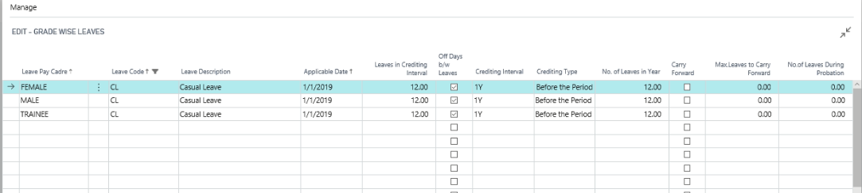
From this page, user can modify the leave information based on requirement. This can be done before generating leaves. Once leaves are generated, user cannot modify this information.

Leave Generation
Leaves for the Employees will be generated automatically when Attendance is generated from Periodic Activities Calendar Generation.
If a new leave is introduced after calendar generation, leaves for the employees can be generated from Periodic Activities Generate Leaves.

Leave Approval Setup
This functionality will cater to the requirement of defining the approval of employee leaves.
Leave Approval setup can be done based on the Leave Document Type. They are as under
- Leave Application
- Leave cancellation
Leave Application Approval Setup
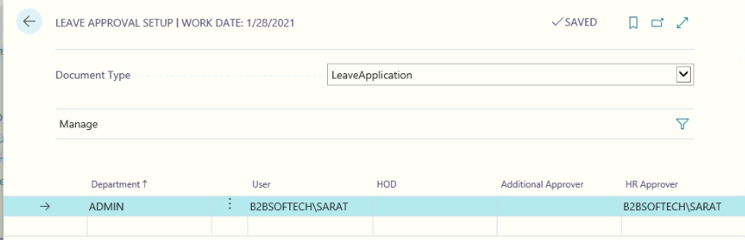
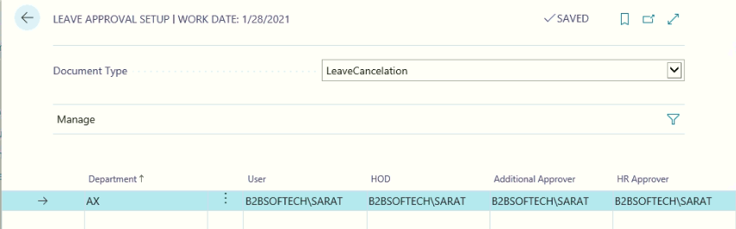
From the Leave Approval setup, select the document type as Leave application or leave cancellation, based on the document type, leave approval setup can be defined.
Key-in the important fields
Department: - Select the department code from the department lookup list
Department user: - Select the Department user form the Database login list. The same will be attached to the Employee master in Administration card. With this, department user will apply the leaves on behalf of his department.
Department HOD: - Select the Department HOD form the Database login list. The same will be attached to the employee master in Administration card. With this, department leaves will be approved or cancelled and forward the same to HR department for leave updating.
Additional Approver: specify the additional Approver user id for approval of the leave application with this combination.
HR approver user ID: - Select the HR user id all approved or Cancelled Leaves will display to HR department for updating the leaves in Daily attendance and Leave Registers.

Resource Indent Approval Setup
Resource requirement by each department will generate the Resource indent and sent for approvals. To do the process, user needs to set up the Resource Indent Approval Process.
Path: Business CentralHR & Payroll SetupAttendanceResource Indent Approval Setup
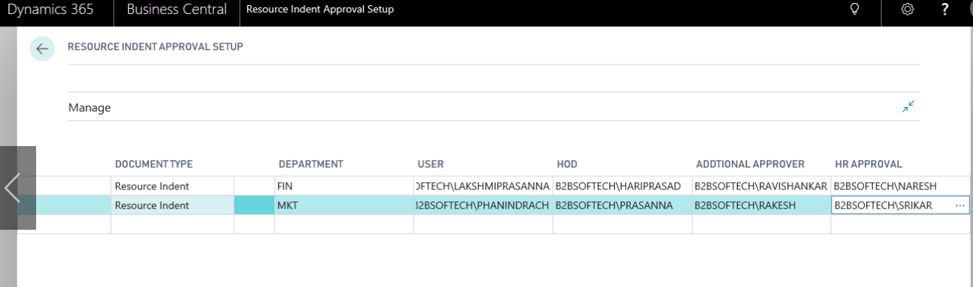
From the above Form define the following information:
Document Type: Select the Document Type as Resource Indent.
Department: Select the Respective department.
Department user: Select the Respective department user to generate resource indent.
HOD: Select the department HOD to send for Authorization and approval.
Authorizer: Select the Authorizer to authorize the Resource and send for final approval.
Approver: Select the Final Approver for resource Indent.

Tour Intimation Setup
Path: Business Central Tour Intimation Setup
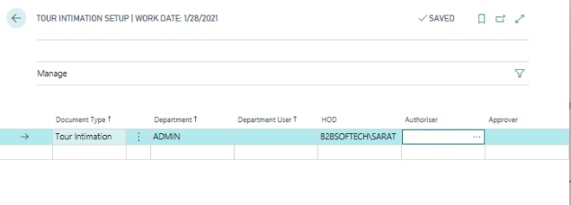
User can setup the tour intimation setup based on the following information.
Document Type Select the document type as Tour Intimation.
Department Code Select the Department Code
Define the 3 levels of approvers. Such as Department User will keen the Tour Intimation for the define department. Department HOD will approve the Tour intimation and send to further t, once the additional approver will approve the document, finally goes to HR department for approve and update the information in Attendance as “Tour”

Statutory Setup

In Statutory Setup, user needs to define the following
- Professional Tax Setup
- Provident Fund Setup (PF)
- Employee State Insurance Setup (ESI)
- Bonus

Path: Business centralActionsSetupStatutory list

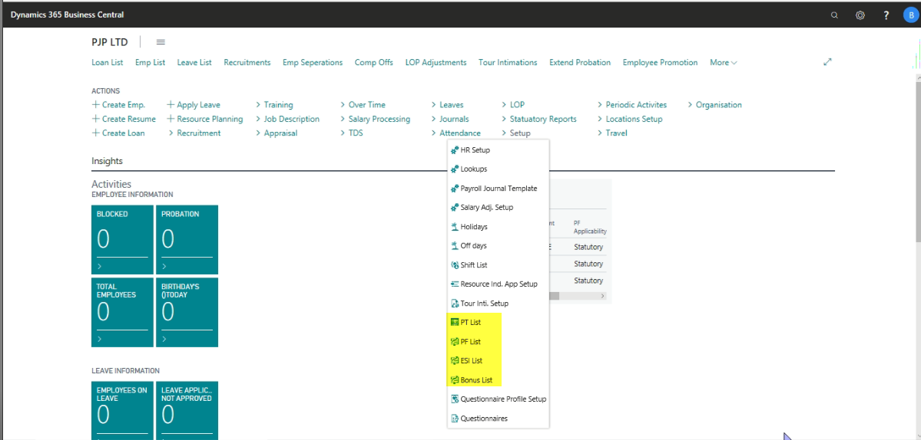

Professional Tax Setup
Path: Business centralActionsSetupStatutory list Professional Tax List
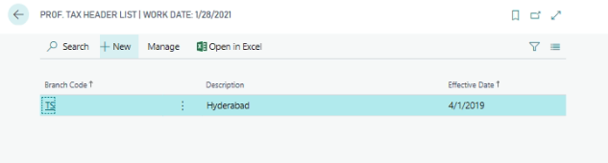
From the above page, Go to action pane and click New to create New Professional Tax Setup
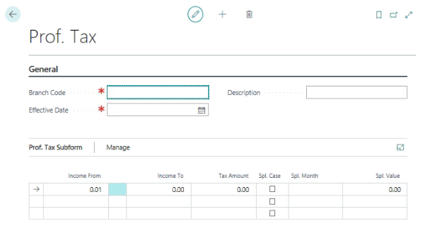
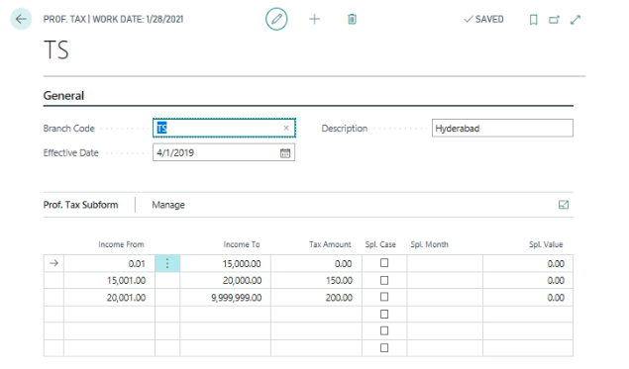
General Fast Tab:
Define the Professional Tax Branch Code (State Wise)
Define the Effective Date from which Professional tax is applicable
Define the Description of the state Code or Branch Code
Professional Tax Sub form:
Define the Income range from and to and Tax amount for the range.
Special Case Place a check mark, if user needs to deduct additional PT Amount
Special MonthDefine month on which additional PT amount needs to be deducted
Special Value Define the PT amount needs to be deducted

Provident Fund (PF)
Path: Business centralActionsSetupStatutory list PF
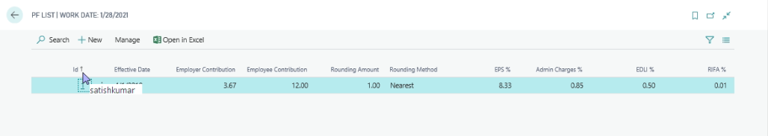
From the above page, go to action pane and Click new to create New PF Setup page.
If the user needs to edit the existing PF setup by using edit button on the action pane.
If the user needs to view the existing PF setup by using view button on the action pane.
If the user needs to delete the existing PF setup by using Delete Button presented in the action pane.
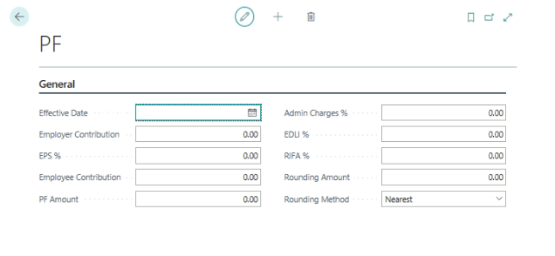

Define the effective date for PF rates are applicable
Define Employer Contribution towards EPF in Percentage
Define Employer Contribution towards EPS in Percentage
Define Employee Contribution in Percentage
Define PF amount (if the PF needs to be deducted as per norms of PF Department)
Define PF Administrative Expenses like Admin Charges, EDLI and RIFA charges needs to be deducted
Define PF Rounding amount and Rounding Method.
Note: if any change in Rates, user needs to create new record with effective date.

Employee State Insurance (ESI)
Path: Business centralActionsSetupStatutory list ESI

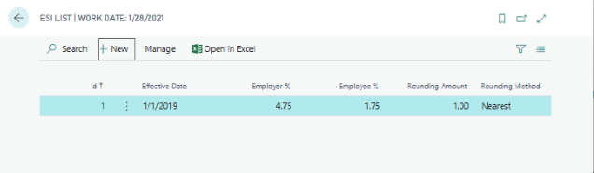
Go to action pane to click on New to create new ESI Setup.

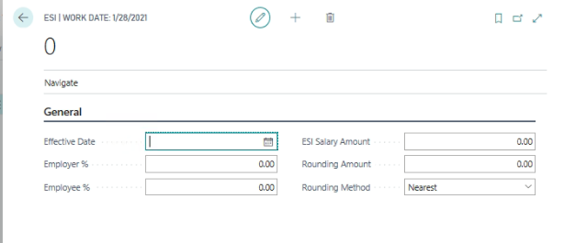

Define effective Date
Define Employer Contribution in percentage
Define the Employee Contribution in Percentage
Define the ESI Salary amount limit for eligibility
Define ESI Rounding amount and Method.
Note: if any change in Rates, user needs to create new record with effective date.

Bonus
Path: Business centralActionsSetupStatutory list BONUS

To create the new bonus setup for the next financial year for declaring bonus amount.
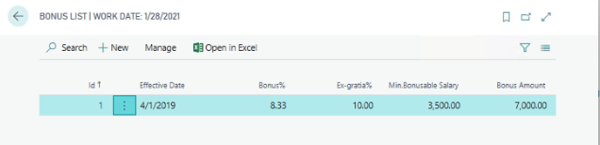
Define the Effective date
Define the Bonus percentage
Define the Ex-gratia Percentage
Define the Bonus able salary as per Bonus Act
Define the Bonus Limit amount as per Bonus Act

Income Tax

The following setups need to be defining for computing TDS from Salaries, they are as under:-
- Income Tax Chapters
- Exemption Sections
- Exec/Ded Groups
- Exec/Ded Limits
- IT Slab
- HRA Setup

Income Tax Chapters
Path: Business centralActionsPeriodic ActivatesIncome Tax Chapters
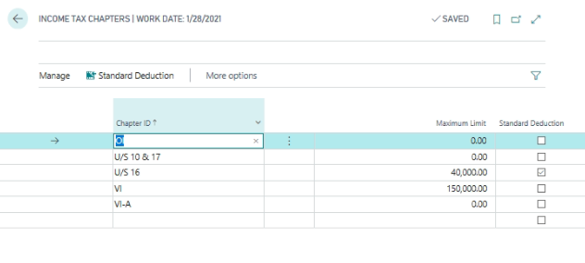
Define the applicable chapters under head of Income from Salary and define the Chapter wise maximum Limit amount.

Exemption Sections
Path: Business centralActionsPeriodic ActivatesIncome Tax Chapters Exemption Sections
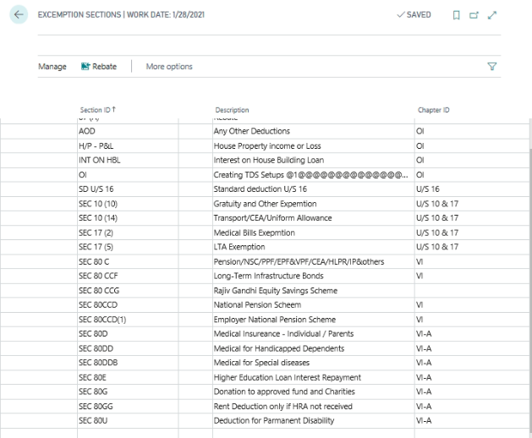
Define the section Id applicable Under Income from Salary and attach the same the applicable Chapter ID.
In the Exemption Sections define the New Exemption Sections like Equity Scheme as well as the Rebate groups.
For the new Equity Shares define a new Exemption ID with the name called “SEC 80 CCG”. The newly defined will not come under any Chapter ID.
And also define the new Section ID with Section ID “SEC 87(A)” to define the Rebate amounts in the TDS Deductions.
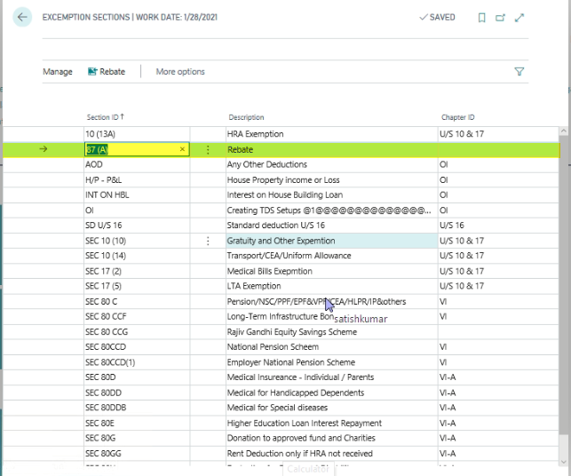
Select the Rebate button to define the new Rebate related setups in the “Income Tax Rebate Setup List” subpage. In the subpage define the mentioned fields.
Sec ID: Section ID automatically updates based on the Exemption Sections.
Rebate Start & End Years: define the financial year start and end dates, when the start has defined system automatically update the Rebate Year End Date based on the Financial Year. It means for the effective financial years the rebate would be applicable for the mentioned tax slabs.
Max. and Min. Net Taxable Income: Define the Max taxable income amount. Based on the amounts when the Employees’ Net Taxable Income exceeds the limit then system automatically deduct the Rebate amount.
Max Rebate Amount: As per the Govt. regulations define the Max. Rebate amount as 2000/-. Which means if the net taxable income exceeds the Max Taxable Income limit then system only deduct the amount of 2000/-
Active: Place a check mark in the Active Field to apply the rebate setups in the TDS calculation part.
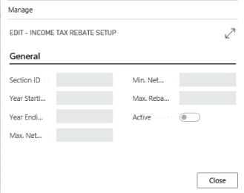

Exemption/Deduction Groups
Path: Business centralActionsPeriodic ActivatesIncome Tax Chapters Exemption Sections Exemption/Deduction Groups
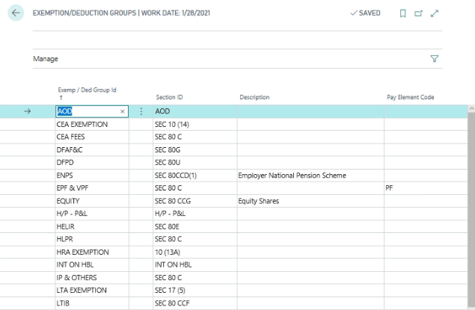
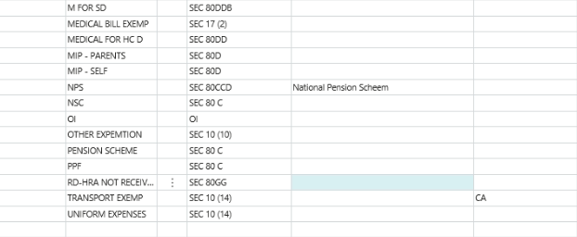
Define the Exemption/Deduction group applicable under each section and attach the Exemption/Deduction Group applicable Pay element. With this system will update the Savings information at the time of computing TDS amount.

Exemption\Deduction Limit
Path: Business centralActionsPeriodic ActivatesIncome Tax Chapters Exemption Sections Exemption/Deduction Groups Exemption\Deduction Limit
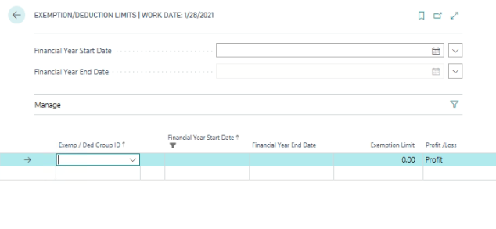
Select the Financial Year from the Payroll Years
Exemption\Deduction Group CodeSelect from the Exemption\deduction group code
Define the Maximum limit amount for that Exemption\Deduction group applicable
Define the profit or loss based on the nature of Exemption\Deduction (put loss only in case of Exemption group falls under Other Income chapter. If loss means this amount will be deducted from the Taxable income, if user place as profit the same will be added to taxable income.
For the Equity Limits whenever the employees’ gross total Income Exceeds amount mentioned in the Max. Gross Total Income field then system will automatically consider the Exemption Limit amount in the TDS Calculations.

IT Slabs (Income Tax Slabs)
Path: Business centralActionsPeriodic ActivatesIncome Tax Chapters IT Slabs
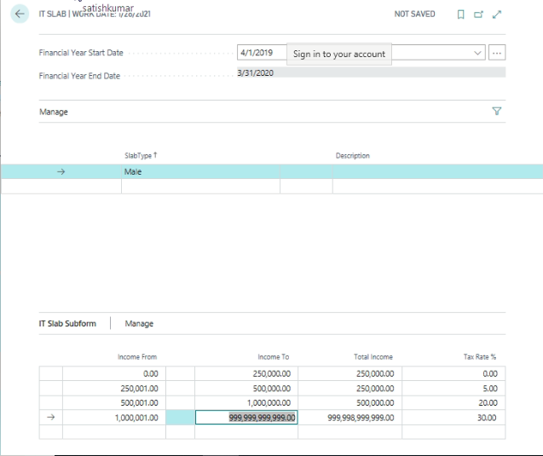
Select the Financial Year
Select the Slab Type: “Male”, “Female” or “Sr. Citizen”
Define the income range and Tax rate based on the Slab Type for computing TDS amount under Income from Salary.

Surcharge (Surcharge Tax Lump)
PATH-> Business centralActionsPeriodic ActivatesSurcharge Tax List
Click on new ->create surcharge slab
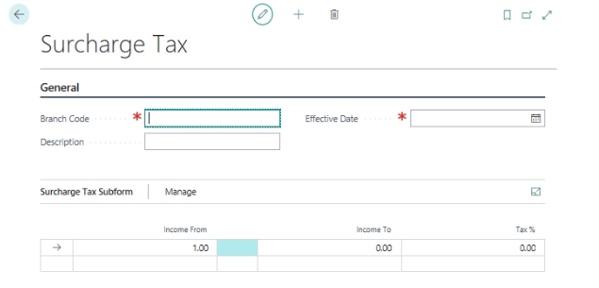
Create surcharge slab
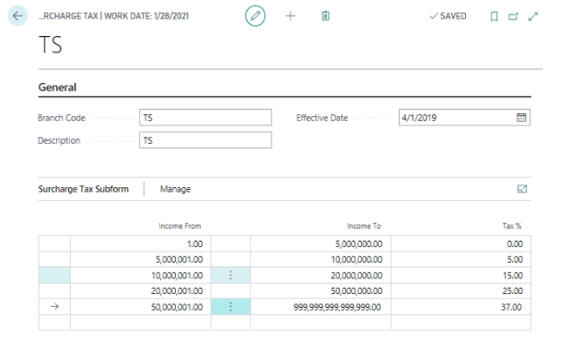

HRA Setup
Path: Business centralActionsPeriodic ActivatesHRA Setup
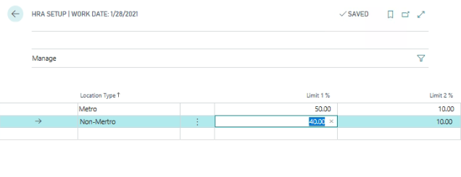
Define the HRA exemption calculation rate based on location Type.
Select the Location Type as “Metro” or “Non-Metro”
Note: HRA Exemption will be consider as under
- % of Annual Basic + DA
- Annual actual Rent Paid - % of Annual Basic +DA
- Actual Rent Received
From the above least will be consider as HRA Exemption
Define the Limit 1%
Define the Limit 2%

Posting Groups
In Payroll Posting groups will be used to integrate the HR and payroll Module to Financial Management. The following posting groups are applicable.

- Payroll Business Posting Group
- Payroll Product Posting Group
- Payroll General Posting Group
- Employee Posting Group
- Statutory Posting Group
- Loan Posting Setup
- Path: Business centralActionsPeriodic Activates Posting Group

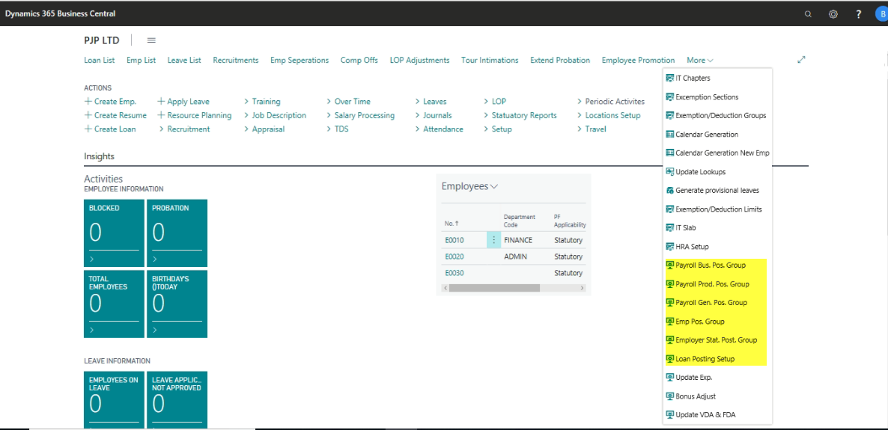

Payroll Business Posting Groups
Path: Business centralActionsPeriodic Activates Payroll Business Posting Group
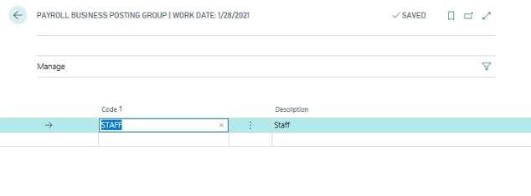
Define the Employee categories as Payroll business posting group

Payroll Product Posting Groups
Path: Business centralActionsPeriodic Activates Payroll Product Posting Group
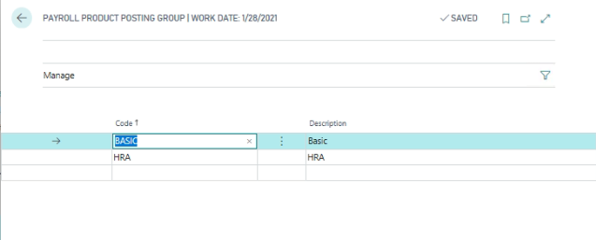
Define all applicable pay elements (Additions and Deductions) as Payroll product posting groups

Payroll General Posting Group
Path: Business centralActionsPeriodic Activates General Posting Group
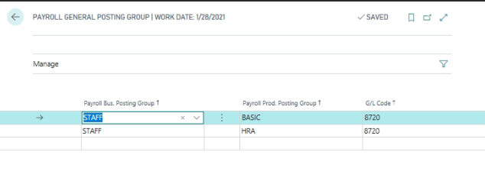
From the above form, combination of Payroll business posting group and payroll product posting group define the applicable G/L Accounts for integrating to finance. This setup will be used for attaching the Expenses accounts in nature.

Employee Posting Groups
Path: Business centralActionsPeriodic Activates General Posting Group Employee Posting Group
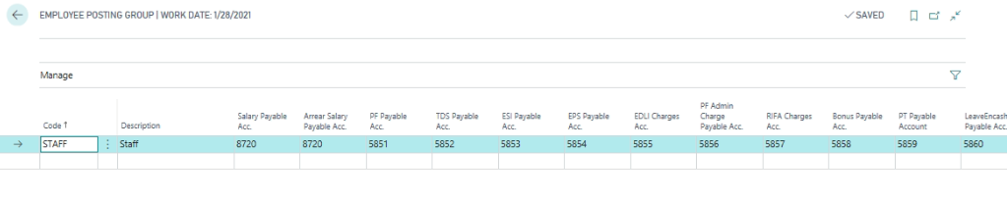
From the above form, define the Employee category wise Liability accounts for Salary, PF, ESI, Income Tax, Professional Tax, Bonus and Leave Encashment accounts.

Statutory Posting setup
Path: Business centralActionsPeriodic ActivatesStatutory Posting Group
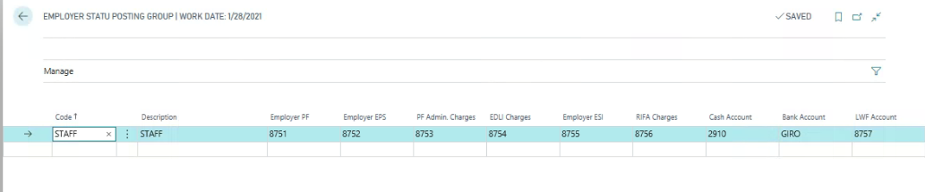
Define the Employee category wise PF, PF charges, ESI, Bank and cash accounts

Loan posting setup
Path: Business centralActionsPeriodic ActivatesLoan Posting Setup
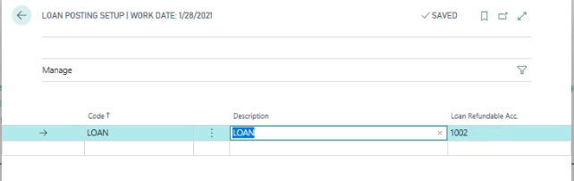
Define the Loan type and define the Loan Recovery account.

Locations

Path: Business centralActionsPeriodic ActivatesLocation List
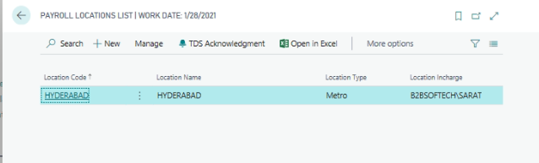
Go to action pane and click New to create new location.
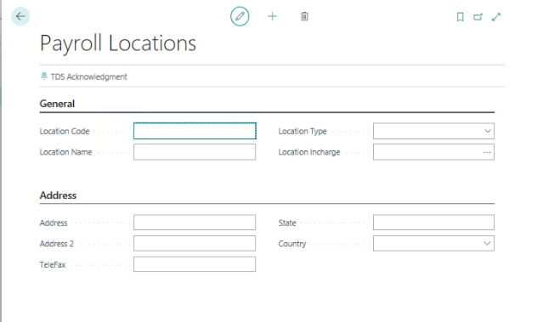

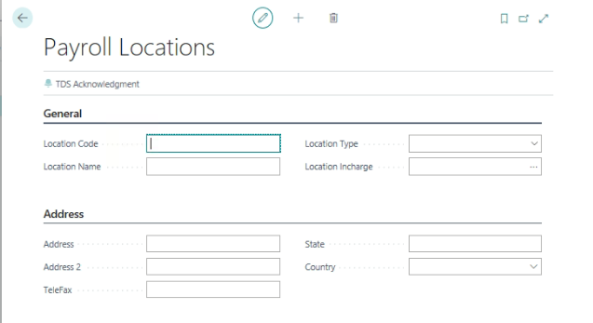
General fast Tab:
Location Code: define the Location code and Location description and define the location type based on city location and attach the location in charge user id.
Statutory Fast Tab:
Define the Organization’s PT, PF and ESI information along with PF and ESI Logo uploading
Address Fast Tab:
Define the Location address information.
Payroll Location user:
Path: Business centralActionsPeriodic ActivatesPayroll location user
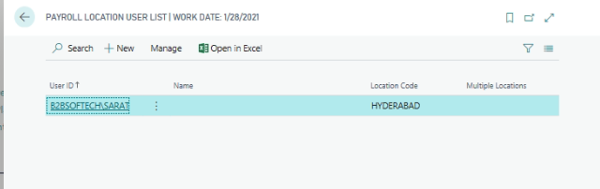

Define the User Id to access the payroll for this location

Employee
Employee Card will display the information relating to the employee. New employee information can be added /existing employee information can be modified in the Employee master.
Path: Business centralEmployee list
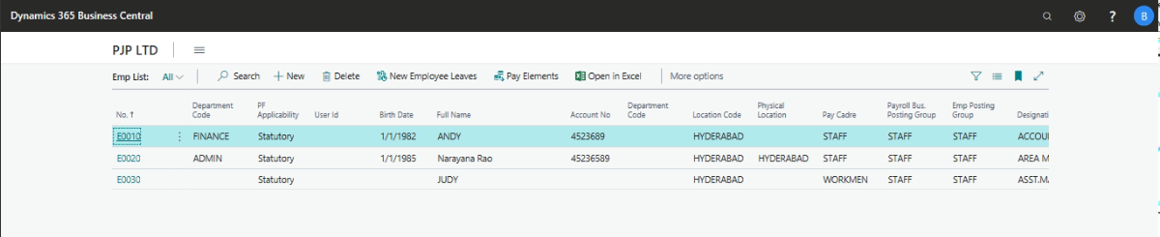

New Employee Creation
Whenever a new employee joins the organization, new employee information should be created in the Employee master.
Go to Action Pane and Click New to Create New Employee master Page.
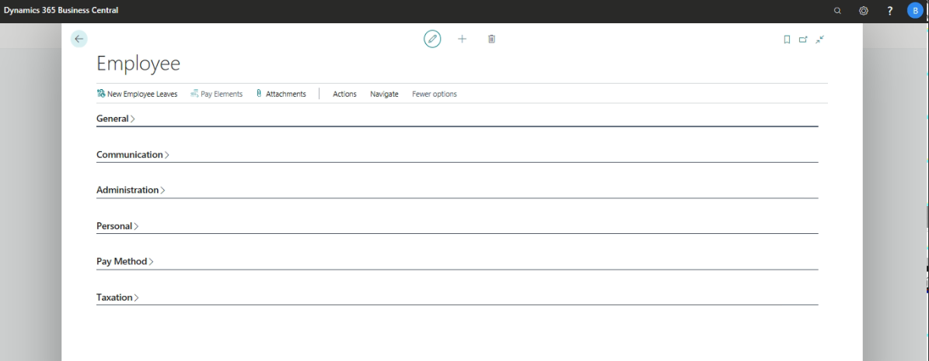
Following are the Mandatory & Important fields to be filled in the employee card.
General Fast Tab
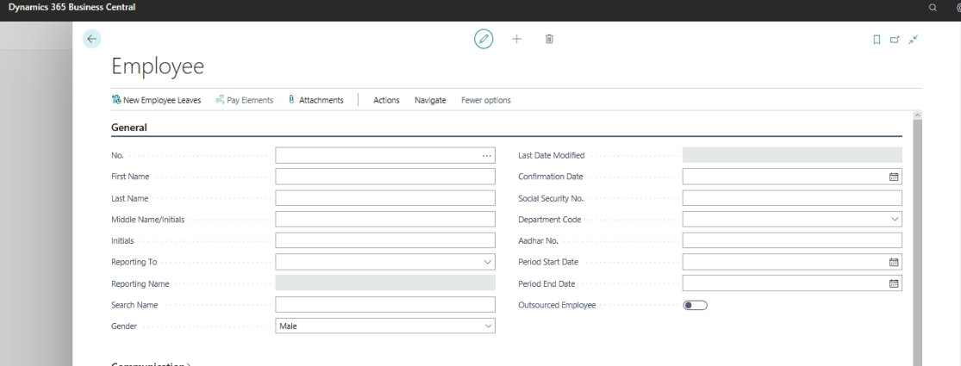
No:
No. will be either automatically generated or can be manually defined based on the No. Series definition in the HR Setup.
Reporting To:
Select the Employee Reporting to information from employee list.
Blocked:
This field is used for blocking the resigned / terminated employees for salary processing.
Confirmation Date:
This information will be updated, once probation employee has been confirmed as regular employee.
Communication Tab
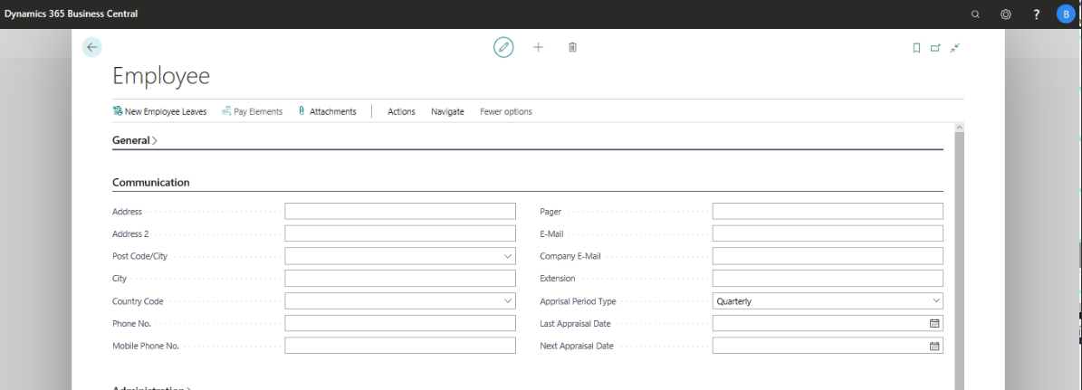
Contact details of the Employee can be specified in the provided fields.
Period Start and End Date:
Define the Attendance processing start date and End date
Administration Tab
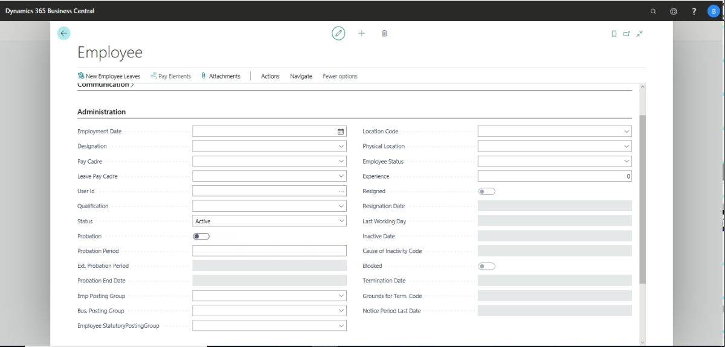
Employment Date:
Employee joining date must be defined in the Employment Date field; this field will be used in Attendance and Salary Processing of an Employee.
Employee Posting Groups:
Specify the Employee Posting Group for relevant postings to G/L.
Business Posting Groups:
Specify the Employee Business Posting Group for relevant postings to G/L.
Pay Cadre:
Specify the Pay Cadre to which the employee belongs as defined in the Pay Cadre Lookup (explained above). Based on the Pay Cadre selected, the default Pay Elements of the Employee will be generated from the Pay Cadre Pay Elements.
Probation:
If any employee is under probation period place a check mark in this field, leave crediting and other relevant processing will be made based on the status of this field.
User ID:
Login IDs as specified in User Table can be picked up, this field will be used in filtering the records of the employee.
OT Applicable & OT Calculations:
If the employee is eligible for OT, place a check mark in the OT applicable field and enter the OT applicable rate, System will calculate the OT Amounts based on these fields.
Department & Designation:
Specify the Employee department and designation information as defined in the Department and Designation lookup.
Physical location:
Specify the Employee physically working location, in case organization having different working locations.
Leave Pay cadre:
Specify the employee leave pay cadre; based on this cadre various types of leaves can be generated.
General information:
Specify the general information of the employee like Height, weight, Probation period and Extend probation period etc.
Personal Tab:
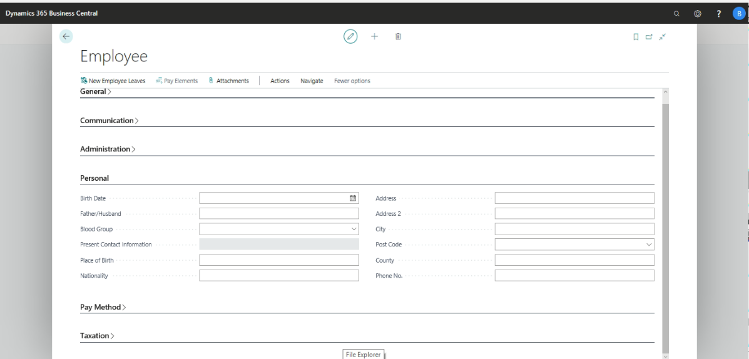
User can key in the Date of birth and Blood group details pertaining to the Employee along with Present Address information.
User can also attach the Employee Photo in BMp format.
Payment Method Tab
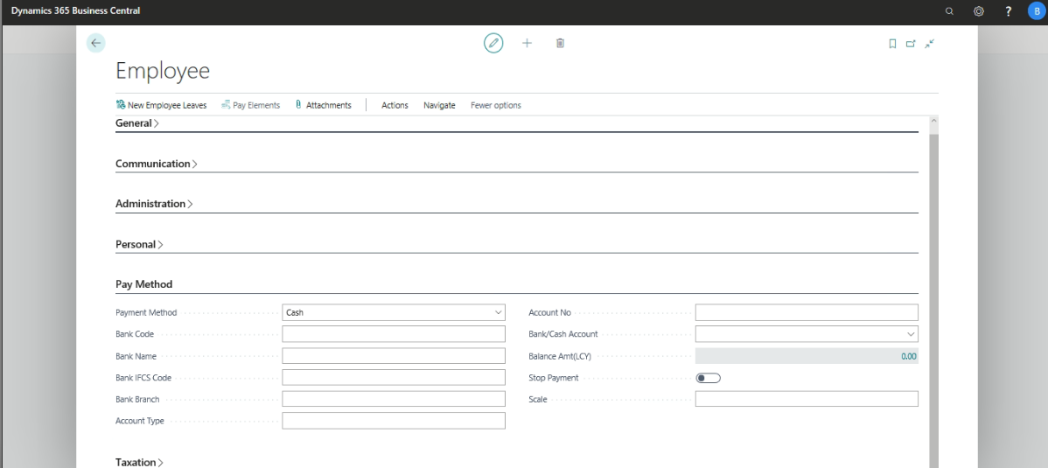
Define the Pay method as applicable - Cash/ Check/Bank Transfer. In case of Bank Transfer, define the Employee Bank details. Respective Cash / Bank account needs to be defined in the Bank / Cash Account field, this will be used for Posting Salary payment to the employee.
Stop Payment:
When Stop Payment is enabled, system will allow Processing of Salary, however, Payment of Salary is not possible.
Taxation Tab
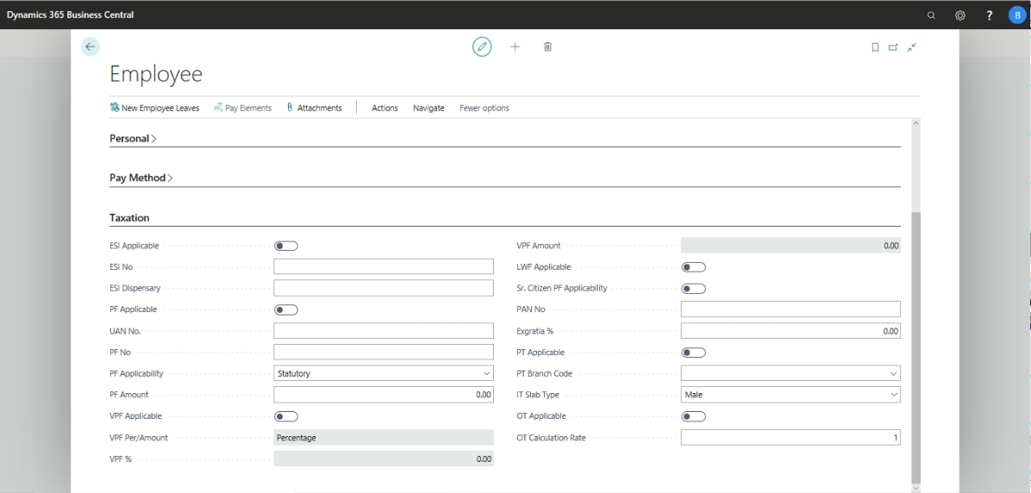
PF, ESI, PT and other regulations applicability for the employee can be defined in this tab, system as a default will place “True” value in these fields, based on the applicability, HR department needs to modify the same.
PF Applicability:
PF amount will be calculated based on the following options opted by the organization.
- Statutory
- Actual Salary
- Employee Specific
If an Organization Selected as Statutory option, System will consider PF Amount as Defined in PF Setup. If an employee Salary over and above the PF amount, System will consider only PF amount for calculating PF.
If an Organization selected as Actual Salary option, System will consider PF amount applicability defined in Lookup No 16 as “Additions and Deductions”
If an Employee selected as Employee specific option, System will deduct PF amount employee contribution as per Employee and Employer contribution as per Statutory only. Define the PF amount field (Employee PF Contribution Amount)
Place a check mark in case of Sr. Citizen PF Applicability, with this system will deduct only Employee contribution.
In case Ex-gratia differs from employee to employee, Ex-gratia % percentage can be defined.
IT Slab Type:
Select the IT Slab type as Male, Female or Sr.Citizen. Based on this option, system will consider IT Slabs for computing TDS amount.
Employee - others
Shifts
It is mandatory to define a minimum of one Shift for functioning of Payroll.
Go to Action pane and go to NavigateShifts
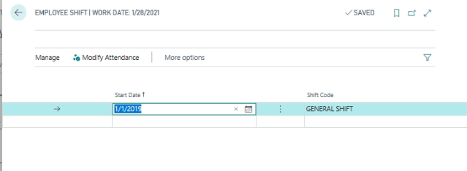
Where there is a change in the shift of an employee, new shift code can be attached with a new start date. After inserting the new record, run Functions Update Attendance. This will modify the Daily Attendance records of the employee.
Pay Elements:
Go to Employee cardPay elements
Pay elements of the employee can be defined by using the payroll menu button in the employee card. These pay elements are the salary structure of the employee. Required modifications to the pay elements can be made in this window.
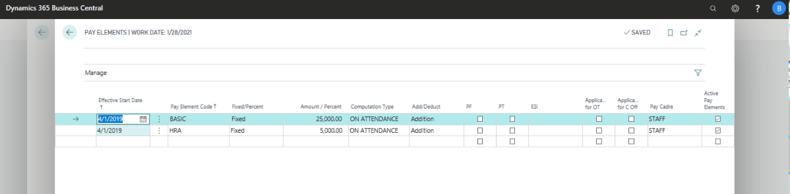
Detailed explanation to the Pay Elements will be provided in the Payroll user manual.
Leaves:
Go to Employee CardNavigateLeaves.
System will update the employee leaves balance information along with details of leave utilization etc.
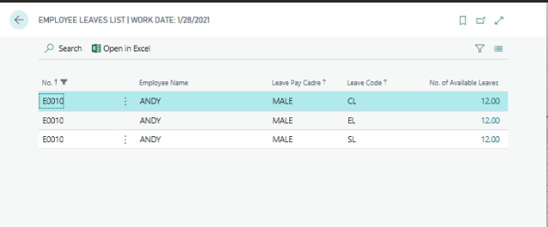
Drill down the No. of Availability, system will show the details of leaves.
Family Details:
Define the Employee family details along with other than family details, Click EmployeeFamily Details
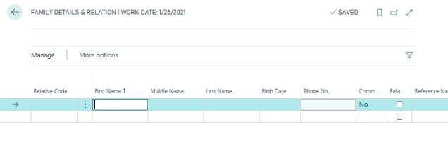
Qualifications:
Define the Employee Qualifications and Past Experience with complete details, go to action paneNavigateQualifications.

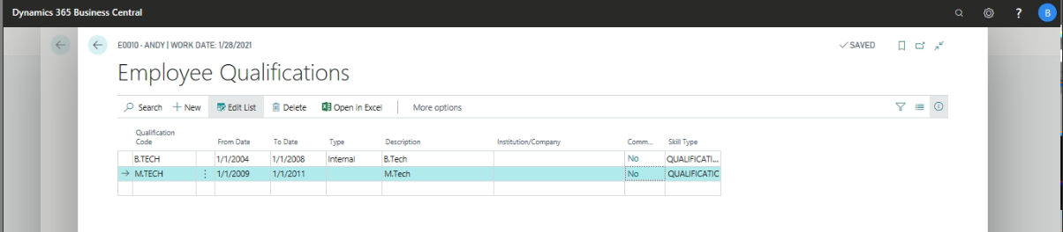
From the above, Employee related Qualifications and Experience information along with additional information like Year of Passing, name of Institution, designation and gross Salary etc., will be tracked.
Hobbies & Languages:
Employee Hobbies and Languages know to speck, write and read information will be tracked.
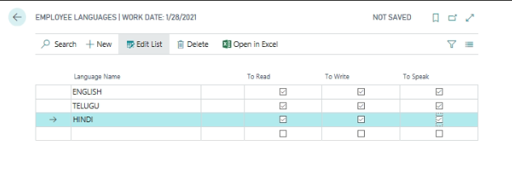
From the above window, define the Employee Hobbies and Languages known information.

Article Information:
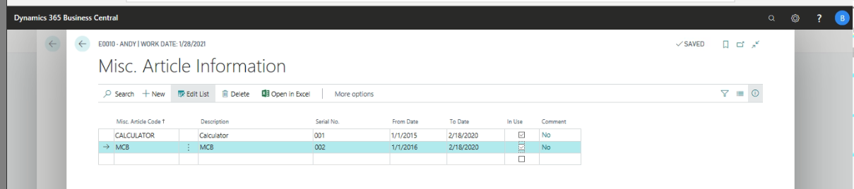

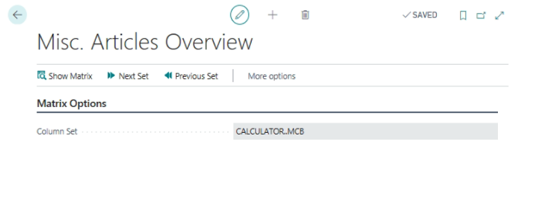
Define the Company articles handed by the employee information.
TDS Information:
If an employee joins in between the financial year, employee needs to submit the previous employment salary particulars, Savings particulars along with TDS Deducted information.
Previous Company Salary particulars and TDS Deducted information:
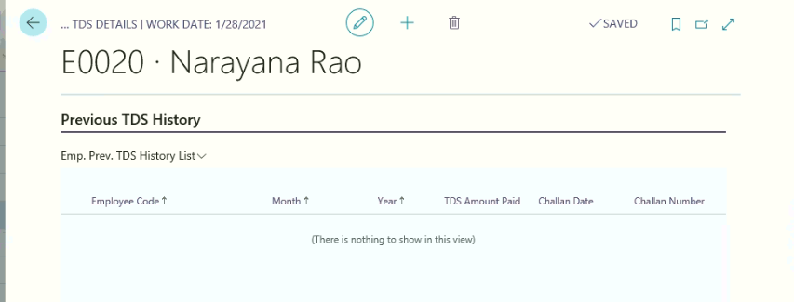
Savings Submitted to previous company details:
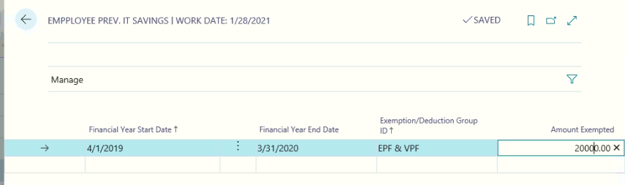
Salary Adjustments Limits:
If an employee is eligible for Salary Adjustments (perks) for the financial year, the same can be defined in Salary Adjustments Limits.
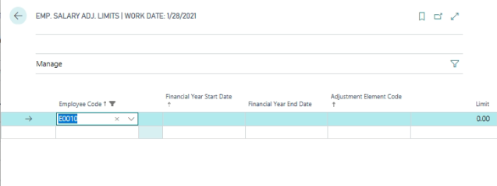
Loans:
Employee loan details can be viewed.
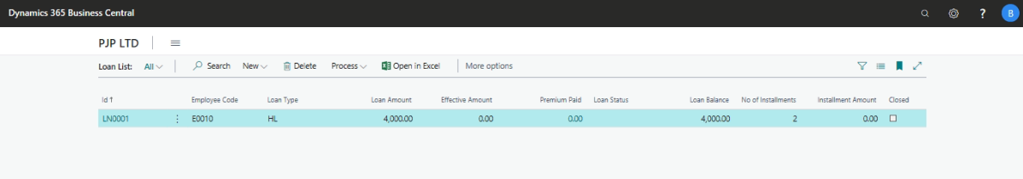

Employee Promotion
Employee can be promoted from one Designation to another designation or transfer from one department to another department by using the following path.
Path: Business Central Employee Promotions
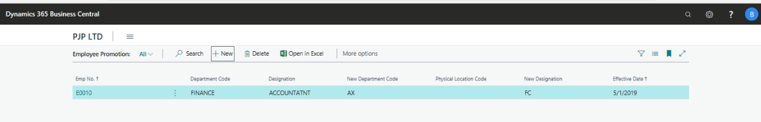
Go to Action pane and click New to creat New employee promotions page.
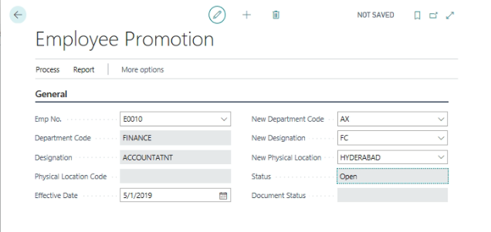
In General Fast Tab define the following information
Effective Date: define the effective date on which employee got the promotion or transfer.
Select the appropriate employee to make transfer or give promotion.
Current Department code and designation code will be populated based on the information on employee master data.
Select the appropriate Designation and Department code to give promotion or transfer.
Go to action pane and click Update
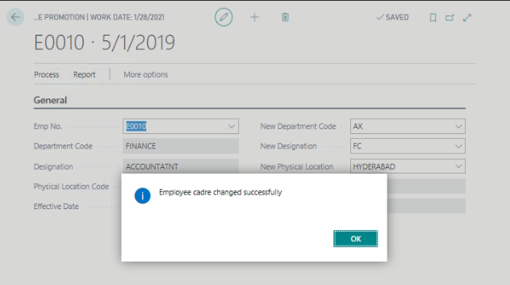
With this system will update the New Department code and new Designation code to the employee master and system will track the complete details of past Department and Designation information.
Past information can be viewed from the employee master data by using the following path
Path: Business centralEmployee history
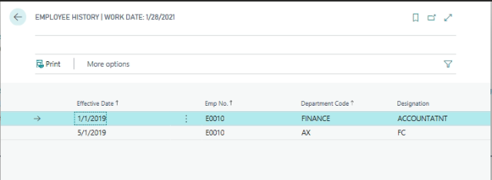

Employee Confirmation
Probation Employees will be confirmed based on the employee performance during the probation period. After conducting employee performance evaluation by the respective departments, employee will be recommended for confirmation. Employee confirmation will be done by using the following path.
Path: Business central –Employee Confirmation
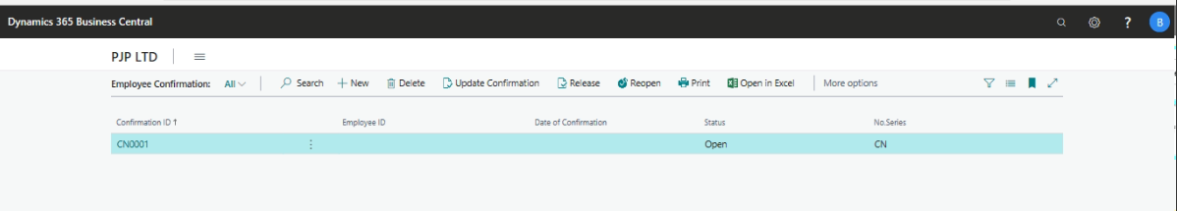
Go to Action pane and Click New
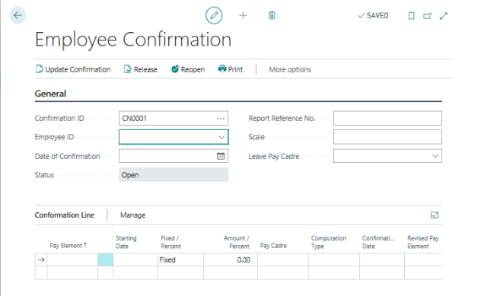
Define the following information on General Fast tab
Confirmation ID: Select the Confirmation Id Number
Employee ID: select the Probation Employee ID
Date of Confirmation: Define the Date on which employee is going to be confirmed.
Employee Name: This information will be updated by the system based on the employee ID.
Type: Select the information based on the applicable options (Employee or Grade)
New Grade: Select the New Grade to which he is going to be transferred.
New Leave Pay Cadre: define the new leave pay cadres based on this new leave to be implicated to this employee.
Employee Confirmation Subpage:
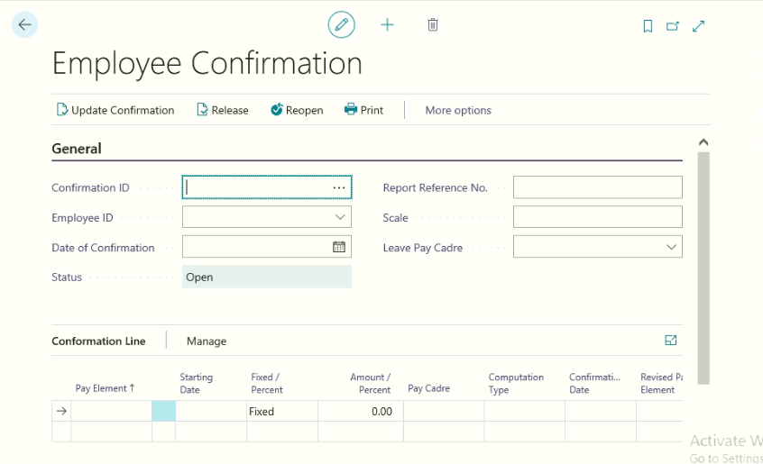
Once the General Fast tab is updated, System will update the following information.
Pay Element Code
Starting date
Fixed/Percentage
Amount/Percent
Computation Type:
Revised Fixed/Percentage: This information will be updated by the system based on the existing pay structure. The same can be modifying by the user at the time of Employee confirmation.
Confirmation Date: This information should be updated by the system based on the “Date of Confirmation” from the General Fast Tab.
Revised Amount/Percent: this information should be updated by the user at the time of Employee confirmation. (If employee’s salary has been revised)
Revised Computation Type: user can change this information, if required.
Revised Date: This information will be updated from the date of Confirmation defined in General Fast tab on Employee confirmation.
Arrear Amount: System will calculate the arrear amount based on the last effective salary paid and Revised pay date.
Pay Cadre: Update the new pay cadre.
Go to Action pane and Click ActionsFunctionsGrade transfer
With this employee Grade will be transferred.
Go to Action pane and Click ActionsFunctionsUpdate Confirmation
With this system will update the employee information as confirmed from the probation.
Go to Action pane and Click ActionsFunctionsUpdate Leaves
With this system will update the new leave applicable based on the new leave pay cadre.

Probation Extension
Employee who are under probation period, on expiry of probation period, they can be confirmed or there probation period can be extended for some more period, based on the performance of the employee.
Path: Business Central HR and PayrollHREmployeeTasksProbation Extended List
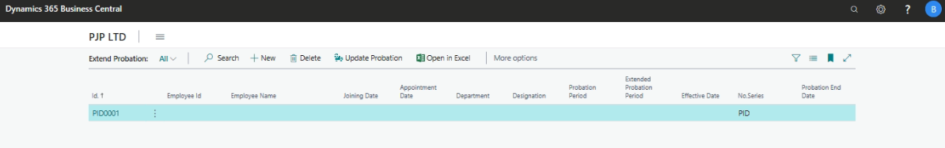
Go to action pane, and click New to create new document for Employee Probation Extension.
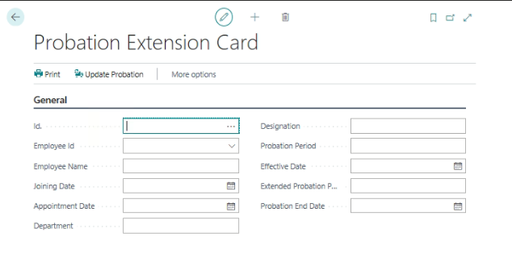
From the above page, select the following information.
ID: select probation extension number series
Employee ID: Select the Employee from the Employee Master List (employee who are under probation are only viewed from this form)
Employee Name: System will update the employee name based on the Employee id
Joining Date: System will update the Employee joining date based on the Employee ID
Appointment Date: user needs to keen the appointment date
Department: System will update the department information based on the employee master
Designation: System will update the Designation information based on the employee master
Probation period: system will update the pronation period (Actual) from the employee master
Extended Probation Period: user needs to keen the extended probation period information
Effective date: user needs to keen the effective period from which probation period will be extending.
Go to Action paneActionsUpdate Probation

Recruitment

Recruitment process consists of three process, they are as under
- Resume Database
- Resource Indent or Manpower Request
- Resource Indent Approval or Manpower Request Approval
- Recruitment process
- Interview History

Resume Database
HR Department or First Officer will keen the Resumes collected from various sources in Resume Database by using the following Path.
Path: Business centralActionsRecruitmentDocumentsResume database
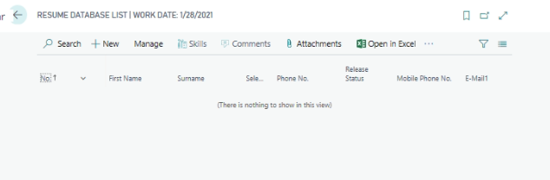
Go to Action PaneClick New to create Resume Database Card.
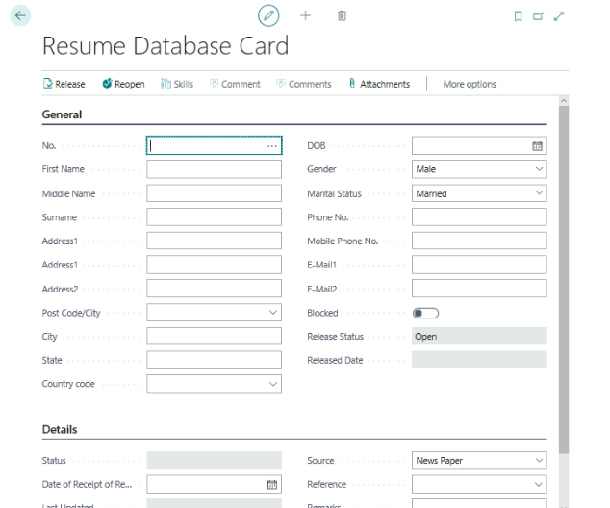

General Fast Tab:
Define the important information on General Fast Tab, they are as under –
Resume Database ID
Candidates Name and address along with Post code, State code and Country Code
Candidates Date of Birth, Gender and marital Status along with Communication information

Details Fast Tab:
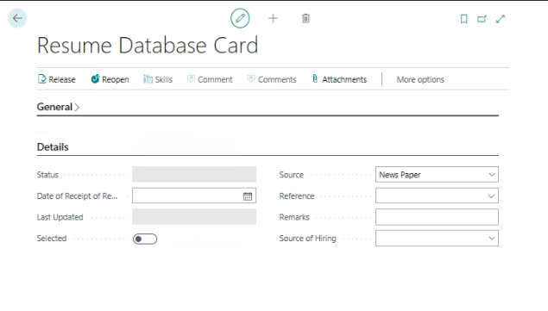

Define the Experience in Years and Months
Select the Source of getting Resume by using the following options
- News Paper
- Employee Reference
- Internet
- Consultant
- Others
Other Information:
Skills:
Update the Candidate’s Skills set like
- Skills
- Certifications
- Qualifications
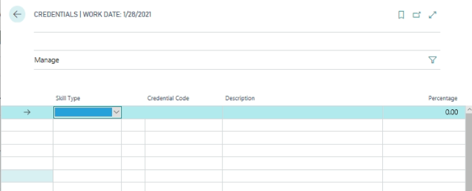
Attachments:
Soft copy of the resume can be attached and stored to view the Resume copy at any point of time.
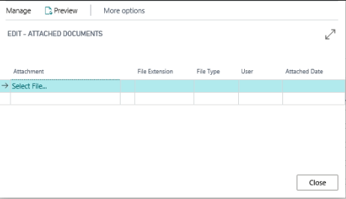
Go to action pane and clickImport to attach the document, Export to export the document from the attachment, Remove to remove the attachment and Open to open the attached document
Once all the required information has been keened in, Resume can be released to use in the Recruitment process.
Go to Action paneActionsRelease or Reopen

Resource Indent (Manpower Requisition)
Whenever the resource is required by any department, they will raise the Resource indent, by using the following path
Path: Business centralActionsRecruitmentTasksMan Power Requisitions list
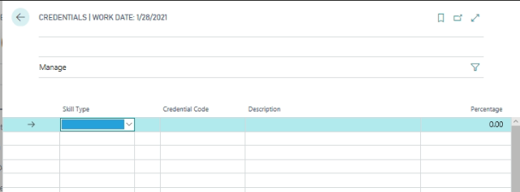
Go to action pane and Click New to create new Manpower requisition.
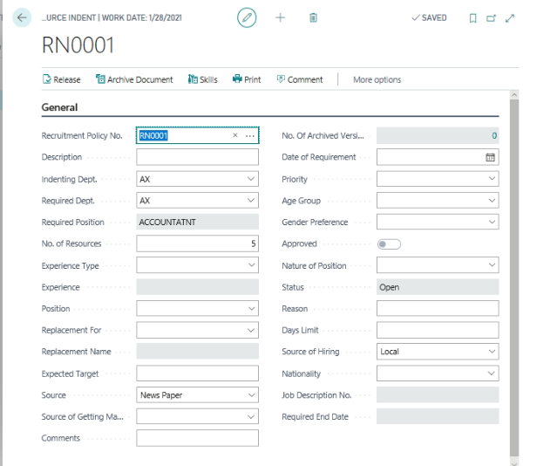

Select the recruitment policy no, with this system will update automatic number series based on the number series.
Description of the Resource Indent
Select the Indenting department from the Department lookup list
Select the Position required department from the Department lookup list
Note: Some time Indenting Department and Required department will be same
Select the Required position from the designation lookup list
Define the no of Resources required for this position
Select the Experience of the candidate for Fresher or Experienced
In case of experienced candidate, define the Experience (Number of years range)
Select the position type with following option
- Replacement
- New Recruitment
- Deputation
Select the salary period by using the options (Per Month or Per Annum)
Select the candidate reporting to information form the employee list
Select the Physical working location for which candidate is looking for
Define the expected targets against this position if any.
Define the source of getting manpower
Define the effective date to full fill this position
Define the Priority with the following options
- Immediate
- High
- Low
- Normal
Select the age group for this position
Select the gender group for this position
Define the salary range for this position
Define the salary type with options of Gross, CTC or Take Home Pay
Define the nature of Position with option of permanent or temporary
Define the probation period for this position if required
Define the position process responsible Employee information
Define the position filled up duration information.
Other Information needs to be defining by using the Action Pane:
Define the Skill set is required for this position.
Click Actions Release – with this system will send the Resource Indent to HOD for Authorization.
With this it will update the Resource indent information in “Resource Indent Approval” form. HOD will log in and check the information and sent the same further approval by using the following Path
Department user will prepare and release the Resource Indent
The same will be display in Department HOD as shown below
Department HOD will Click Show Document Button to view the Resource Indent, after verifying the document, HOD will write comments and Approve to send the document to HR and Admin Department for Further Approval
HR & Admin Department will check the Resource Indent information by using the Show Document Button, after verifying the document, they need to write any comments on resource indent, and they can modify the existing comment and sent for final approval.
Once the HR and Admin Department will send the document for final approval, Final Approval will open the Resource Indent Approval document and same can be approved or rejected.
Once the document is approved, the same document will appear for recruitment process, in case of rejection; user will write “Reason for Rejection” and reject the document. It will directly go to the initial user to modify or cancel the Resource Indent.

Once the Reason for Rejection information has been updated, Click Reject. With this Document will go the Department user and Reason for rejection will update on the Resource Indent.
Department User will open the Resource Indent, and Click the FunctionsArchive Document
Click Yes to Archive the Document. After archiving the document, Department user will make the respective changes suggested and send the same process once again for approval.
To view the changes done for that particular resource indent, the same can be viewed by click No. of Archive Version field in Resource Indent.
Click Line Button to view the Original Resource Indent
Once the Resource indent has been approved, approved information will update in Resource Indent
The same will also display in recruitment process as shown below

Recruitment
All approved Resource Indents will appear in Recruitment process.
Path: Business CentralActionsRecruitmentDocumentsRecruitment
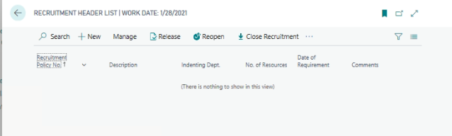
Go to action pane and clickEdit
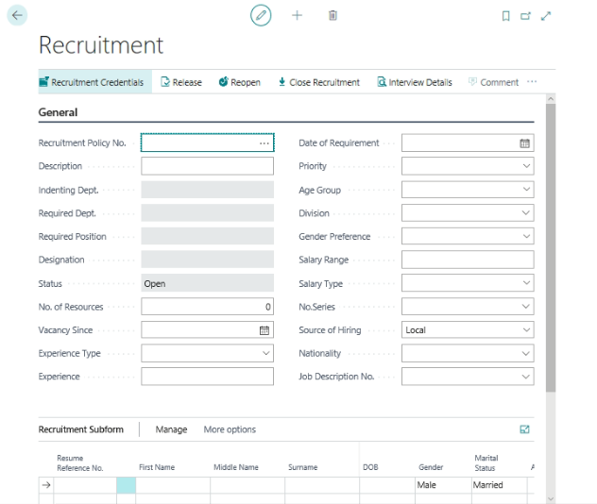
All approved resource indents will display in recruitment process to recruitment. Open the recruitment form; select the recruitment policy number from the list. System will update the recruitment header information.
Selection of resumes of the candidates manually or by selecting Credentials
Go to Action paneHomeRecruitment Credentials.
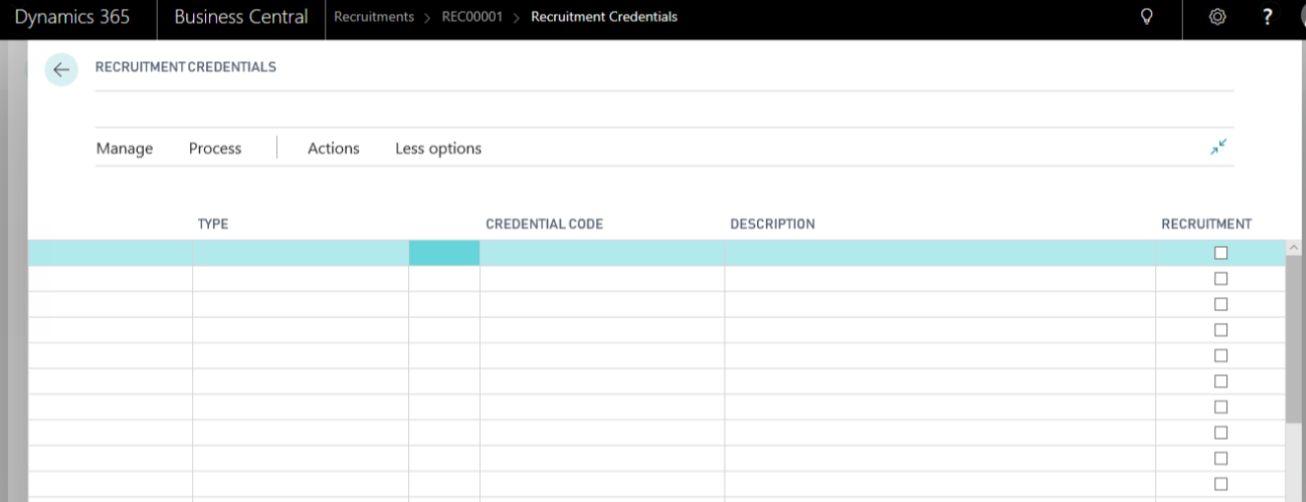
From the above, select the required Skills, Qualifications and Certifications for this recruitment and Go to Business CentralActionsRecruitmentDocumentsRecruitment Home and Insert.
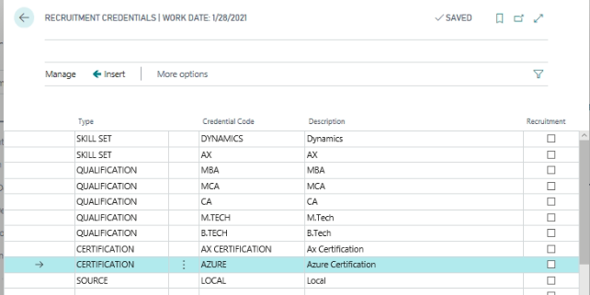
From recruitment lines, select the applicable resumes from resume reference number, with this system will update the rest of the fields in recruitment lines.
From the above screen, place a check mark for required credentials and Click “Insert”, based on the selected credentials system will check the resumes fall under selected credentials will update in Recruitment sub form.

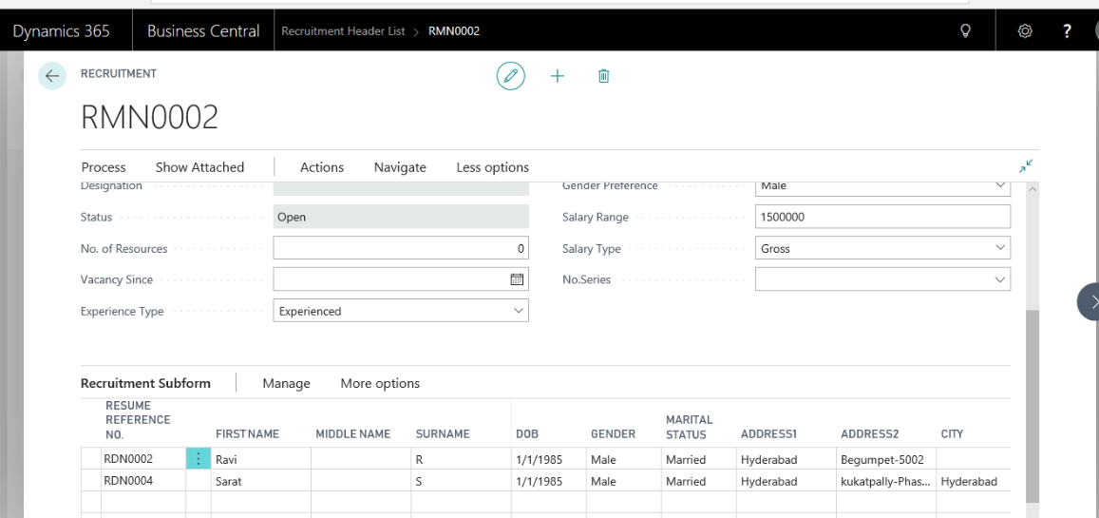
With this system will update the all applicable resumes on Recruitment sub form, the same will be sent to applicable departments for sorting and finalizing the resumes.
Go to Recruitment sub form Business CentralActionsRecruitmentDocumentsRecruitment Interview Details
With this Interview planning will be done against these candidates.
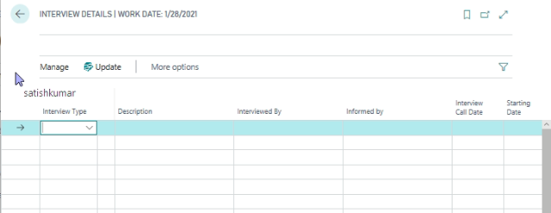
From the above window, select the type of interview and define the interview call date and interview start and End date information.
Once the above information has been defined, click LineUpdate Interview History. With this system will update the interview details in the following page.
Path: Business CentralActionsRecruitmentDocumentsRecruitment Interview History
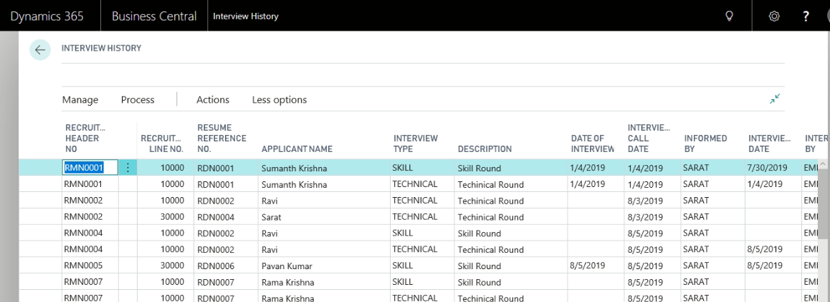
The above information will be displayed based on the interviewer user id, they can select the interview status and also enter Interviewer comments on remarks field and click Update button from action pane. With this system will update the interview details in Recruitment sub form.
Once the candidate has been selected, HR and Admin department will be issued Offer letter and appointment letters. Click Recruitment Sub Form and UpdatingIssue offer letter
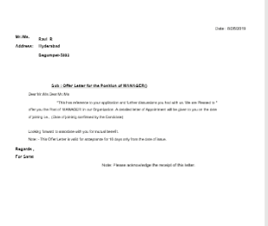
Once the offer letter is issued and accepted, user can issue an appointment letter to the candidate by using Action pane on Recruitment sub formUpdationissue Appointment letter.
io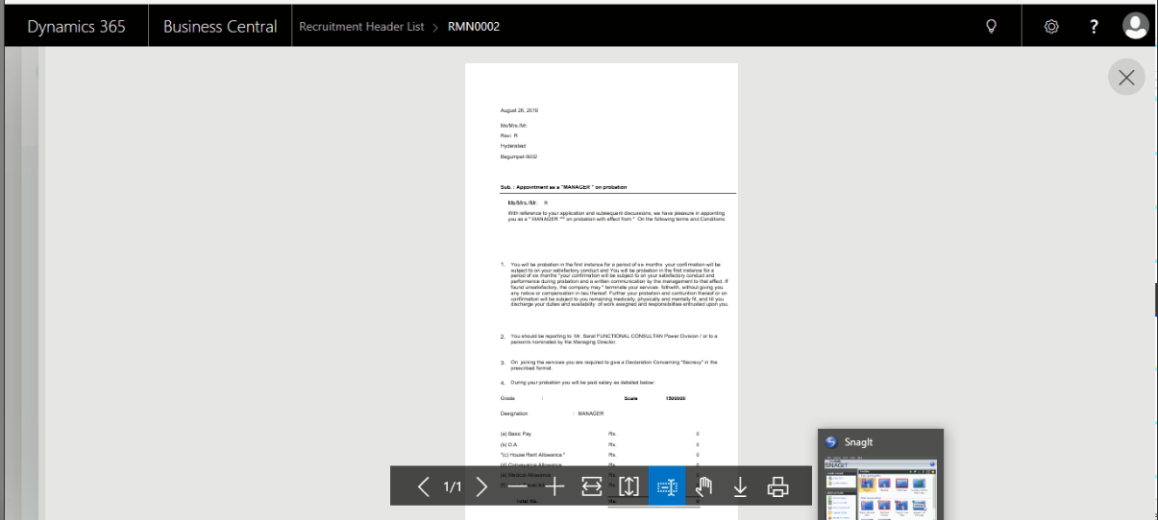
Once an appointment letter has been issues, candidate will give the joining date, the same can be updated on the Recruitment sub form Joining date field. HR and admin department will keen the Candidate agreed salary structure by using the following path in recruitment sub form
Business Central - Recruitment Sub form –Function –Update payelements
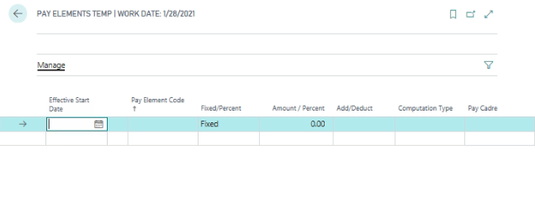
Click Ok to close the pay element page. On updating of the same, click UpdationsConvert to an Employee.
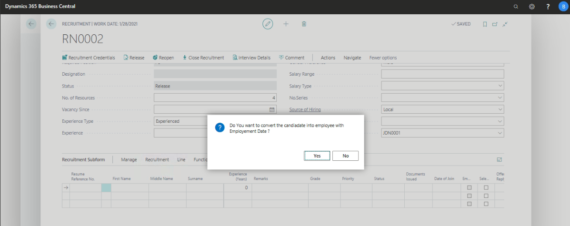
Click yes to convert as an employee. With this system will update the candidate information in employee master data of the organization.
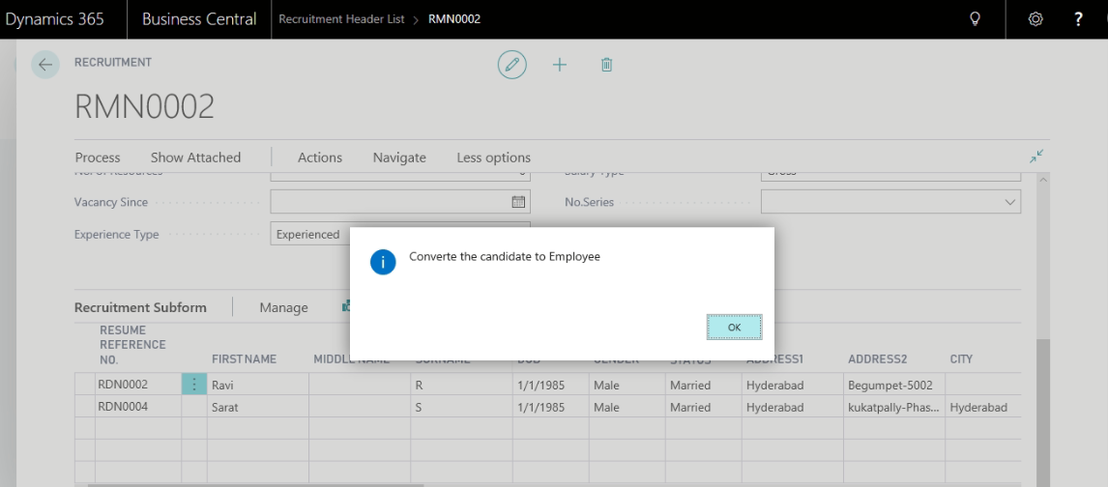
Click Yes to convert the candidate into Employee, with this system will assign the automatic Employee ID and also update the following information on the Employee Master.
- Employee Name
- Employee Address
- Employee Communication Information
- Employee Joining Date
- Birth Date
Once the above information has been updated, user needs to keen additional information on the employee master card. They are as under
- Reporting to
- Period start date and End date (Attendance Generation)
- Job Title
- Designation
- Department
- User ID ( In case of Leave applying and cancellation)
- Qualifications
- Height and weight
- Probation Period
- Resource No ( Agency Number)
- Probation (Place a check mark in case of probation)
- Physical Location
- Leave Pay Cadre
- Employee Status
- Father/Husband Name
- Blood Group
- Place of Birth
- Nationality
- Percent Contact Information
- Payment Mode and Bank Details
- ESI, PF, PT and Income tax information
Additional Information needs to be attached
- Employee Shift
- Family Details
- Qualifications and Past Experience information
- Hobbies and Languages information
- Article Information
- Pay Elements information (in case of modifications)
Generate new Employee Attendance
Path: HRMSPeriodic ActivityGenerate New Employee Attendance
Once attendance is generated, go to new employee card and Generate applicable leaves
Click FunctionsNew Employee Leaves.
Once the recruitment is completed, user can close the recruitment process by using the following function.
Go to action pane on the recruitmentClick Close Recruitment

Training

Training program of the employee has been divided into following sections
- Employee Training Need
- Training Schedule
- Training
- Training Feedback

Employee Training Need
Each employee wise training need will be identified at the time of Employee performance Review and create an Employee Training Need by using the following.
Path: Business CentralActionsTasksEmployee Training Need
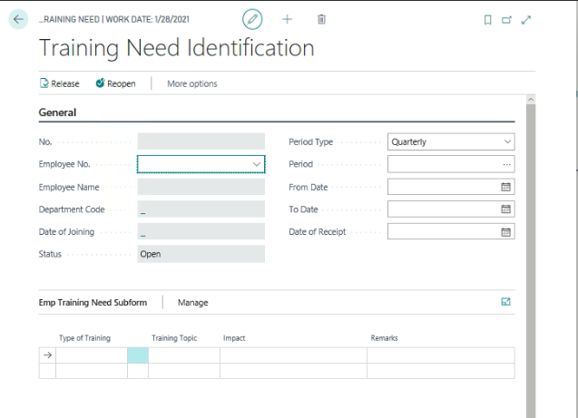
User needs to define the required information on General fast tab of Employee Training need
Employee Number:
Period Type: Select the applicable type from any one (Quarterly, Half yearly and yearly)
Period: define the period manually in case of Quarterly and Half Yearly, in case of yearly select the applicable period
In case of Period type as Quarterly or Half Yearly, user needs to keen the Period Start date and end date manually.
From date and to date: This field will be updated based on the defined period
Date of Receipt: this field needs to be defined on which date Employee training need is identified and planned for training.
Employee Name and Designation: These fields will update based on the employee
Date of Joining: This information will also update from the employee master information
Select the required information from the Employee Training Need lines
Type of Training: select the required training type
Training Topic: Select the training topic
Impact: User needs to define the training topic impact on the employee
Remarks: user needs to define any remarks against the training (if required)
Once the required information has been defined, Click Home (Action Pane) Release the document for next process.

Training Schedule
Based on the Employee Training need, training schedule will be prepared for the selected period.
Path: Business CentralActionsTasksTrainingTraining schedule list
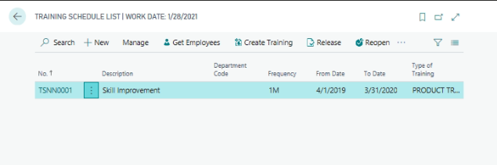
Go to action pane and click New to create New Training schedule page.

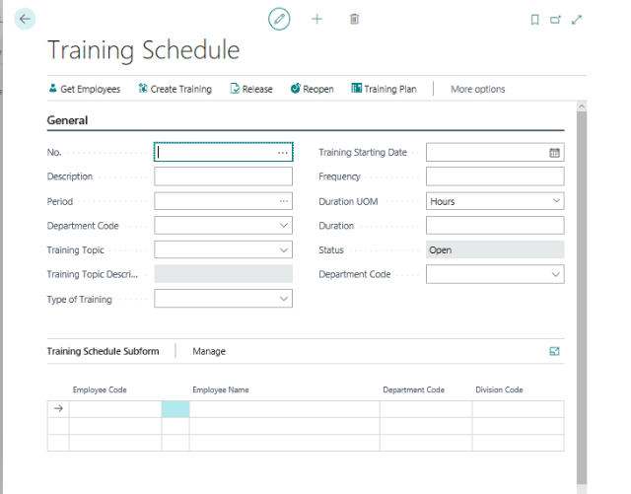
Document No: Select the Training Schedule document number
Description: Define the Training program description information
Period: Select the Training program period
Training topic: Select the topic
Type of training: select the type of training from the lookup list
Training start date
Training frequency during the period selected
Duration of training in Hours or in days
Other information:
Click on (action pane) Home Get Employees
With this system will update the employee information based on the training type and training topic. On updating, user can also add few more employees to attendant the training manually.
Click training plane on action pane on the training schedule to create training plan for the defined period.
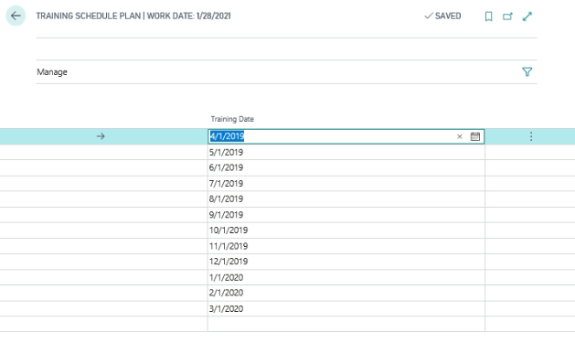
With this system will prepare the training calendar based on the frequency and period

With this system will update the training dates, if user needs to modify the training dates can be modified manually based on the requirement.
Once the training schedule has been created, user needs to create training go to action pane and click create Training.
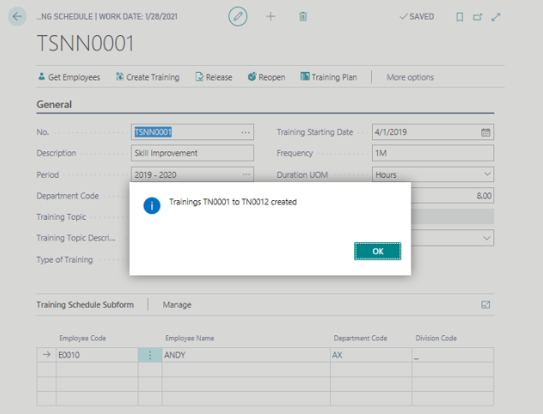
With this system will create training cards as per training schedule and training dates
Once the training card has been created, trainee will attend the training and update the various information.

Training List
From the training schedule, system will create the training card based on the training frequency and period.
Path: : Business CentralActionsTasksTraining Training List
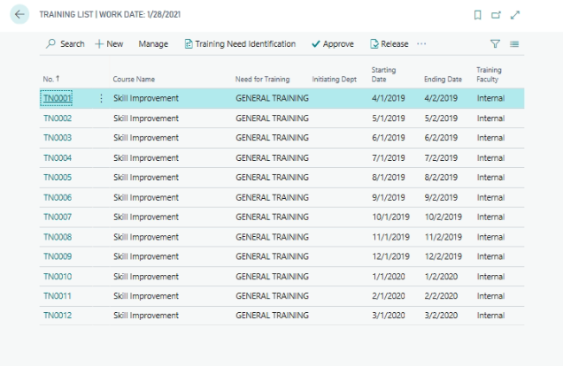
Select the training number and click Edit or view to open the training page.
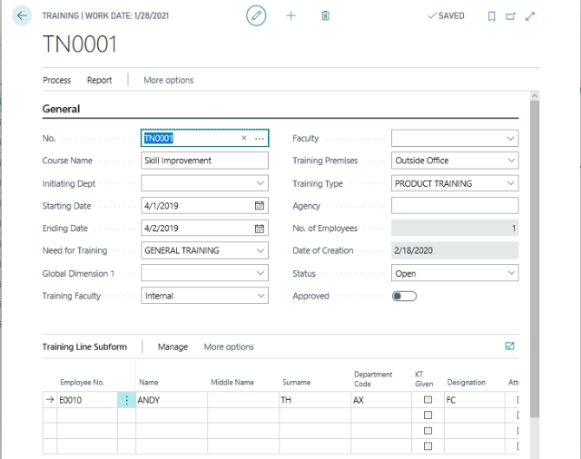
System will update the information in Training header and lines, user needs to keen addition information on header and lines as under
In Training Header
- Faculty information
- Training Premises
- Training Agency
In Training Lines
If user needs to attach additional employees to attend the training needs to be attaching manually.
Other Information:
Home Release or Reopen
With this training document status will updated.
Home Approve
Once the training program has fixed and finalized, click approve.
Once the trainee attend the training, they will update the training feedback form
Training Line sub formLineTraining Feedback
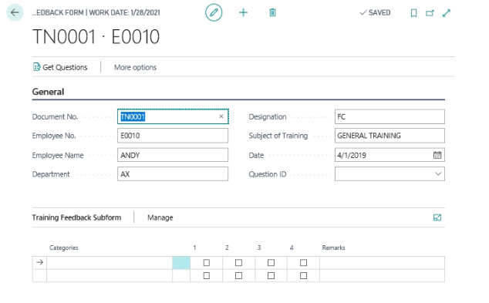
From the above page, each employee who attended the training, they should update the training feedback.
System will update the header information. Trainee needs to select the Question Id from the header.
Go to HomeGet Questions
With this system will update the Question related to training will update
Few questions will be based on rating as 1 to 4 and few question needs to be update the information
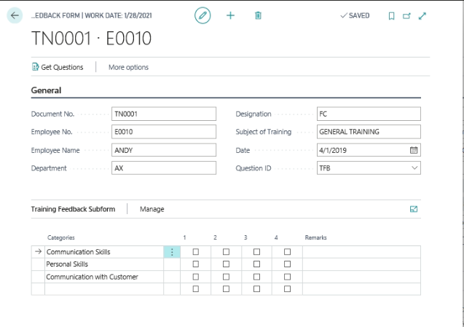
Once the trainee will update the training feedback information, close the Training feedback form
Once the training feedback was updated, the same can be print
Training feedback Report
On successful completion of Training, the trainee will share the knowledge to their internal team, by using the Training Line sub formLineKnowledge Transfer
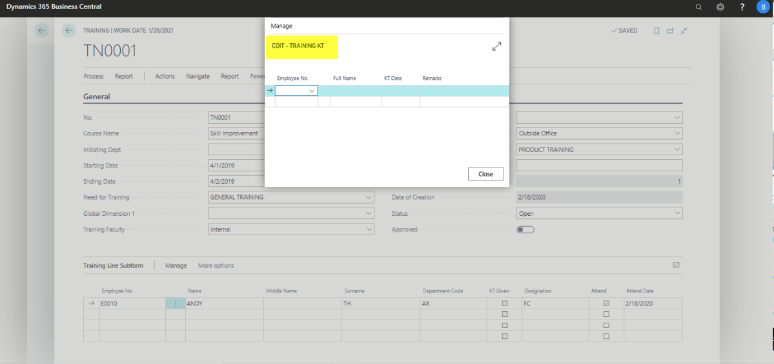

Training Dash Board
Path: Business Central HR and PayrollHRTrainingTraining Dashboard.
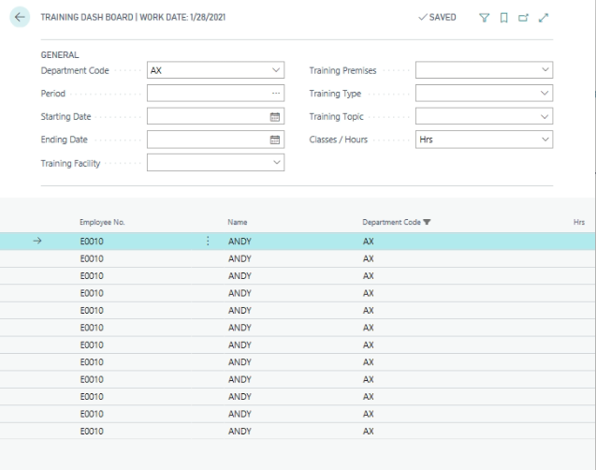
User can view the training wise no of employee’s training attended information for the selected period.

Employee Performance Appraisal
Employee performance review will be done on periodical basis.
Path: Business central Actions Appraisal
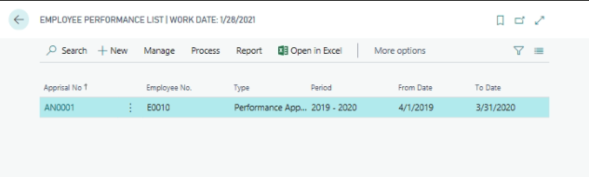
Go to Action Pane and Click New to create new Performance Apprasial Page.
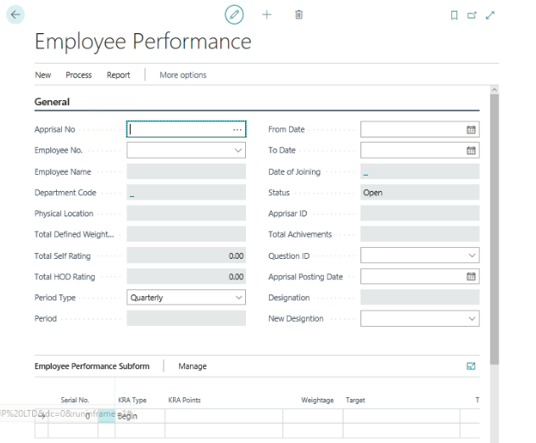
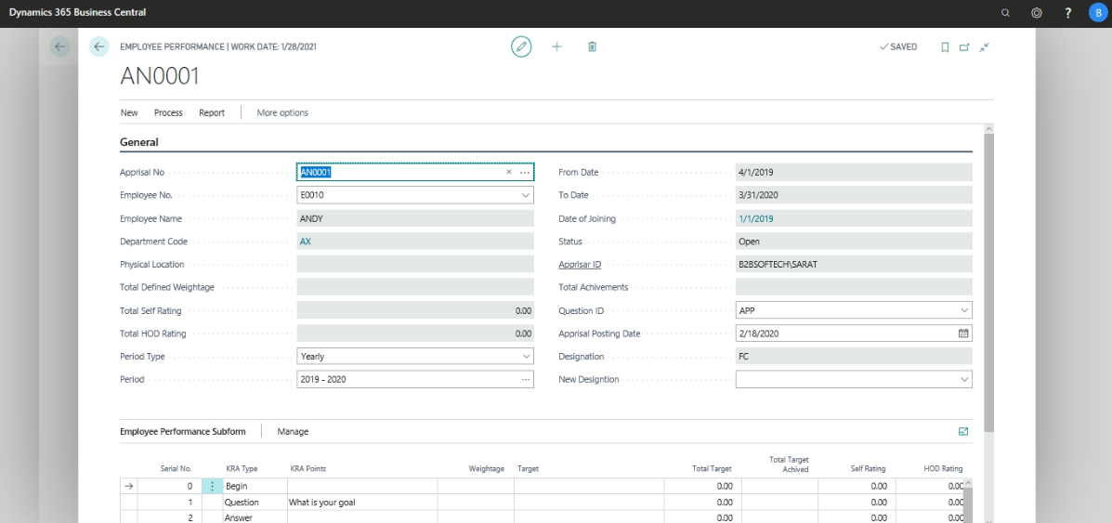
From the above Page update the following information in General Fast Tab
Appraisal Document No: Select the appraisal document number
Employee No: Select the Employee Number from the Employee list
Once the employee code has been selected, system will update the following information
- Department Code
- Physical Location
- Date of Joining
Once the user select the period type and define the period information, system will update the from date and to Date information.
System will update Appraiser Id based on the user log in ID
Employee Performance Sub form:
The following information needs to be keened in Appraisal lines.
- Serial No
- KRA type
- KRA Point
- Weightage
- Target
Go to Home from Action pane and click Get Questionnaire, with this system will update the Questions or KRA points applicable for this employee based on the Appraisal Question Id.
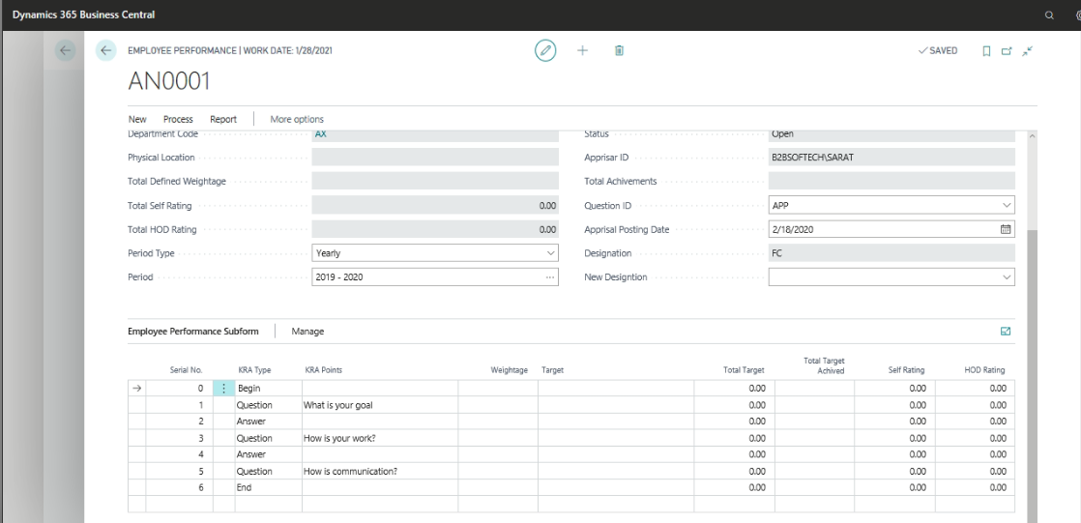
Once the KRA points are updated, user needs to define the each and every KRA point wise Weightage information needs to be defined. Total weightage should be 100 only. Once the weightage has been defined, go to HomeRelease.
At the time of Performance review, go to HomeReopen.
Then go to HomeSelf Rating
Before updating self-rating and HOD-rating, go to HomeCalculate Weightages. With this system will update the total weightage information for this employee.
Once the above information has been defined, on periodically self-Rating and HOD-Rating will be updated.
Go to Self-rating field and Select the Rating scale for each and every point from the lookup.
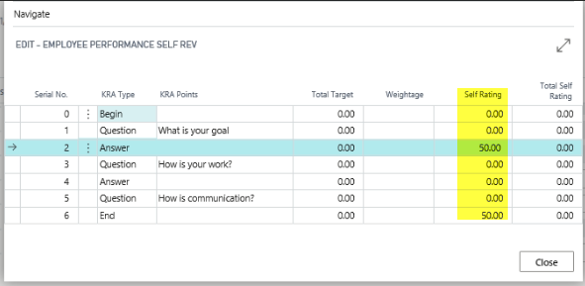
Once the Self-rating has been done, go to NavigateSelf rating, with this system will update the self-rating details.
Once the Self-rating has been done, go to Home and Release the document for further review of HOD.
After self-rating by the employee, the same can be reviewed by the HOD and updating HOD Ratings.
Go to HomeHOD Rating
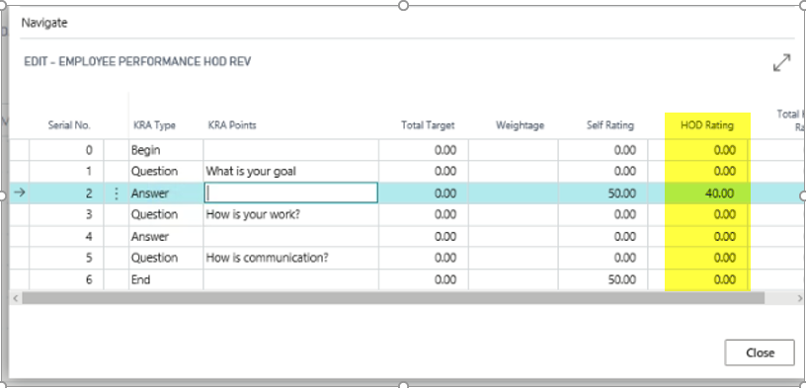
Once the HOD Rating has been done, go to HomeHOD Rating. With this HOD-Rating details will be updated on Employee Performance Sub form.
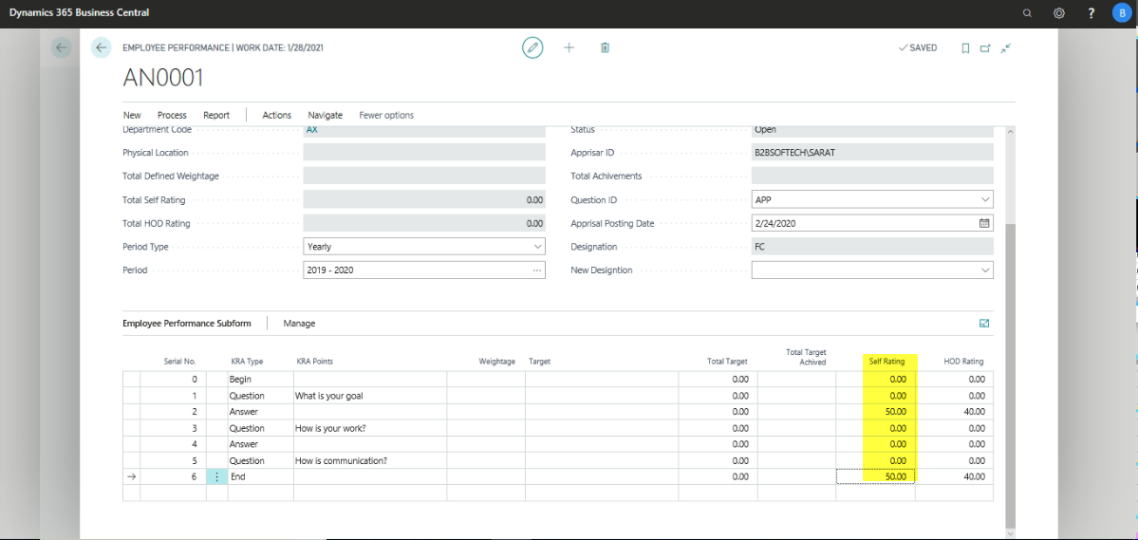
For each and every performance review will be tracked by using the Log. In this system will update the detail information.
HomeNavigateLog
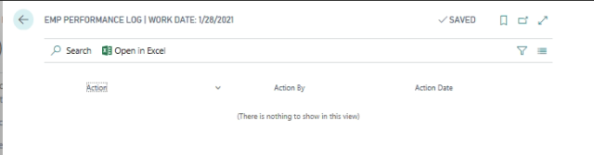
With this user can track, who has done the self-rating and who had done HOD Rating etc.
In case of HOD-Rating will also update as Self-rating updating
Once the Self-rating and HOD-Rating has been updated, HomeCalculate Weightage
With this system will update the Self-rating and HOD-Rating information on the Performance appraisal header.
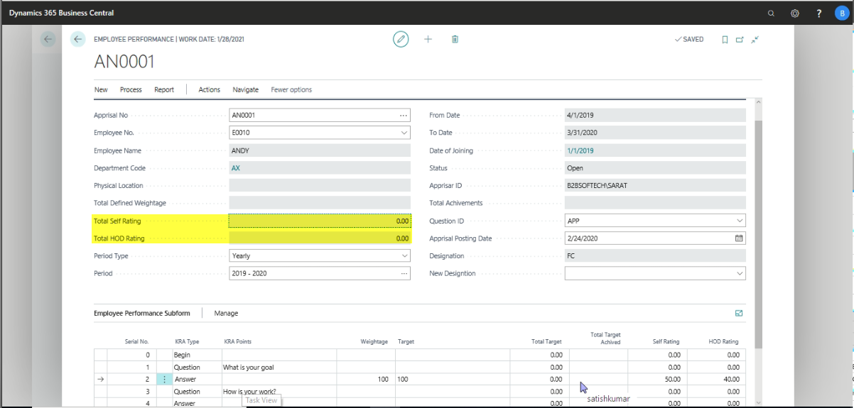
Once the Self & HOD Ratings are calculated and updated, user needs to assess the targets with actuals, to update actual target achieved in Total Target Achieved field against each target.
Once the actual Target Achieved, Click FunctionsCalculate Weightage
With this system will update the Total achievement field in Performance Appraisal header.
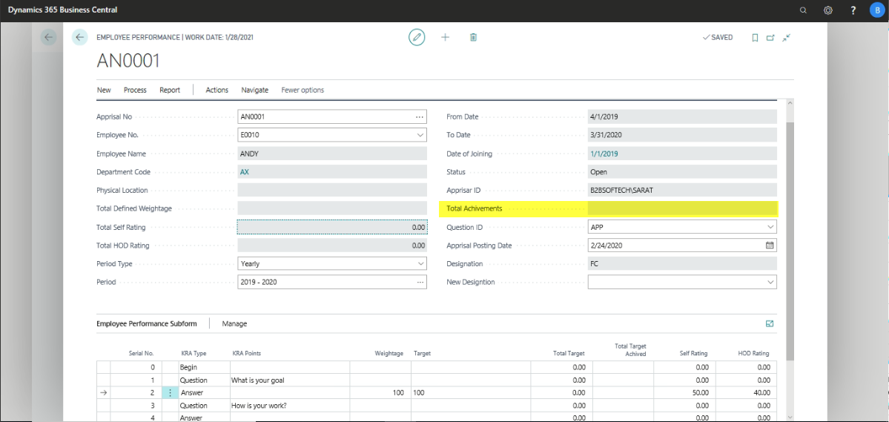
Once the Employee performance process completes, take a Print out of Performance Appraisal report
ClickPrint
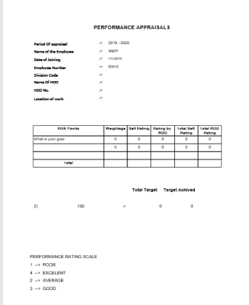

Job Description

Path: Business CentralActionsHR Job Description.
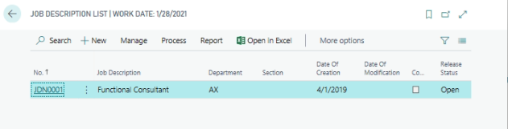
Go to HomeClick New to create New Job Description Page.
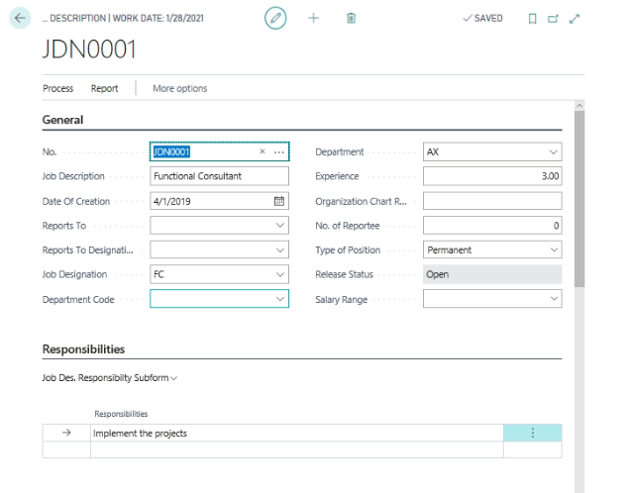
General Fast Tab:
Define the Job Description ID and Description
Define the Report to and Reporting designation
Attach the Job Designation and Department
Define the minimum Experience required for this job
Define the Organization Chart Reference Number
Define the number of reporting for this Job profile
Define the Job Position type as (Permanent or Contract)
Define the Salary Range applicable for this Position.
On Job Description sub form:
Define the Roles and Responsibilities for this Job Profile.
On Job competences:
Define the on Job competences details
Additional Information can be attached from Action pane:
Attach the Skill set required for this Job Profile (Skills, Qualifications and certifications)
Once the above information has been defined, this document will be released by using HomeRelease.

Employee Separation

Employee Separation will be done by way of Employee living the organization by way of Retirement, Resignation or by way of Termination. Once the employee separation process has been completed, employee becomes the history of the organization.
Path: Business Central Employee Separation List
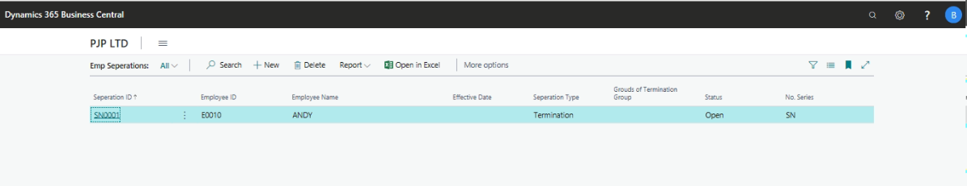
From HomeClick New to create New Employee Separation page.
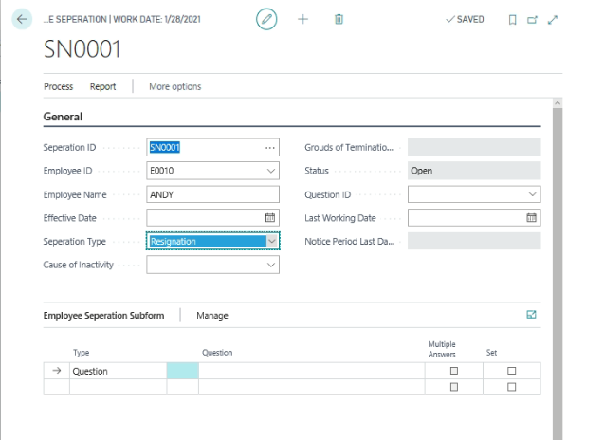
From the above page, select the Separation document id and Employee ID
Define the effective date, employee is living the organization.
Select the Question ID to be asked at the time of Exit interview
Note: In case of Termination, Exit Interview is not applicable
Go to Action PaneActionsConduct Exit Interview.
With this system will update the Questions to be asked at the time of Exit Interview. User needs to be keen in the answers against each question.
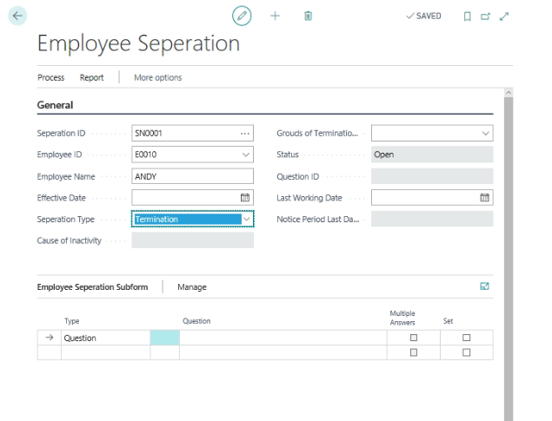
Once the Exit interview has been done, go to homeRelease and Click Update Retirement/Resignation.
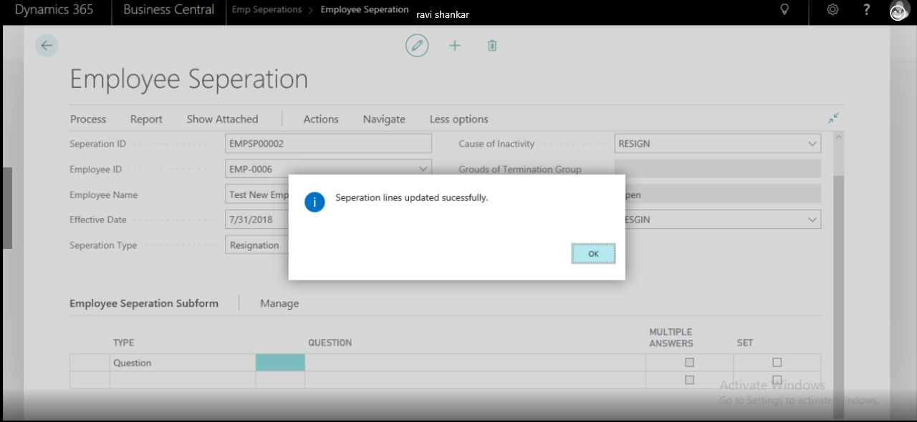
Click OK.
Once the above function has been done, system will block the employee and remove the data from the attendance management.
To view the information, go to employee master card.
General Fast Tab
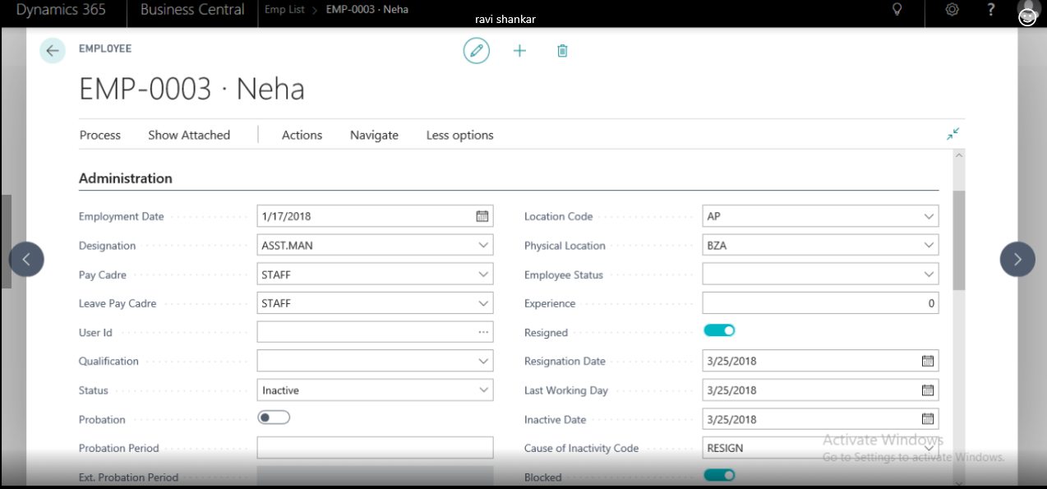
Once the employee has been blocked, check the Attendance information form the Daily Attendance form.
HomePrintRelieving cum Experience letter form the employee Separation form
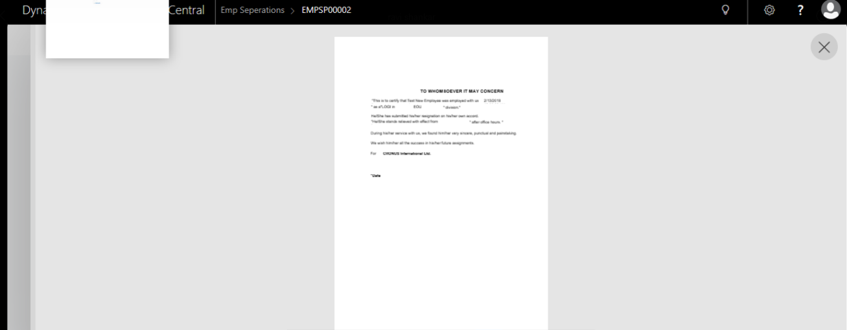

Note:
- In case of Termination, only termination letter will be issued and Exit interview will not be conducted.
- In case of Terminated employees, System will update the Termination Date and Grounds for Termination information will be updated.
- With date of termination, employee becomes the history of the organization and daily attendance records will be removed from date of termination.

Attendance Management

Attendance Management will consists of two ways
- Manual Attendance Updating
- Machine Attendance Updating
Attendance generation will be done based on the following parameters
- HR Setup
- Leave Year
- Leave Pay Cadre
- Pay Cadre
- Employee Shifts
- Period Start and End Date in Employee Master
- Generating Calendar
- New Employee Attendance Generation

HR Setup Attendance
Path: HRMSSetup HR Setup
General Fast Tab
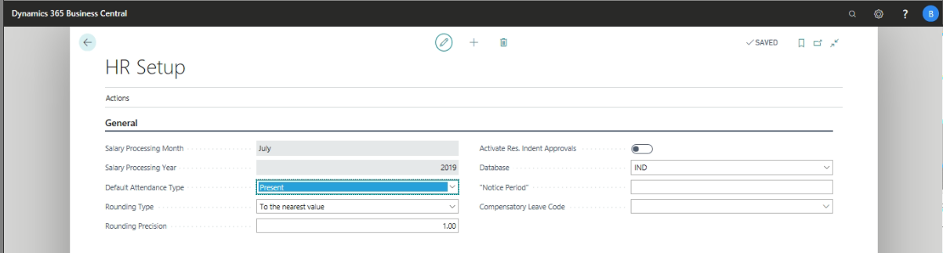
Salary Processing Month: Select the salary processing month first time, with this system will update the month information in Daily attendance form.
Salary processing year: define the Salary processing year first time to generate the attendance.
Default Attendance Type: Define the Default attendance type as “Present” or “Absent”
Attendance Storage Location: define the Machine attendance storage location path
Archive Attendance Storage Location: define the posted machine attendance storage location path

Leave Year
Path: Business CentralHR and Payroll ActionsSetup LookupsPayroll years
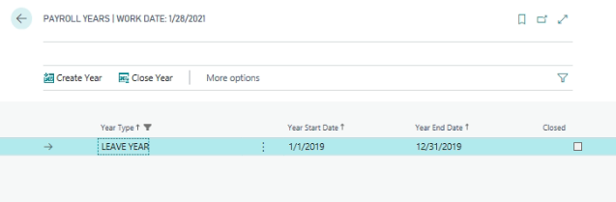
Check the Sections (4.15) Lookups for process of creating Leave Years

Leave Pay cadres
Path: Business CentralHR and Payroll ActionsSetup LookupsPayroll years Leave Pay cadres
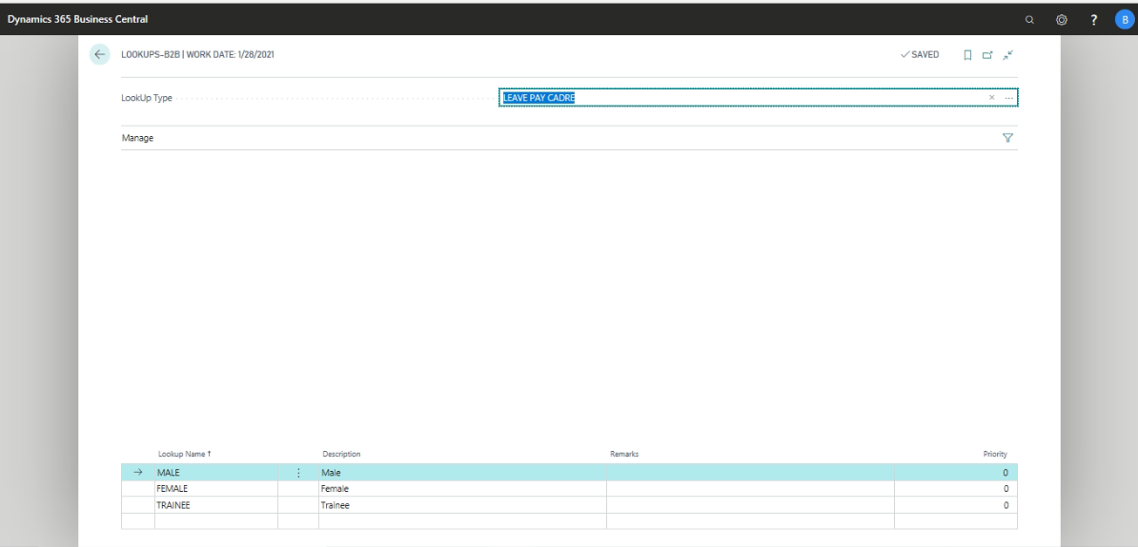
Check the Section (4.18) look ups for process of creating Leave Cadre and 13.1 to attach the leave pay cadre to employee Master.

Employee Shift
Path: Business CentralHR and PayrollSetupAttendanceShift List
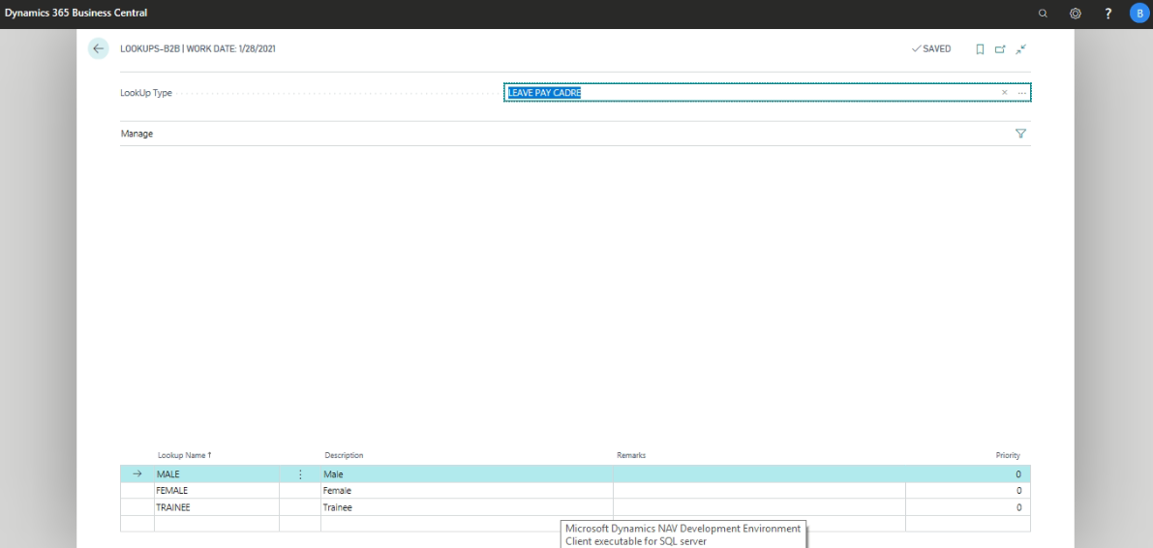
Check the Section 8.3 and 13.1 to create the shift and attach the shift code to employee master data.

Period Start and End date
Path: Business Central Employee List
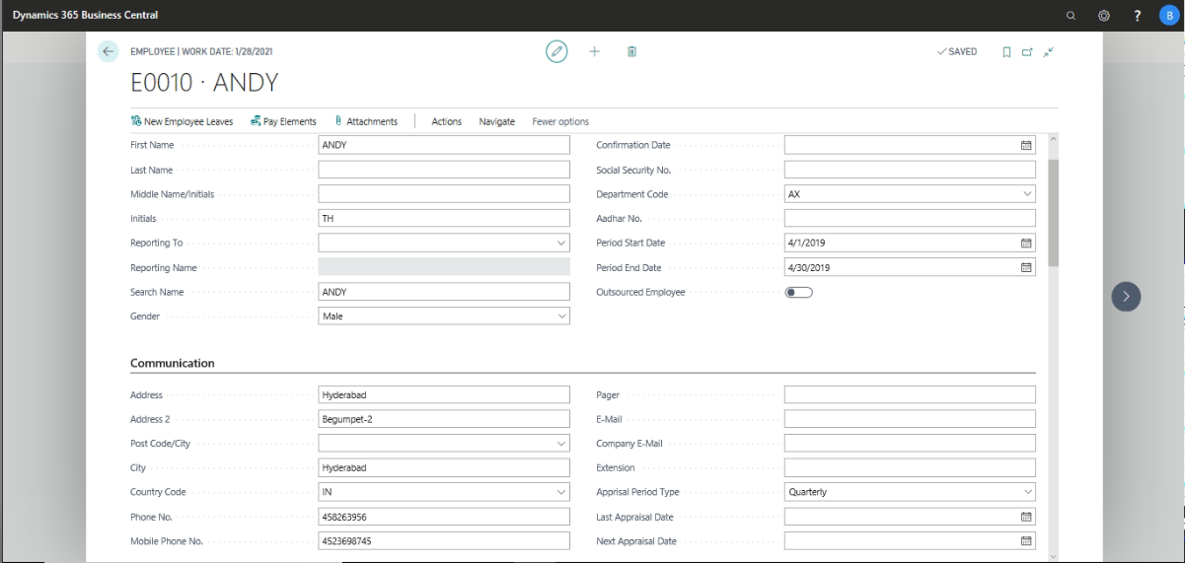
Check the section 13.1 process for creating period start date and End date.
Once the above important information has been define and attached to employee master card. Once in leave year one batch job needs to run. In case of Employee joins in between leave year another batch job needs to be run.
Path: Business Central Actions Periodic ActivitiesCalendar Generation
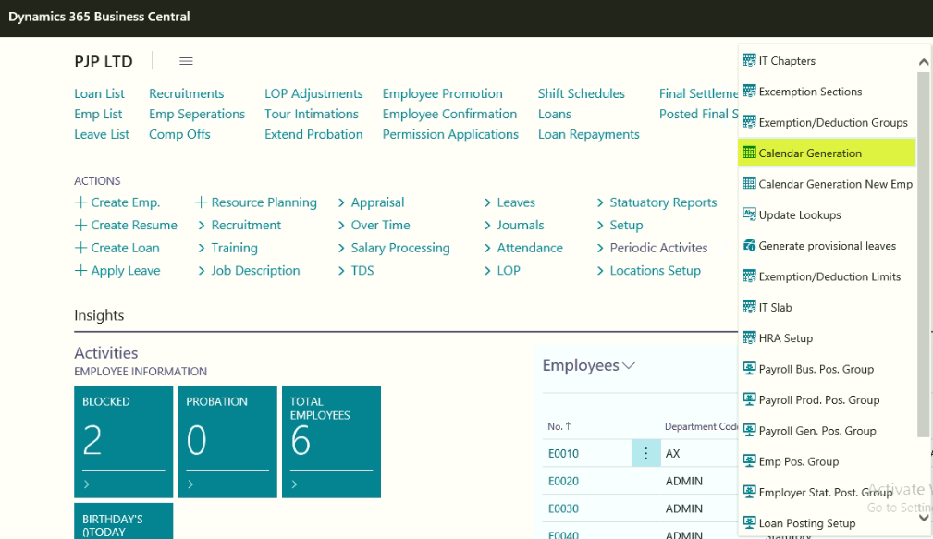
Path: Business Central Periodic ActivitiesNew Employee Attendance Generation
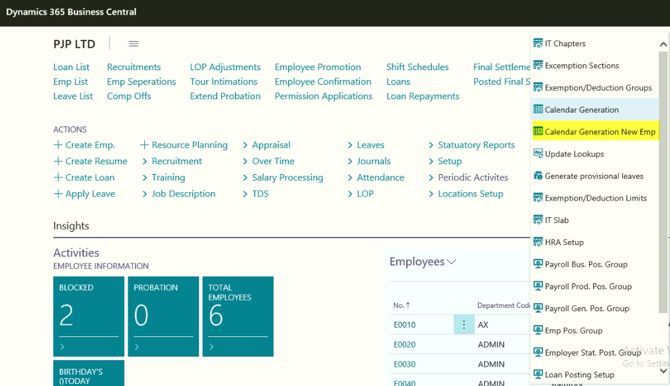

S.No | Batch Job | Usage of batch Job
01 | Calendar Generation | This batch job needs to be run every leave year. With this system will generate the default Attendance for existing employees.
02 | New Employee Attendance Generation | This batch job will be used to run, as and when employee joins the organization in between the Leave year. With this system will generate the attendance based on the employee joining date.

Manual Attendance Updating
Once the attendance is generated for the leave year, user needs to update day to day attendance information of all the employees.
Path: Business CentralHR and PayrollpayrollAttendanceDaily Attendance
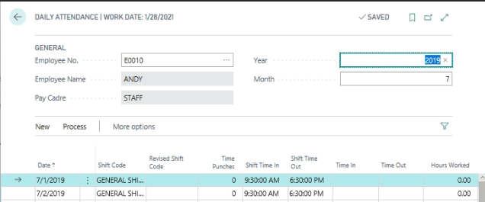
Select the Employee Code
Month and year will automatically update based on the HR setup Salary processing month and year
User needs to keen the day wise and Employee wise Time in and Time out. Based on the time in and out, system will update OT hours, these OT Hours needs to be approved.

Machine Attendance Updating
Process – 1:
To update the Attendance Machine attendance information on daily bases, user needs to setup the following information.
- Attendance Storage Location
- Archived Attendance Storage Location
Attendance Machine generated data will be stored on daily bases in “Attendance Storage Location” once the Attendance Automation batch job needs to run from the periodic activity or Scheduler needs to run with this system will automatically update the attendance in daily attendance. Once the attendance is updated into the system, the same file will be archived and stored in archived attendance storage location.
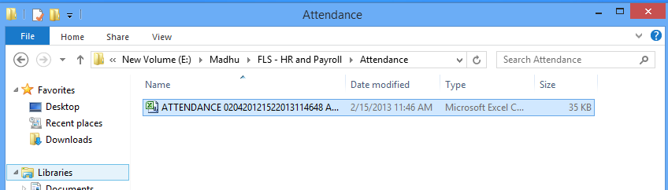
Once the batch job is run, they system will update the attendance file in daily attendance and copy of the file will be moved to posted Attendance Folder defined in HR Setup Archived Attendance Storage Location path.
We can view the posted attendance file as below
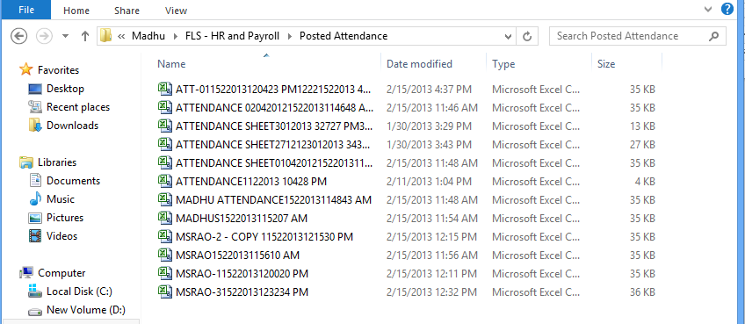
Process -2:
User needs to get the machine attendance day wise with following information.
- Employee Code
- Date
- Time In
- Time Out
- Shift Code
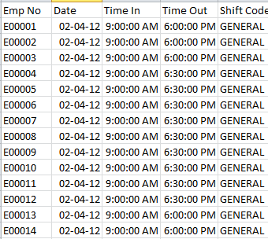
Once the data updated in the attached format, the same can be saved in .xlsx file. Once the data is ready, Please use the following path to up load the attendance file.
Path: Business central ActionsAttendanceUpdate Daily Time Punches.
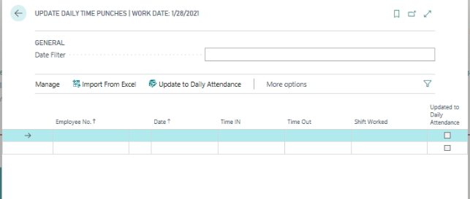
If user needs to update the day wise machine attendance, they can use the date filter, or ClickHomeImport from Excel functions.
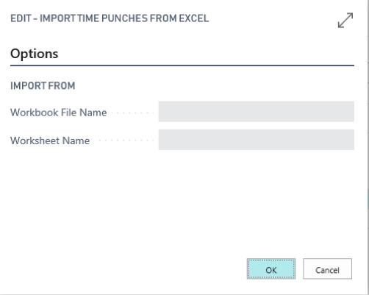
From the above, select the workbook file name and also select the worksheet Name
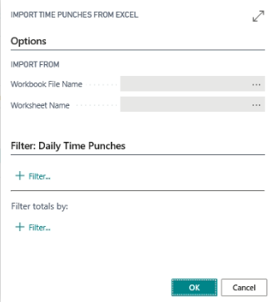

Click Ok to update the attendance.
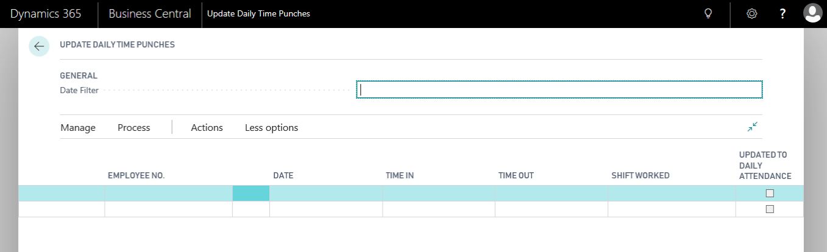
After verification, click HomeUpdate to Daily Attendance to update the attendance in Daily attendance page.
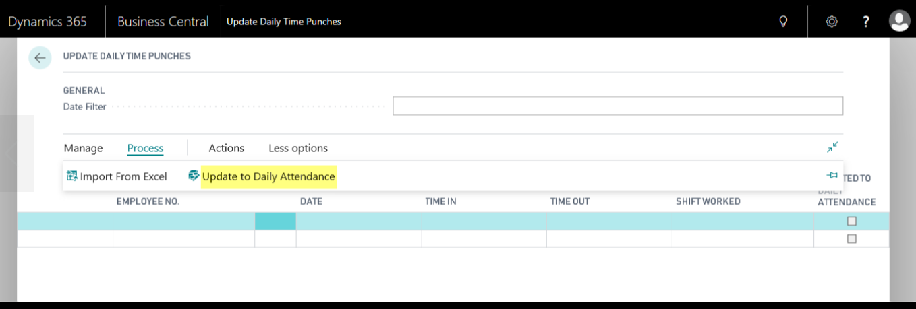
Click OK
Updated attendance can be viewed from Daily attendance page.
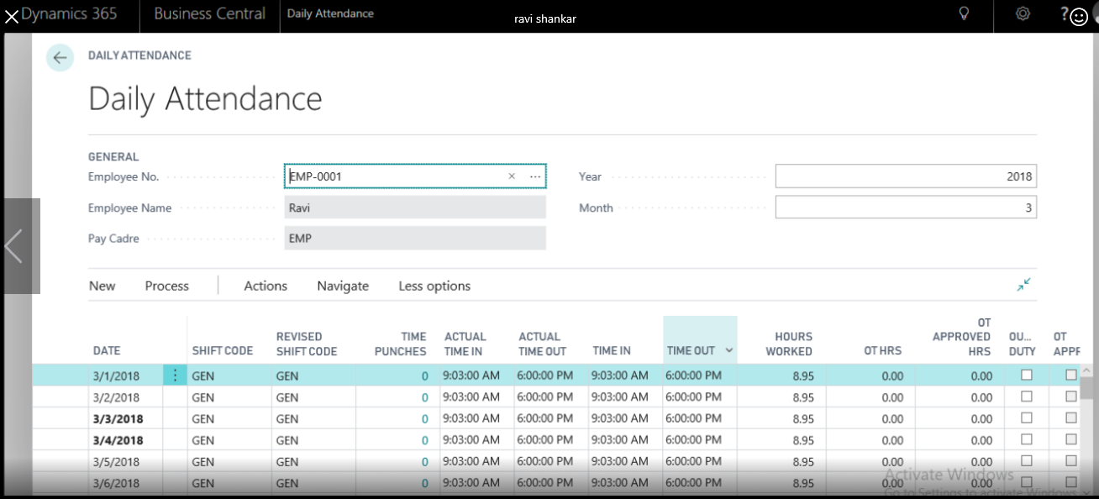

On-duty or Tour Information Updating
If any employee is going out of office on official work for short period or longer period, the same information needs to be updated in daily attendance system.
Path: Business Central Tour IntimationChoose by CategoryLists
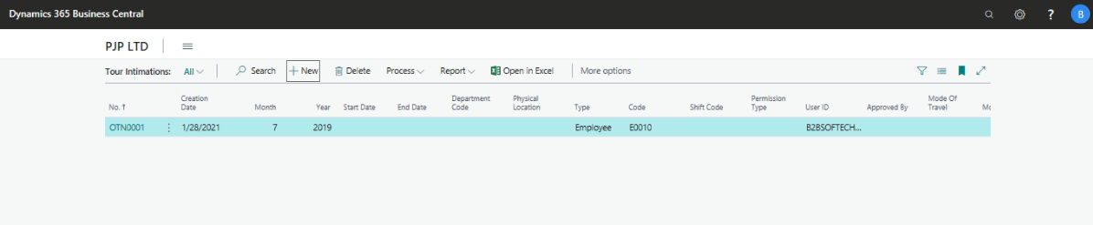
Click New to Create New Tour Intimation page.
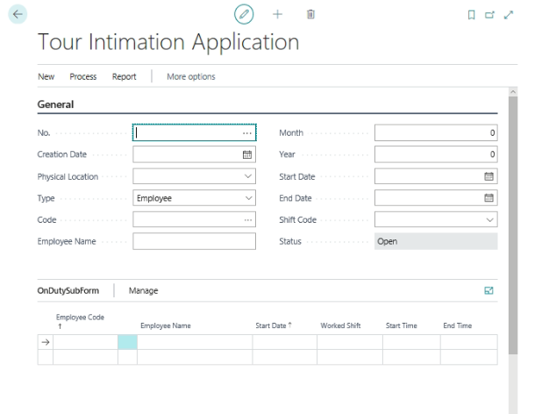

Select the following information form the General fast Tab of on Duty/Tour Intimation Header information
No: On-Duty Application document Number
Creation Date: This will be updated as System data, user can modify the same
Physical Location: Select the physical location
Employee Code and Employee Name
Month: This will be updated based on the HR setup processing month
Year: This will be updated based on the HR setup processing year
Start and End Date: user needs to define the Tour start and end date
Shift: Select the shift code
Other Fast tab:
To Location: Select the visiting location information
Places to Visit: In case of Multi locations to visit, user can define the locations information.
Advance Request: If any tout advance is required, they can define the advance request. (This is only for information)
Assignment No: Define the Assignment No
Assignment name: Define the assignment Name
Define the Global Dimension 1 and 2
Select the mode of Travel as (By Road, By Rail or By Air)
Once the above information has been updated, Click ActionsGet Dates
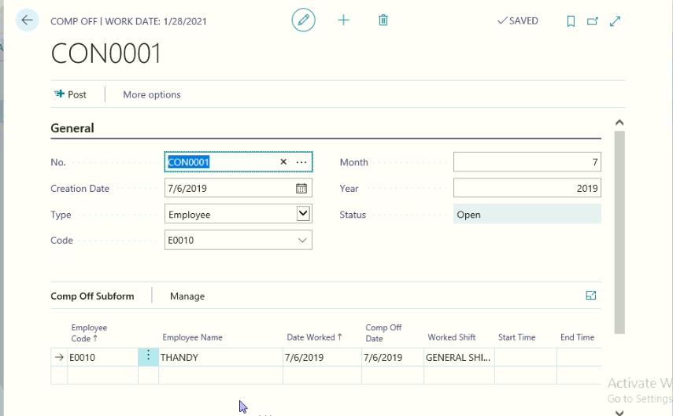
With this system will update the tour dates on Tour Intimation sub form.
Click ActionsSend for Approval
ClickNavigatePrint
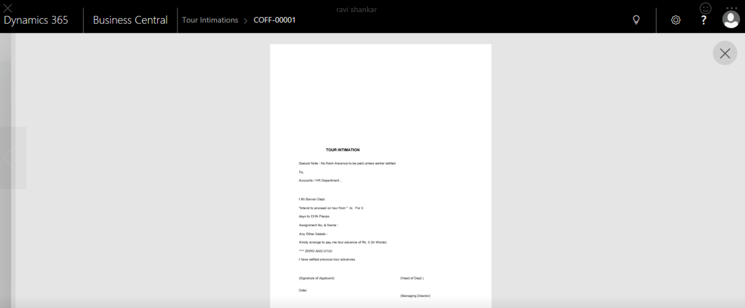
Click FunctionsUpdate On-duty
Once the On-duty has been updated, system will update the on-duty information on Employee Daily attendance information.
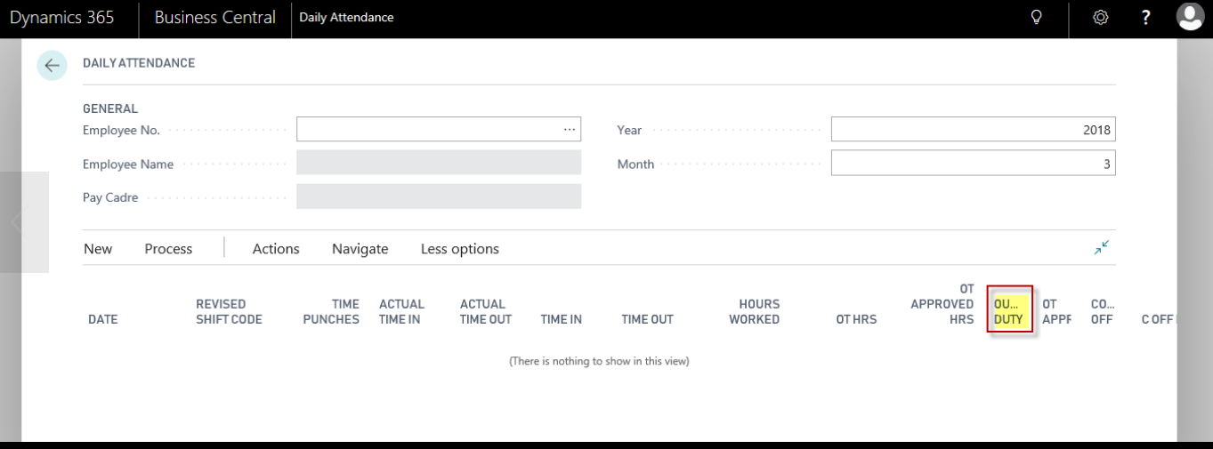

Over Time
To Compute the Over time the following information needs to be recorded in HR and Payroll
- Employee Over Time applicability in Employee Master
- Employee Over Time Rate In Employee Master
- Over Time Applicable Pay Elements In Additions and deductions lookups
- Recording of Over time in Daily Attendance
- Over time Approval for Payment
Overtime will be paid to employee as per applicability, employee works an extra hours needs to be approved for payment of Overtime.
Overtime can be approved by way of Employee wise or Day wise.
From the daily attendance information OT Hours are recorded, the same needs to approve for over time Payment.
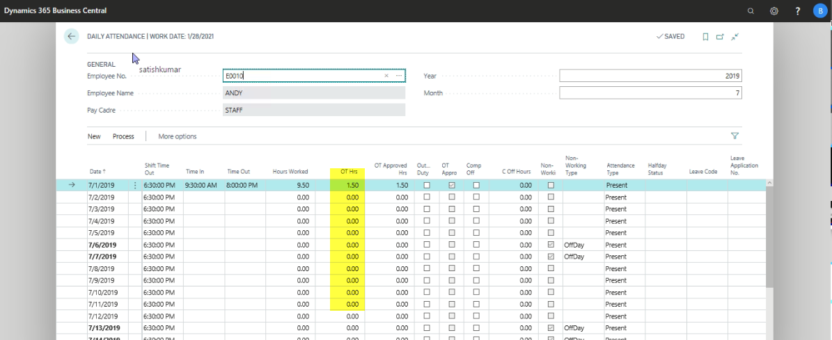
Overtime approval will be done by two ways –
- Overtime approval Employee wise
- Overtime approval Date wise
Overtime approval Employee wise:
Path: Business CentralActionsTasksOver timeEmployee OT Approval
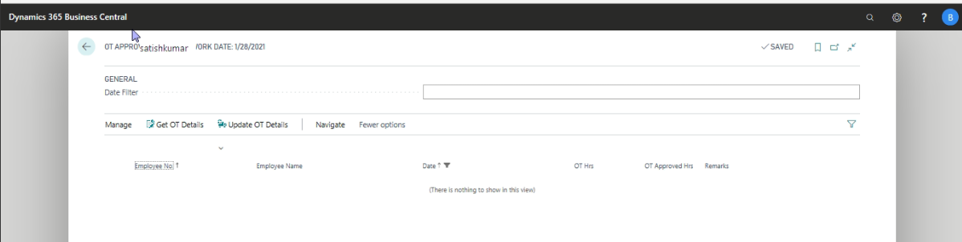
From the General Fast Tab select the employee code and Month and year for Over time approval
Click HomeGet OT Dates
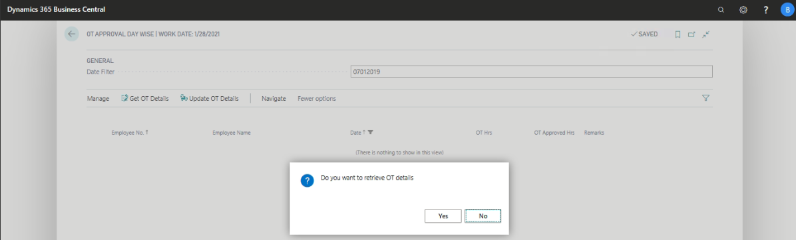
With this system will ask do you want to retrieve OT details, Click Yes to update OT Details
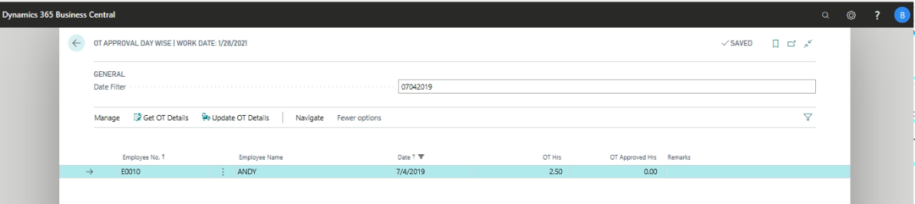
From the above, user can approve or Cancel OT Hours day wise and also define the remarks for canceling the OT Hours.
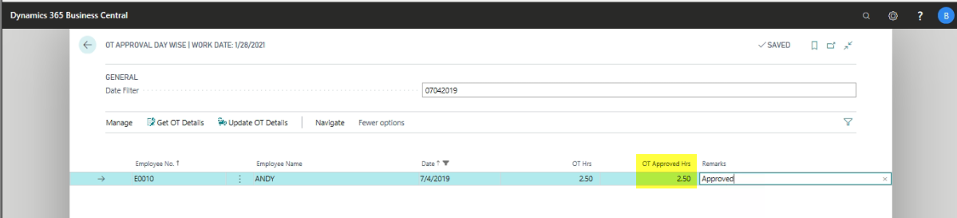
Click HomeUpdate OT Details
With this system will update the OT Hours to OT Approved Hours in Daily Attendance.
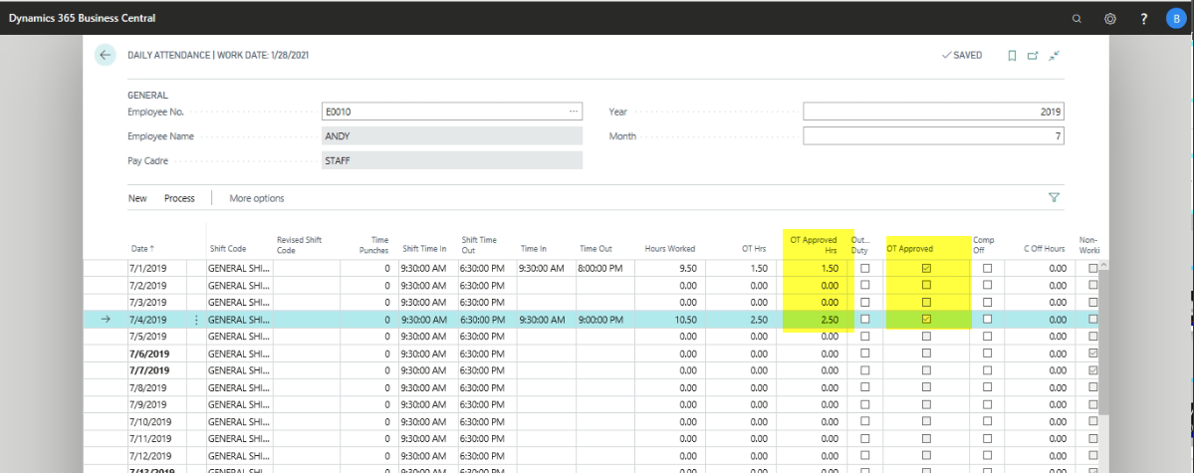
The same approved Overtime information will carry to Monthly attendance for calculating Overtime payment for the month.
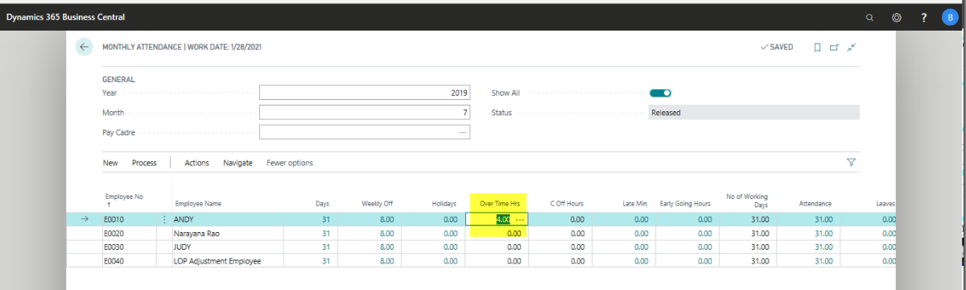
OT Approval Date Wise:
Overtime approval will be done day wise.
Path: Business CentralActionsOvertimeTasksOT Approval Day wise
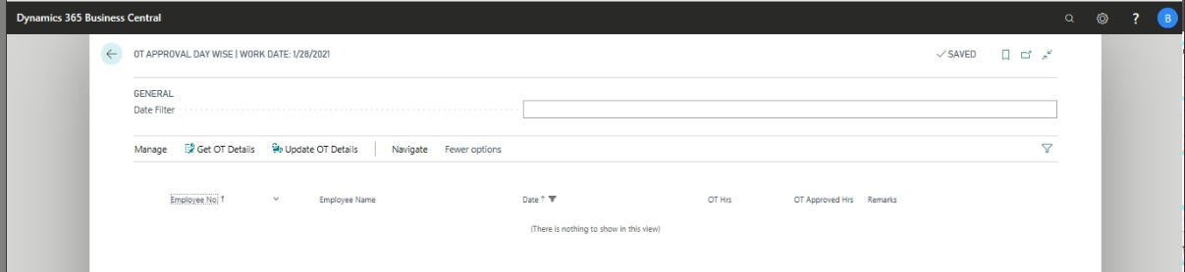
Enter Date on which Overtime needs to be approved
Click HomeGet OT Details
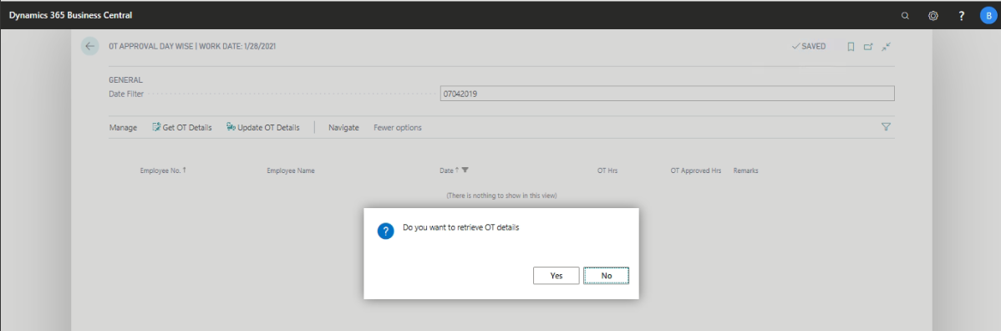
Click Yes to Update the Employee wise OT details for the day.
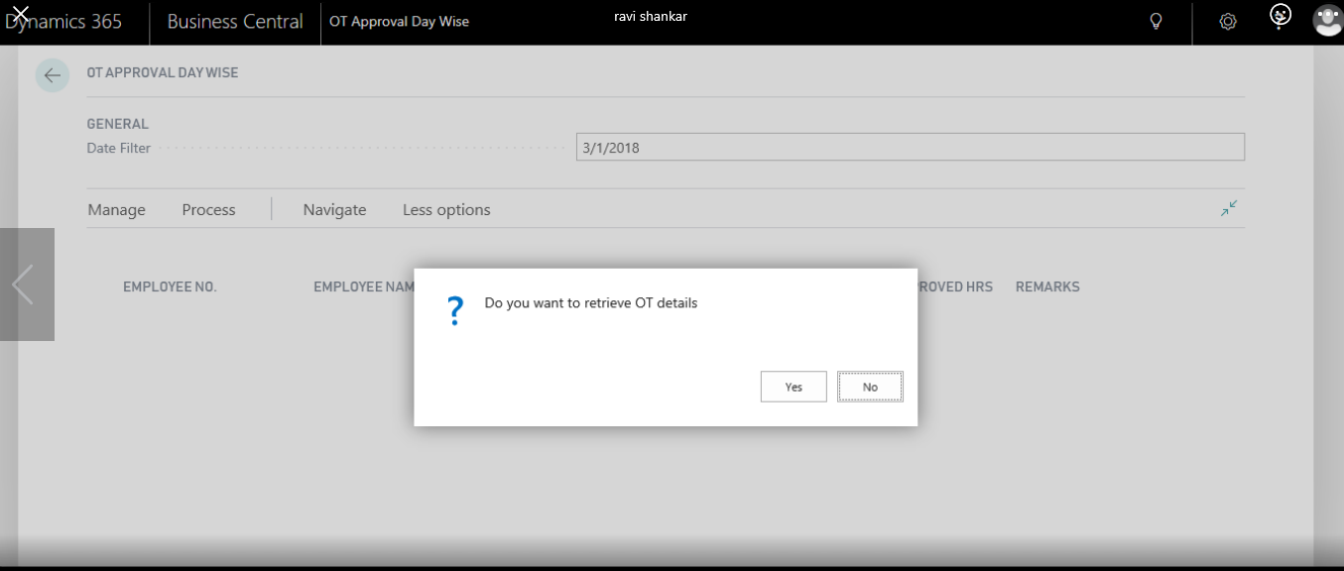
ClickHomeUpdate OT Details
With this system will update OT hours in Daily Attendance and monthly attendance as approved OT hours for calculation of Employee Overtime.

Compensatory Off (Comp. Off)
Path: Business CentralComp Offs.
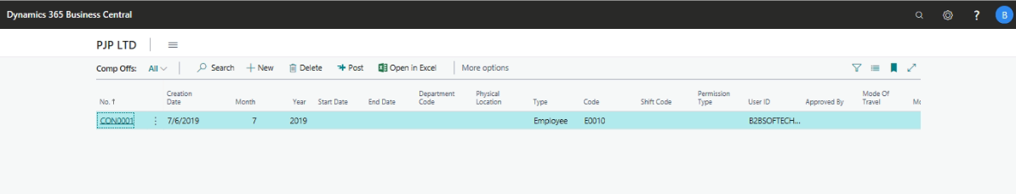
Click New to Create New Comp. off Page.
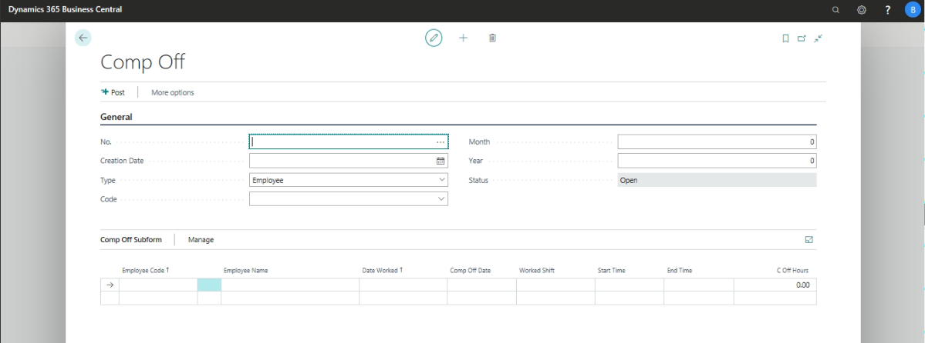
General Fast tab
- Define the Comp off ID
- System will update the creation Date
- Division Code
- Type: Employee or Department
- Employee Code
- Month and year
- Status
Once the above information has been updated, user needs to keen in the following information on Comp. off Sub form
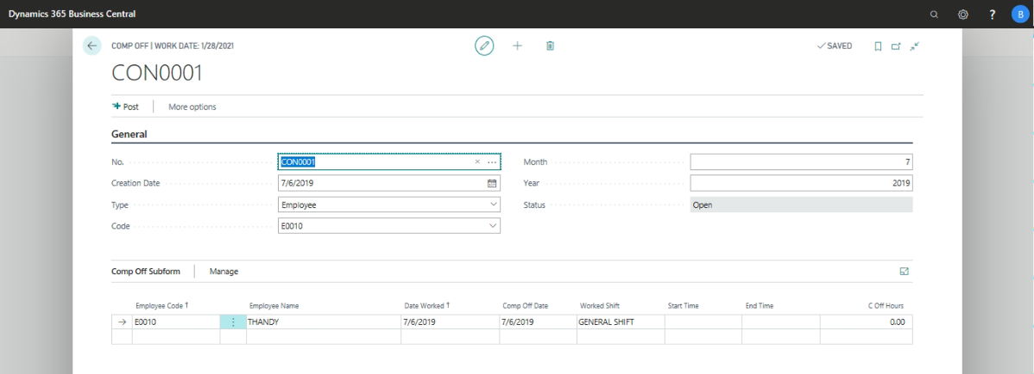
Select the Employee Code
Select the Date worked (on Non-Working Day)
Select the Comp. off Day (On which Comp. off is utilized)
Once the above information has been updated, go to Action pane and Click to Post.
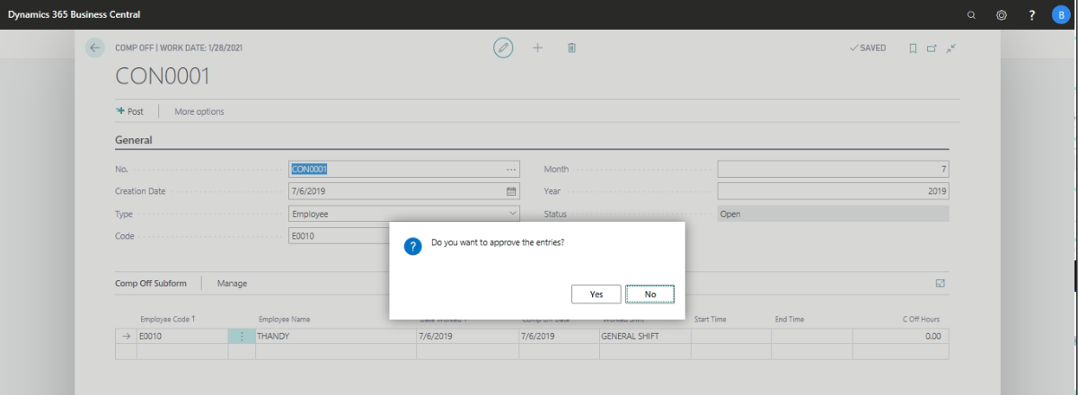
In Daily Attendance of an Employee will identify that day as comp. off Day as shown in below
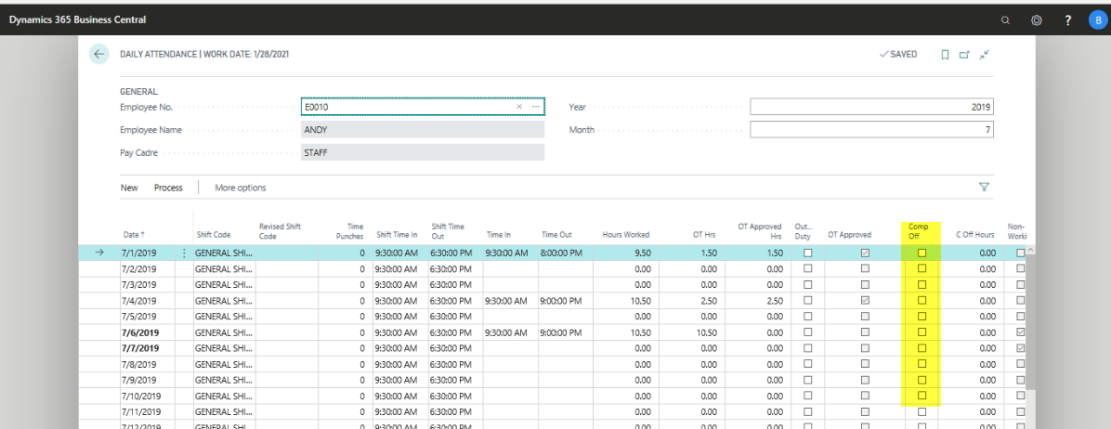

Salary Process Check List
Path: DepartmentsHR and PayrollPayrollAttendanceSalary Process Checklist
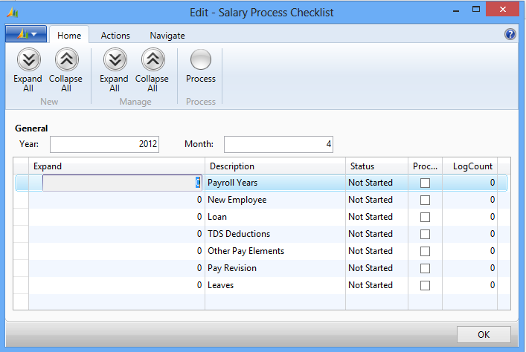
Define the Year and Month and Place check mark in Process filed
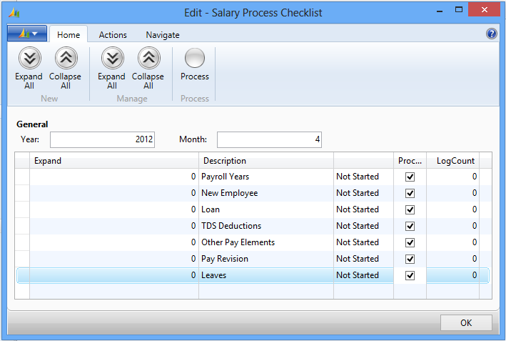
Go to Action pane and Click HomeProcess
Once the Process is completed, System will show the Errors against each predefine parameter as shown Below Screen
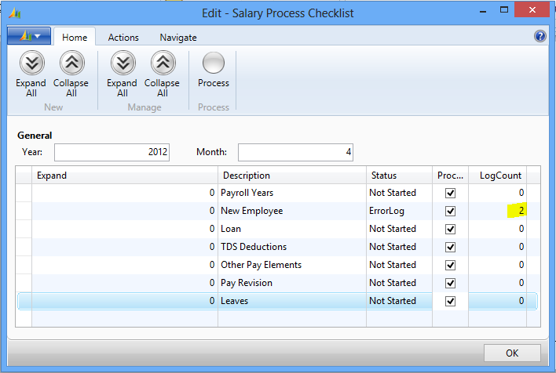
From action paneExpand All
System will show the errors for each predefine parameter
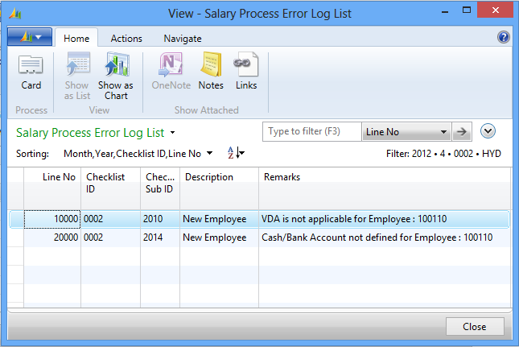
With this user needs to update required information and process salary for the month, with this user can avoid mistakes at the time of salary processing.

Payroll Processing

At the time Salary processing every Month the following important process needs to be check and update, then only user should process the salary for the month. They are as under:-
- Pay Revision
- Loan
- VDA & FDA Updation
- Final Settlement
- Other Pay Elements
- TDS
- Monthly Attendance

Pay Revision
For computing Pay Revision, through the System, Previous Month Salary needs to be processed and posted; otherwise system will not compute the Pay Revision.
Path: Business Central ActionsSalary ProcessingTaskPay Revision.
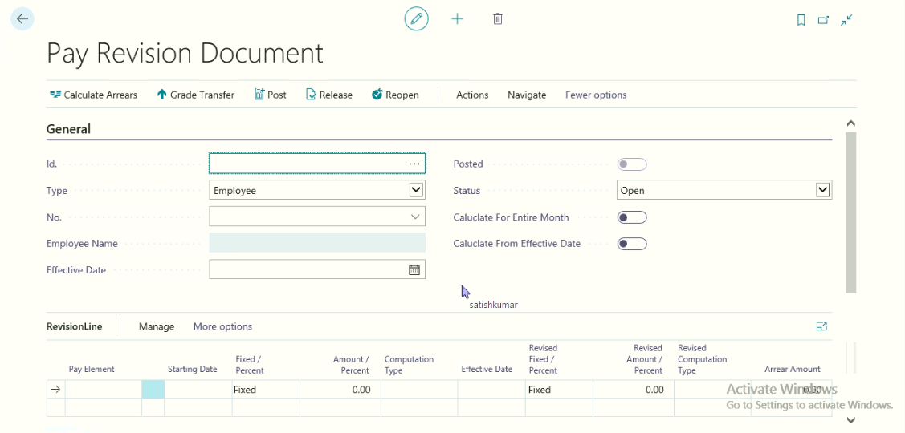

General Fast Tab:
Select the Pay Revision Document ID:
Select Type as Employee or Grade.
Select Employee ID
Define the Pay Revision Effective date
Place a check mark for calculating for Entire amount or Effective amount.
Once the Pay Revision Effective start date is updated, System will update the Pay Revision Sub form information as shown below.
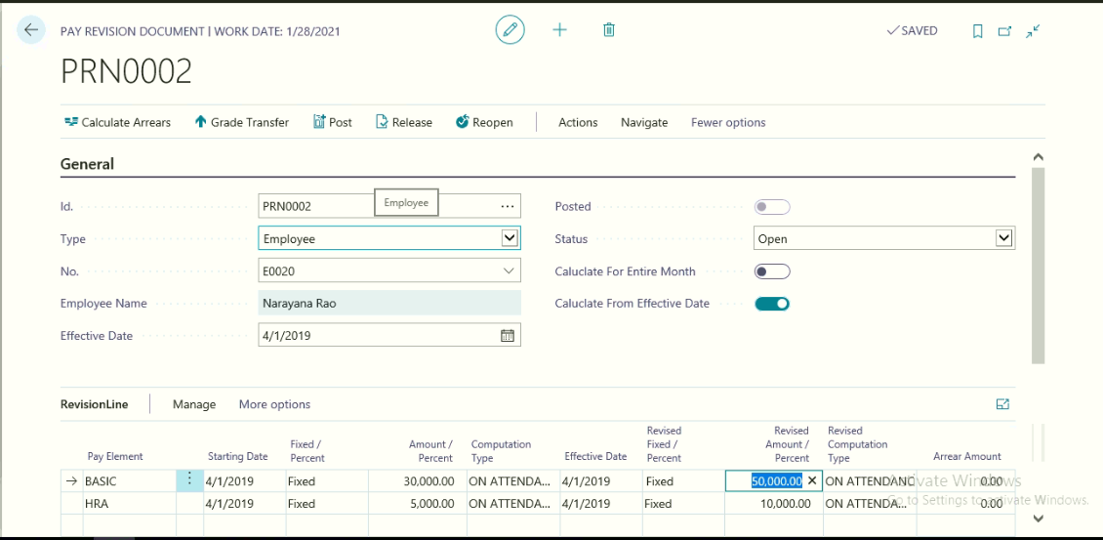
From the above; user needs to updated Revised Salary Structure in Revised amount/Percent field.
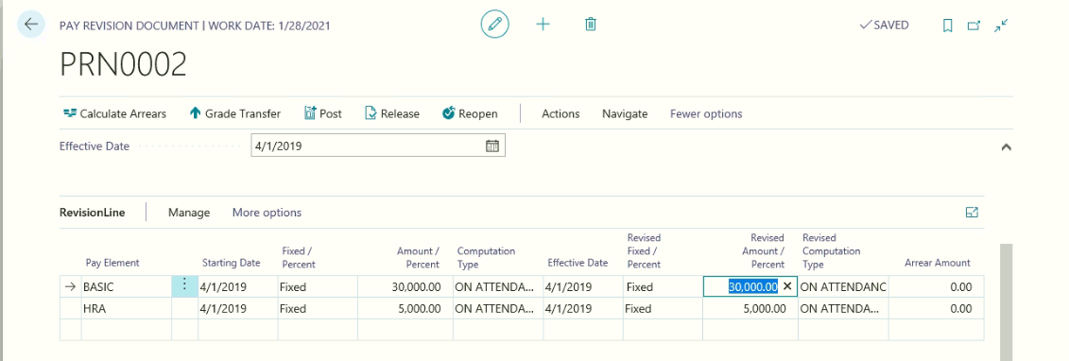
Once the revised salary structure information has been updated, go to HomeCalculate Arrears amount, with this system will calculate the salary arrears amount.
Once the Arrear amount is calculated, go to Posting Fast tab and Select the following information
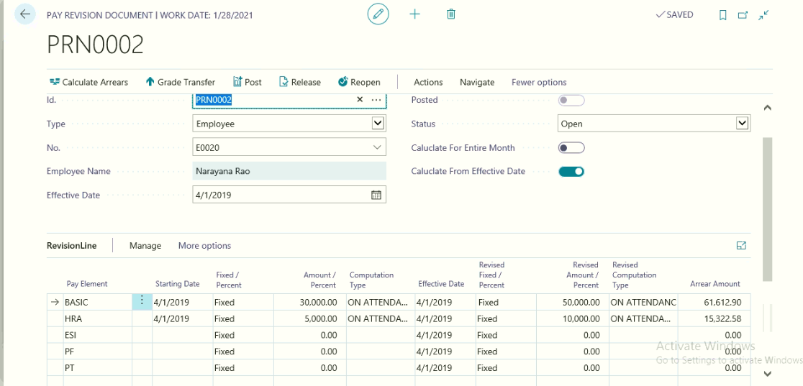

Select the Journal Batch name, Posting date and document no
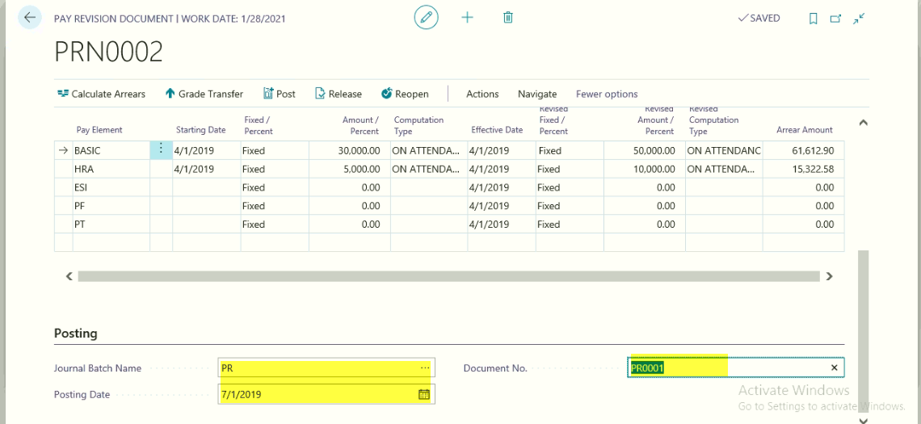
Go to HomePost.
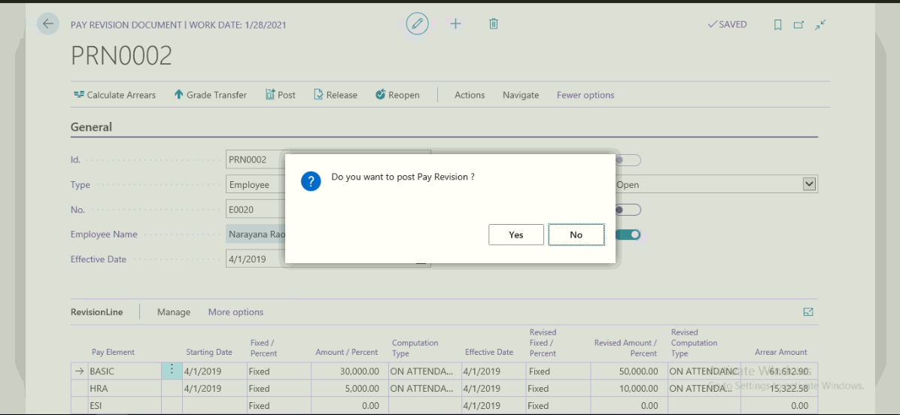

Click Yes to Post
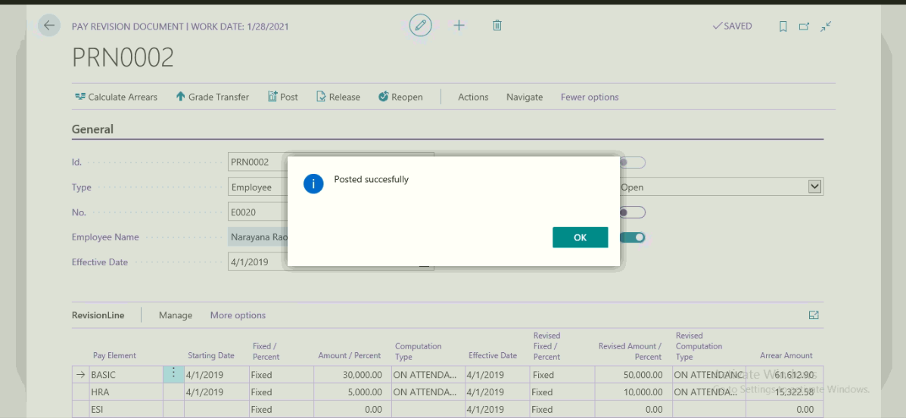
After posting the Pay Revision System will update the revised Pay Elements to Employee Master with new effective date as shown below
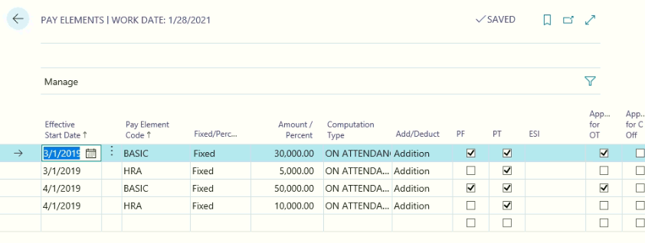

Loan
Employer provides various types of loans to Employee and the same can be deducted from the employee salary as per agreed Terms and conditions.
Path: Business Central Loan list
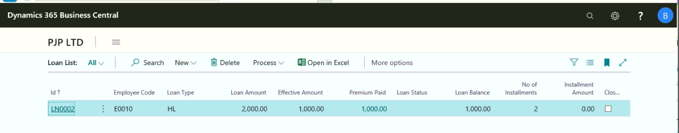
Go to HomeNew to create a new Loan master card.
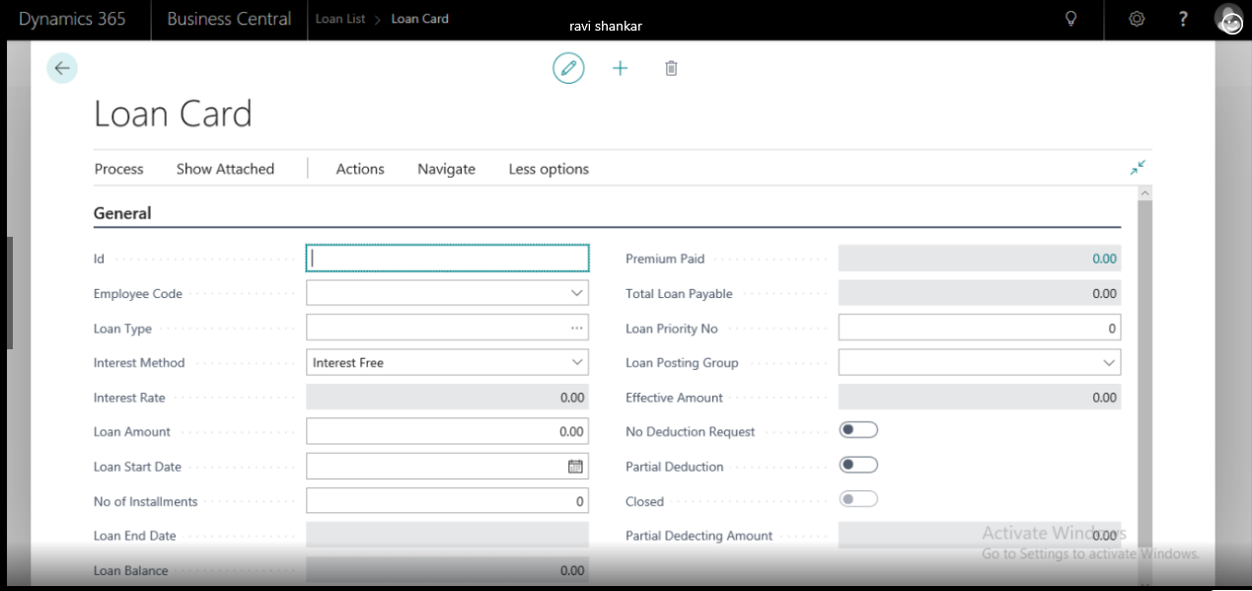
Define Loan Id
Select the Employee Code from the Employee List
Select applicable Loan Type
Select the Interest Method from the options (Interest Free, Flat Rate or Diminishing Rate)
Define the Rate of Interest only at Flat rate or Diminishing rate
Define the Loan amount
Define the Loan starting Date from which EMI amount needs to be deducted.
Define No. of Installments to recover EMI amount from the employee Salary
System will update the following information based on the above
Loan End Date, Loan Balance
Define the Loan Priority No
Loan posting group to recover the loan EMI amount and update in Loan Recovery account
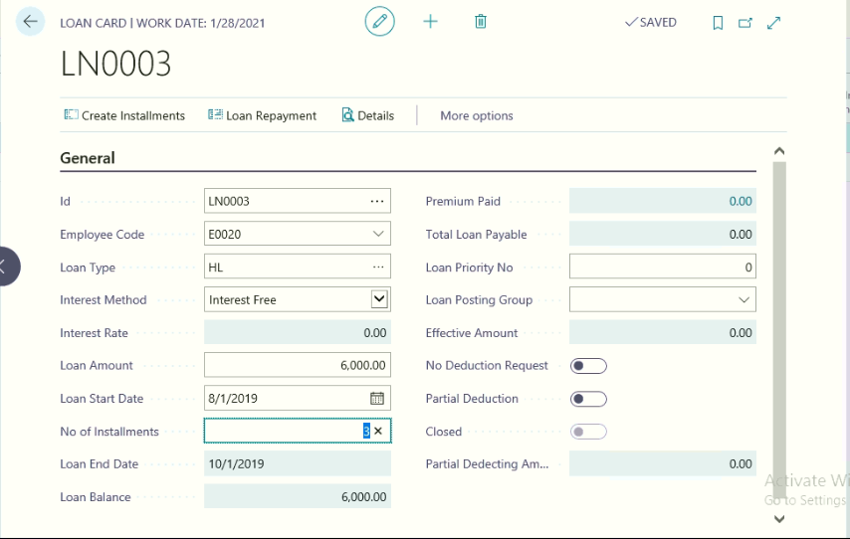
Once the above information has been updated, go to HomeCreate Installments.
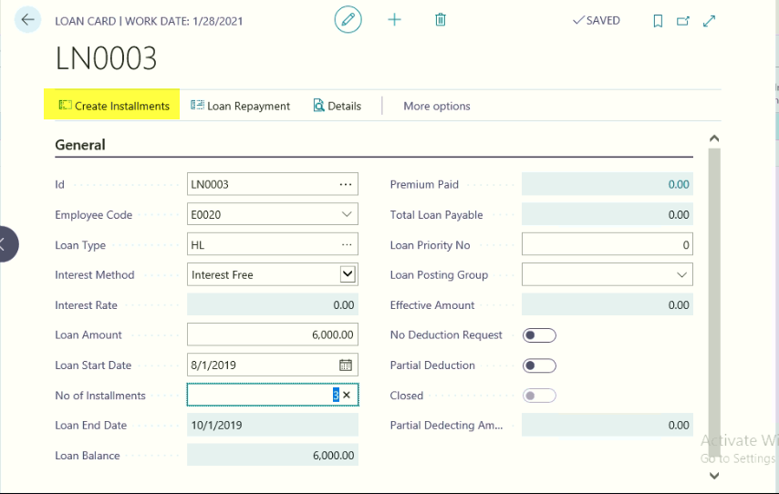
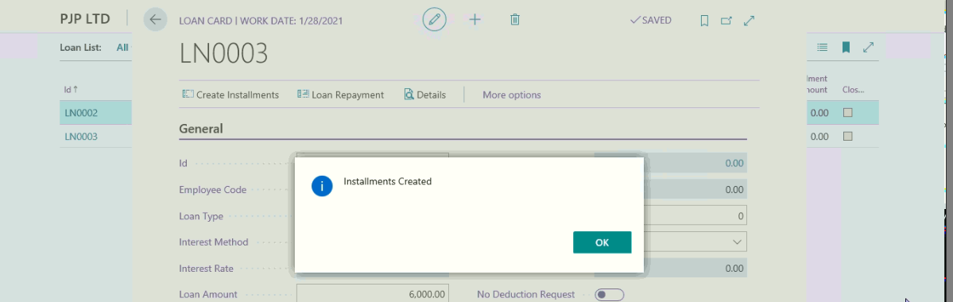
With this system will create loan EMI amount based on no of installments and loan amount, the same will be deducted from the employee salary every month.
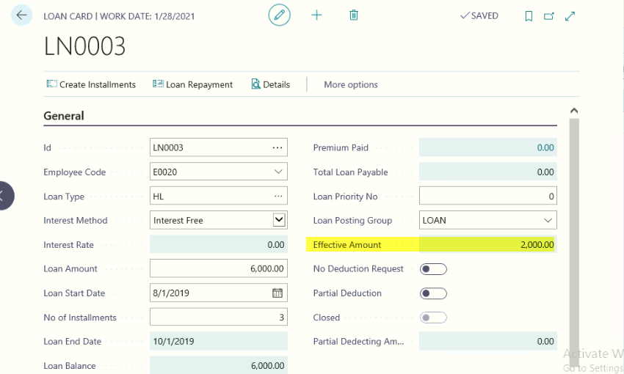
Click HomeDetails
With this user can view the loan detail information month wise EMI amount, Interest Amount, Principal amount, Interest amount, Loan Amount, EMI Deducted Amount, etc.,
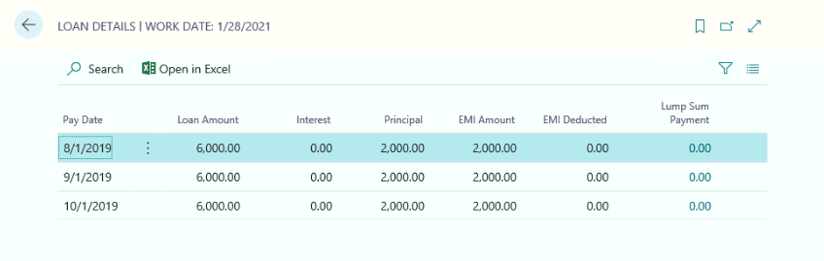
Requests received from the Employee at the time of Monthly Salary Processing:
The following requests frequently received from the employee at the time of Salary Processing, they are as under:-
- No Deduction Request
- Partial Deduction Request
- Loan Repayment
No Deduction Request:
Based on the Employee request and approval, user should place a check mark for No deduction request on the Loan card.
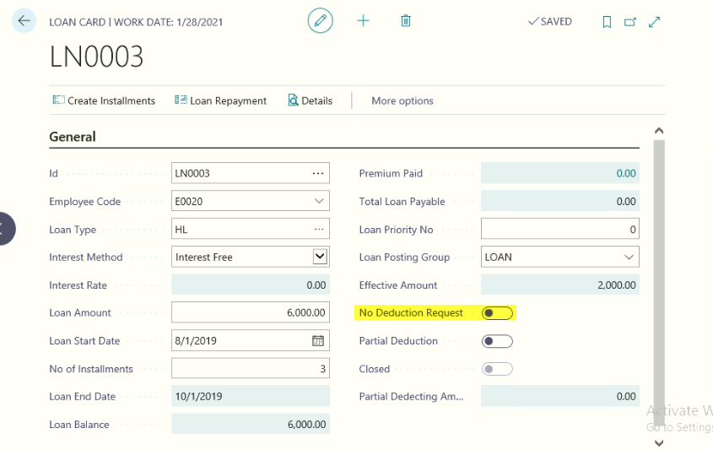
With this system will not deduct the loan EMI amount from the salary for the month. After salary processing for the month is done, remove the No Deduction Check Mark from the Loan card.
Partial Deduction Request:
Sometimes Employee willing to pay only partial EMI amount, in this case user should place a check mark as Partial Deduction Request and Define the Partial Deduction amount before processing salary.
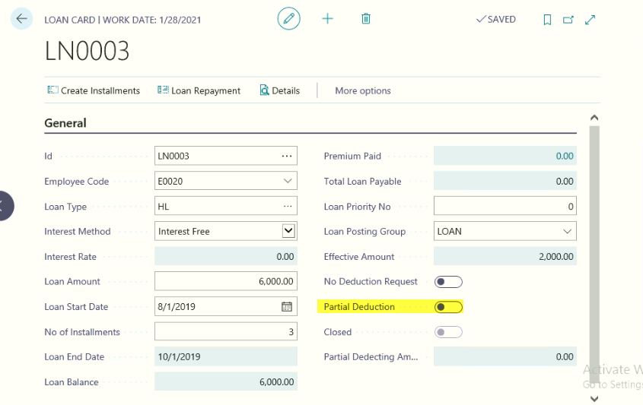
After processing the salary, system will deduct only partial amount defined for the month.
Loan Repayment:
If an employee is having enough amounts, he can pay loan repayment fully or partially. For this Click
HomeLoan Repayment
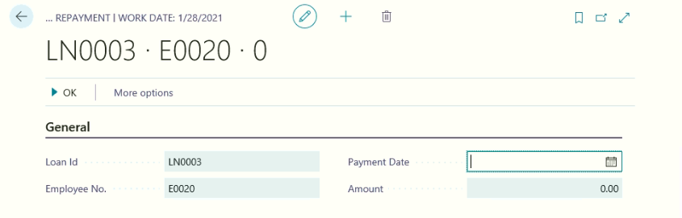
Define the Loan Repayment Date and Loan amount and Select the Loan Prepayment Type as Same EMI or Same Installments. Based on this system will recalculate the EMI amounts and No if installments.

VDA and FDA (Variable Dearness Allowance and Fixed Dearness Allowance)
Variable Dearness Allowance will be calculated and updated based on the Price Index of Local Government. This will be updated Quarterly basis on the points earned during the quarter will be paid for subsequent quarter.
Q1 Points will be calculated and paid in Q3, Q2 will be on Q4, Q3 will be on Next Financial year Q1 and Q4 points will be calculated and paid on next financial year Q2.
To compute the VDA the following are the important activities needs to be performed.
- HR Setup Define the VDA Calculation Rates(Linking factor 1 & 2) and Neutralization Points and VDA Calculation Rate
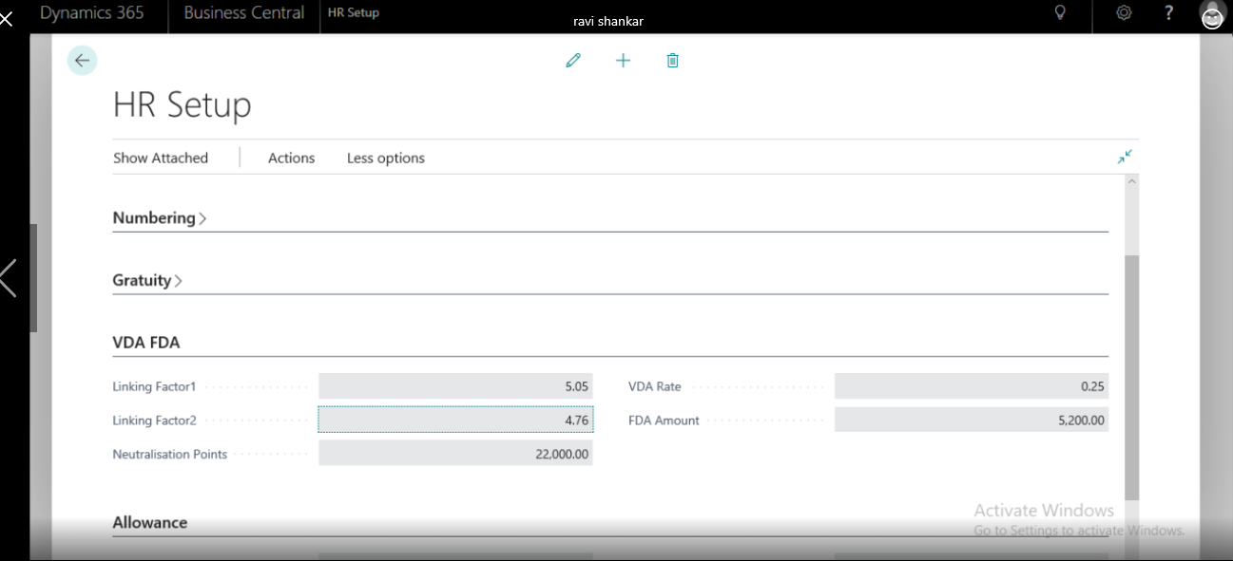
- Employee Master Card Place a check for VDA and FDA applicability.
- Define the VDA and FDA Pay elements in Look Up no 16 (Additions and Deductions)
- Define the VDA and FDA Pay Element for Applicable Employee
Process for calculation and Updation of VDA and FDA for Applicable Employees:-
Path: Business Central VDA
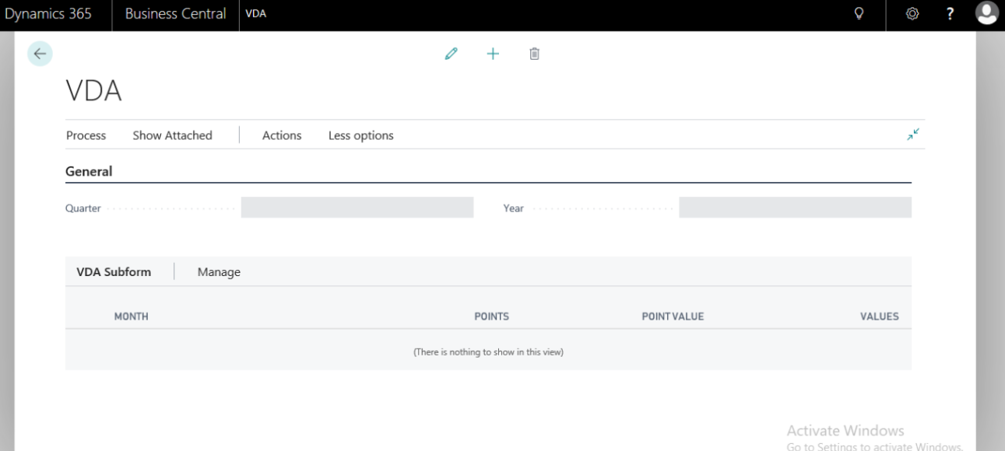
From the above page, ClickHomeNew
To create New VDA card for computing VDA amount for applicable employees for the defined period.
General Fast Tab:
Select the Quarter and Year
VDA Sub form:-
Based on the quarter selected, system will update the Months information; user needs to update Month wise Point earned as per Price Index needs to be updated.
Once the Month wise Points are updated, system will calculate the Point value field and value field based on the Linking factory 1 and 2 defined on HR setup
After computing the Value, ClickHomeUpdate VDA
Click Yes to Update VDA amount to applicable Employees Pay elements.
In case updation of FDA, Click HomeUpdate FDA
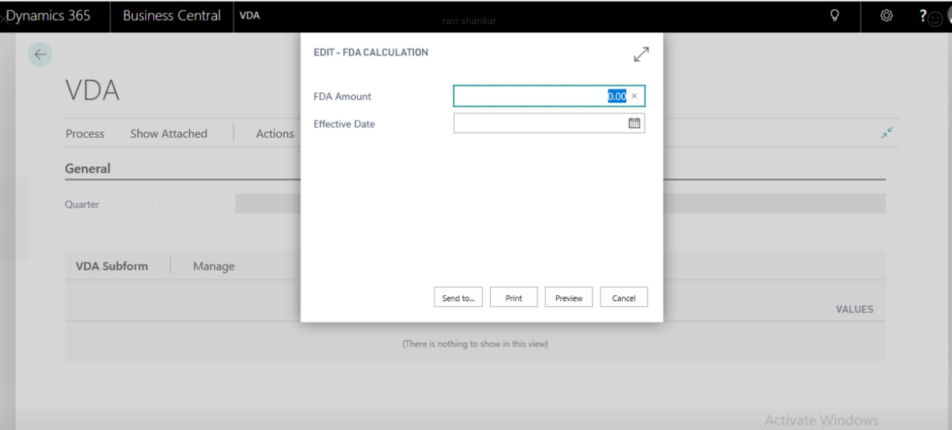
From the above page, and Update the FDA Amount and Effective Date,
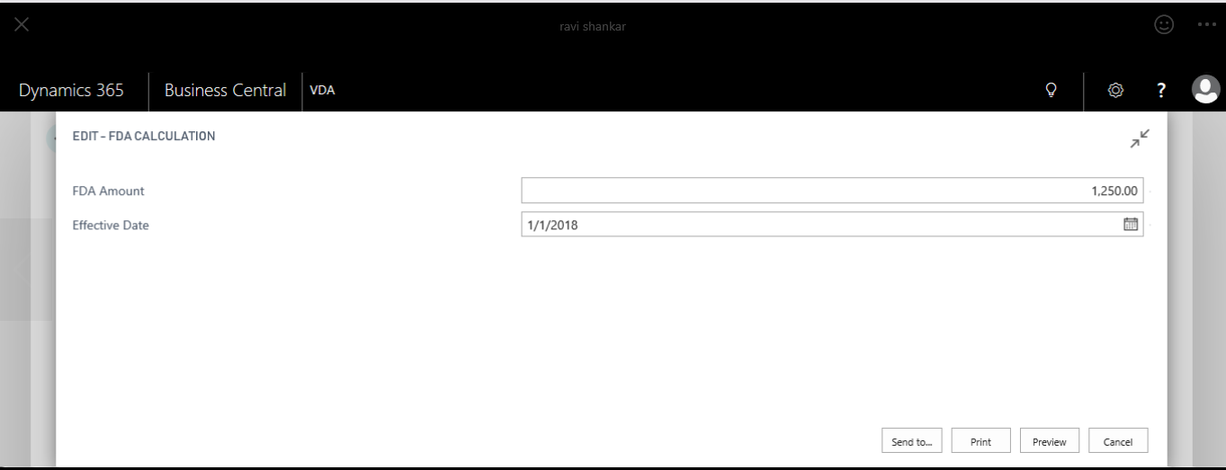
Click Preview to Update the FDA amount to applicable employees. The same can be viewed from the employee pay elements.
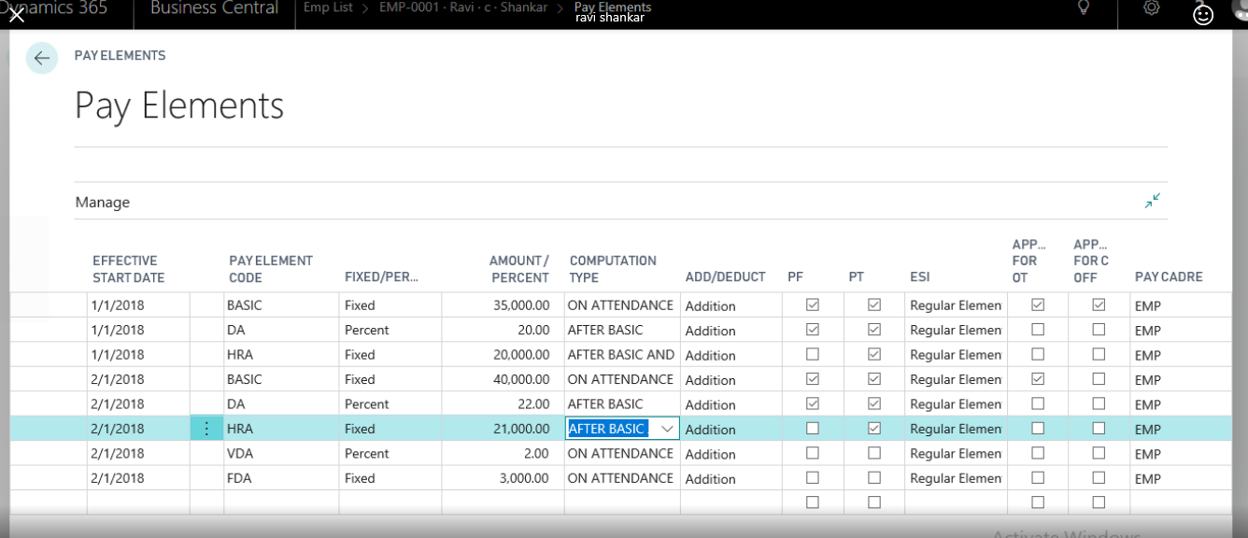

Other Pay Elements
From the Other pay elements, user can give additional salary component for the specific month or they can deduct salary component for the same.
Normally monthly deductions would be “Canteen Deductions, Transport Deductions, and one day contribution towards funds etc., as deductions, Special incentives to the staff, festival incentives etc., as an additions for the specific month.

Path: Business Central Other Pay elements
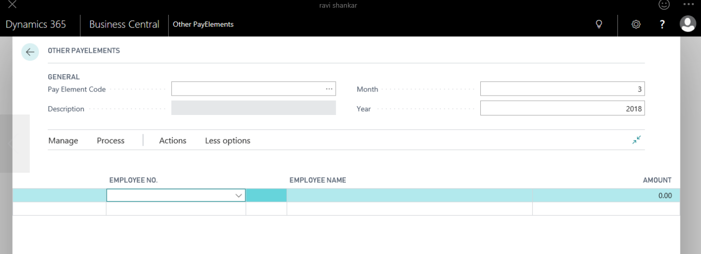
From the General fast tab:
Select the Required Pay element
Define Month and Year on which this pay element is going to be processed.
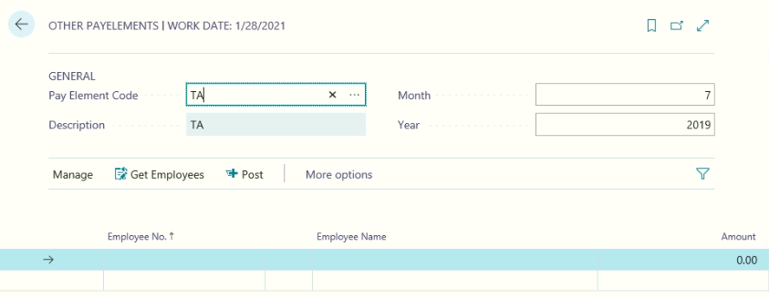
Click OK
HomeGet Employees
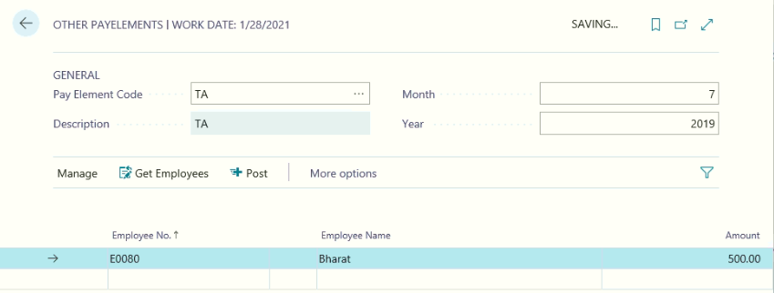

Update the amount needs to be deducted or add for each and every employee based on the applicability and go to HomePost.
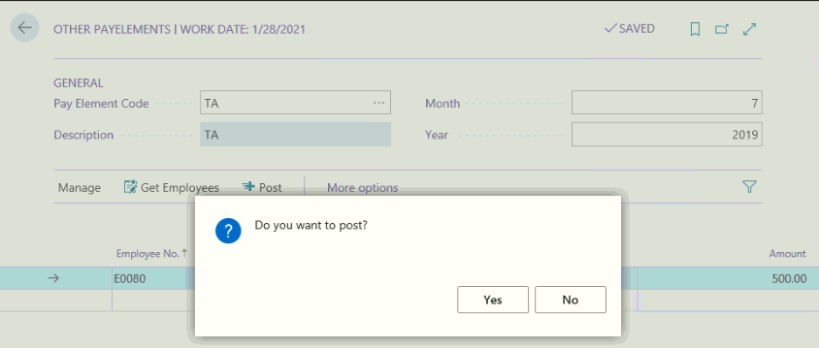
With this system will deduct or added to employee salary for the month.
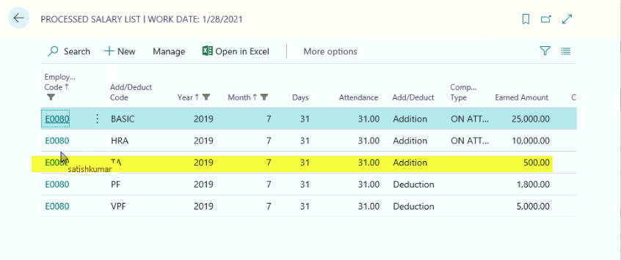
Once the amount is processed and posted from the other pay elements, the same will be stored in Posted Other Pay elements.

TDS Process (TDS under Income from salary)
TDS amount needs to be deducted from the employee salary based on the Employee income and the same will remitted to Income tax authorities and end of the financial year form 16 will be issued to employees.
To deduct the monthly TDS amount from the Employee salary, the following process needs to be done.
- TDS Deduction
- Updating Employee Savings information
- Calculating Tax Liability
- Calculating Monthly TDS Scheduling
- Archiving TDS Details
- TDS Payment
- TDS Monthly Scheduling
- Updating TDS Register
- Issuing Form 16 to employees.
Path: Business Central Actions DocumentsTDS Deductions.
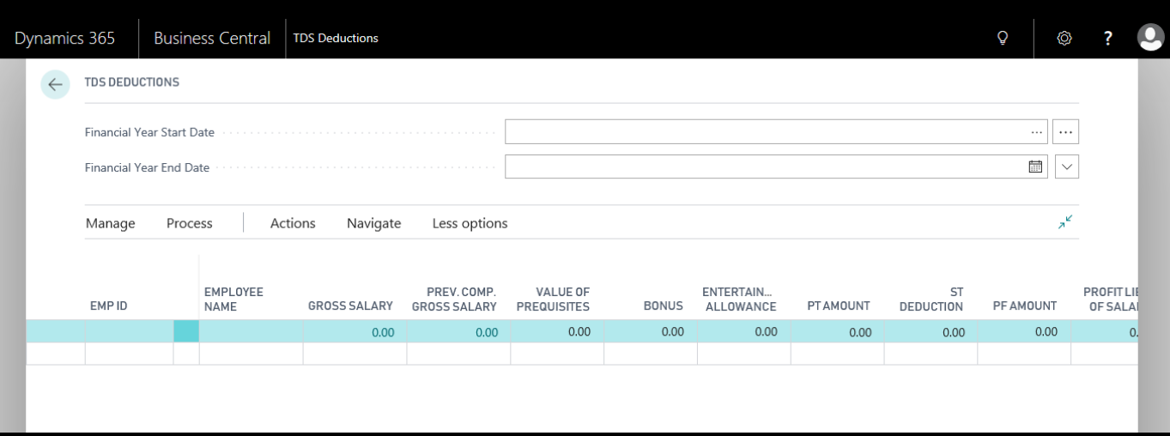
From the above page, Select the Financial Year and Go to HomeGet Employees
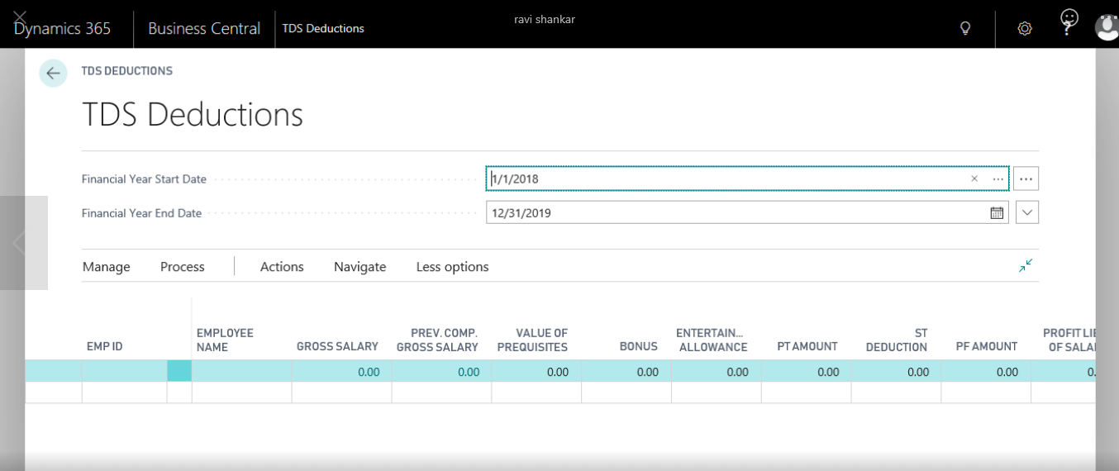
With this system will update the active employee information for the financial year. Then Click ActionsCalculate Gross Salary <For Current Employee or All Employees>
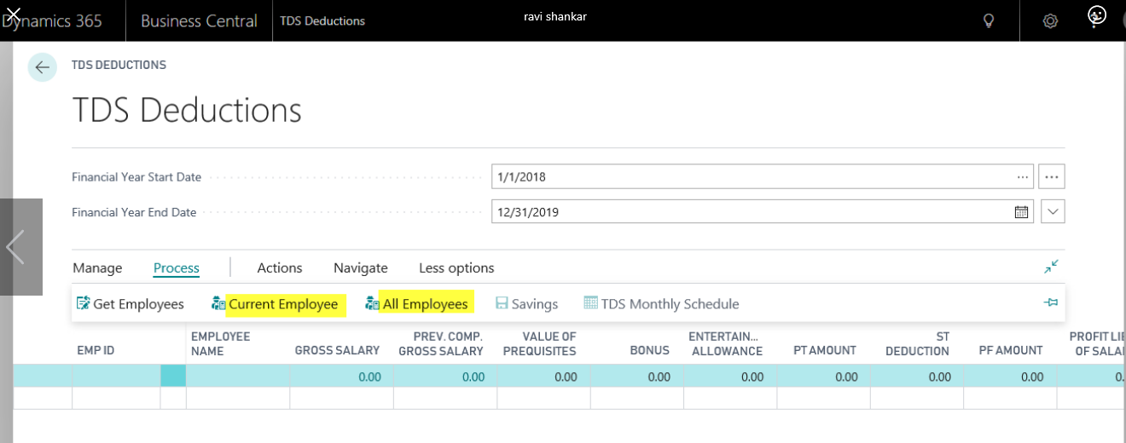
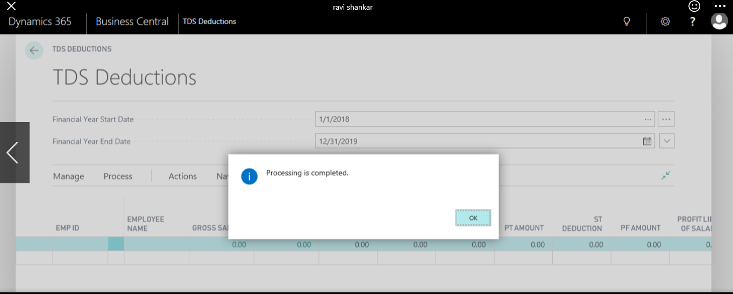
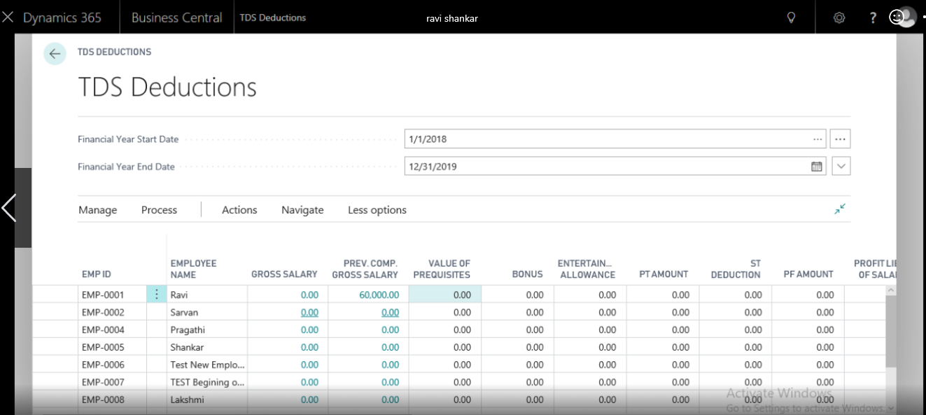
With this system will calculate the Employee wise Gross salary along with Employee wise Professional Tax and Gross Total Income.
Click ActionsCalculate PF amount <for Current Employee or All Employees>
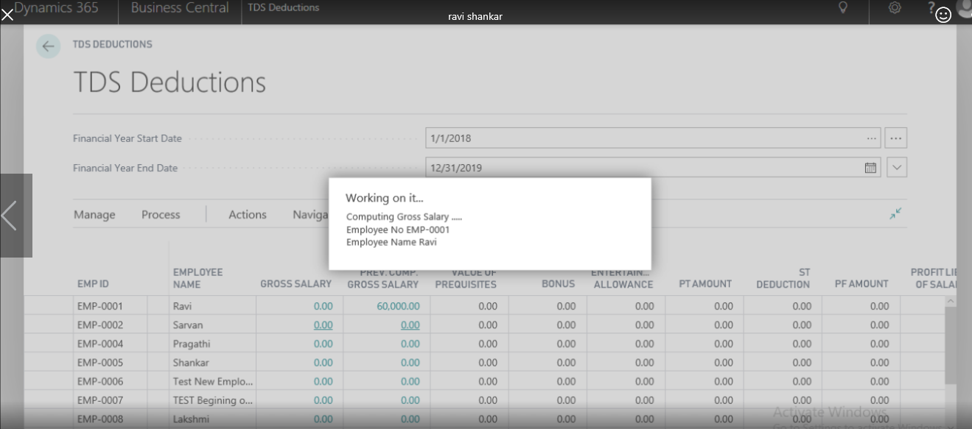

With this system will update the Employee wise PF amount in TDS Deduction page and also in Employee Savings information U/s 80 C. The same can be viewed by NavigateSavings.
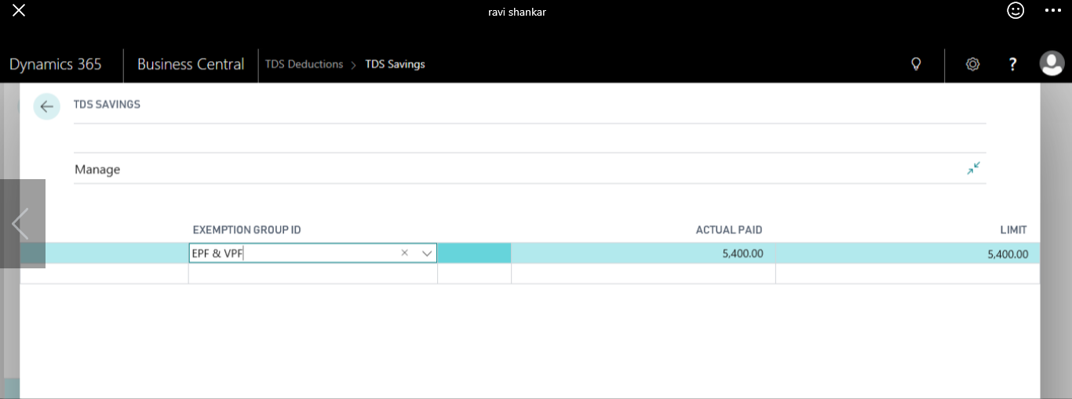
From this page only employee wise other savings information needs to be defined.
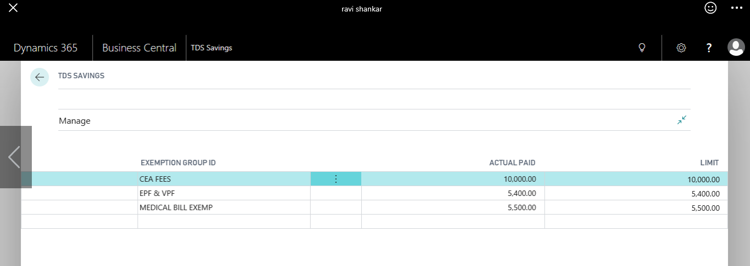
Update the employee savings information based on the exemption group wise and enter actual amount of Savings, with this system will calculate exemption limit amount and press OK to close the employee Savings page.
Click ActionsUpdate Savings <Current Employee or All Employees>
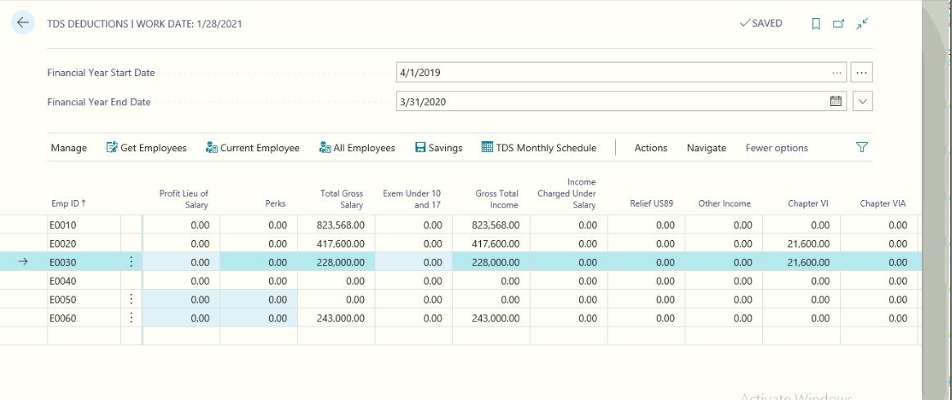

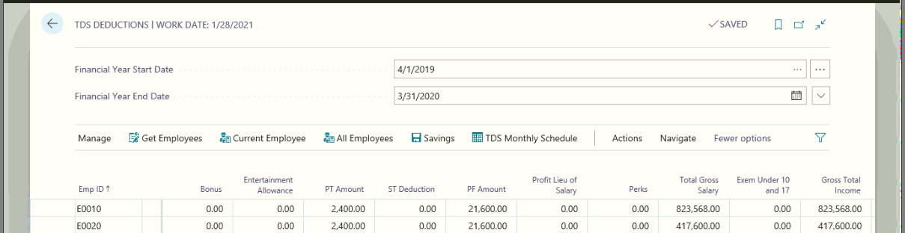
With this system will update the Employee savings chapter wise and update the Net Taxable income for the year. This information will be before the Income tax Slabs limit amount. Once user calculates the Tax Liability with this system will deduct the IT Slab amount based on the eligibility and calculate the Tax liability amount.
Click ActionsCalculate Tax Liability <Current Employee or All Employees>
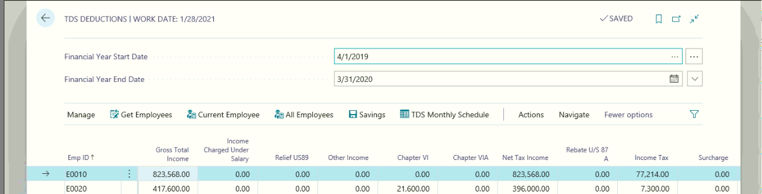
With this system will calculate the tax liability with Income tax amount and Ecess amount for the financial year.
Herein as per the new mentioned Exemption Sections and Groups system calculates the amounts based on the exemption limits as well as the setups.
- For the Equity Shares Value Calculation in TDS Deductions:
Calculate the Gross Salary for the Single Employee or All Employees. If the Employees’ gross salary exceeds the exemption limits then system consider the Equity amounts.
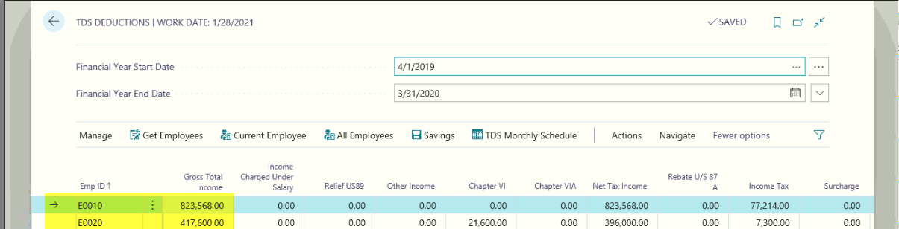
After calculating of gross Salary, update the savings against the employee, to update the savings details go to Navigate tab and select the Exemption Groups.
Here for the Equity Exemption ID system will calculate the as per the gross salary amounts.
Eg: For employee EMP-1001, Gross salary is greater than 12,00,000, so that system will not calculate the Equity Exemption value in the TDS Deductions page.
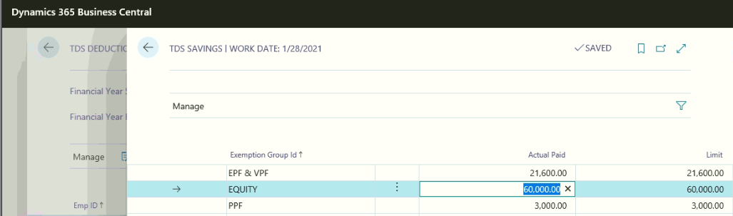
Define the savings and then select “Update Savings” button presented in the Actions tab.
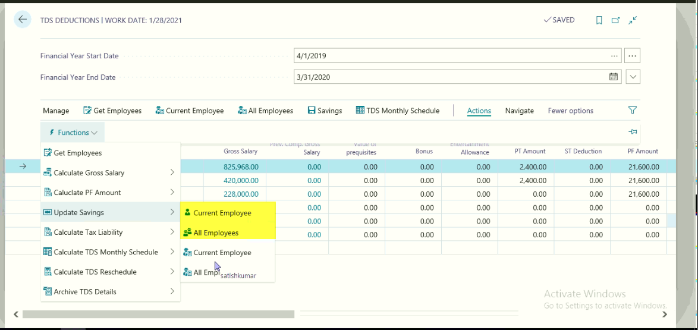
- To Calculate the Rebate Amount in the TDS Deductions:
As of the Rebate concept if the Rebate amount can be calculated based on the Employees’ Net Taxable Income. In the TDS deductions form calculate the gross salary for the single employee or all employees.

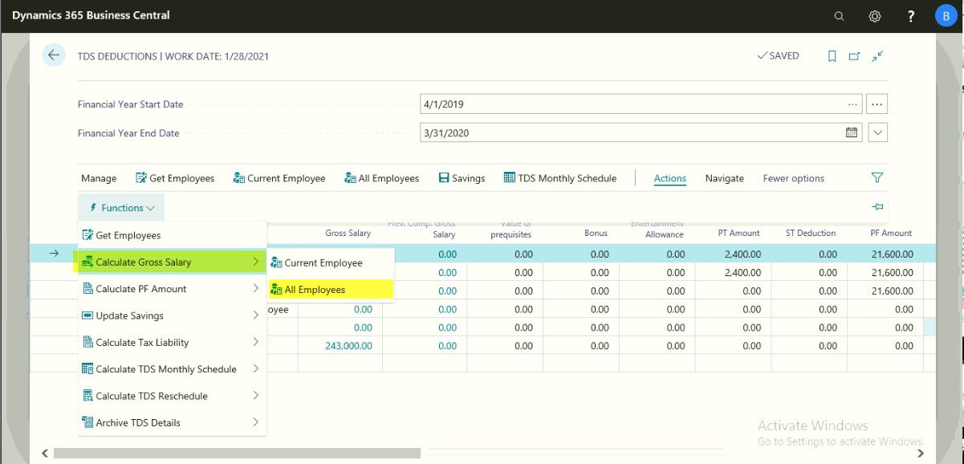
After calculating the gross salary update the employee savings with the defined exemption sections and groups. After defining of savings, should update the savings in the TDS form.
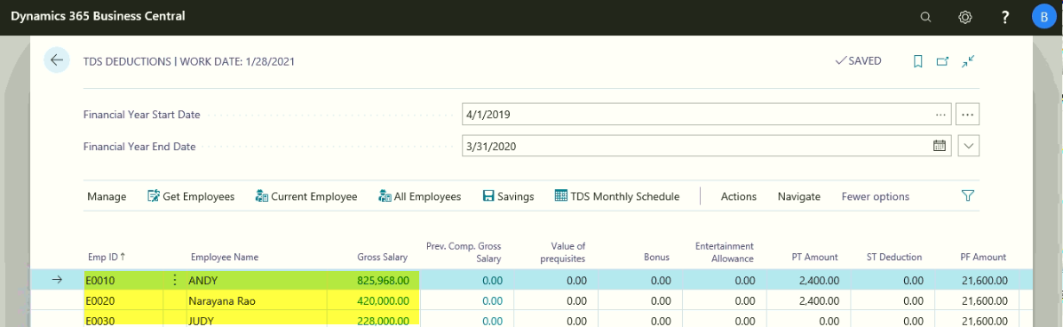
Select “Calculate Tax Liability” option to calculate Net Taxable Income. If the Income is less than the mentioned limits, system will automatically deduct the rebate amount, and also update the amount in “SEC 87 (A)” field.
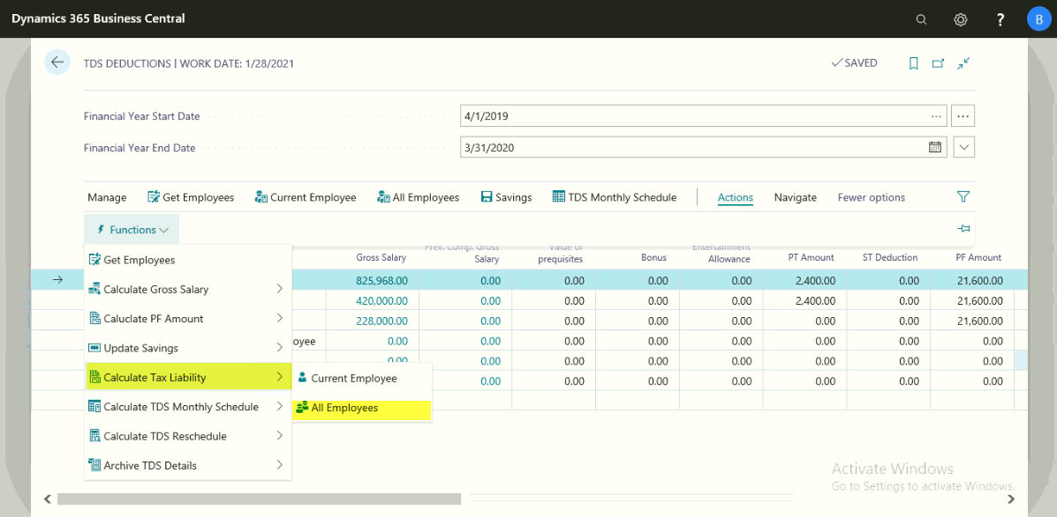
If the Net Taxable Income is calculated in b/w the mentioned rebate settings then system will update the Rebate amount in “Rebate U/S 87A” field.
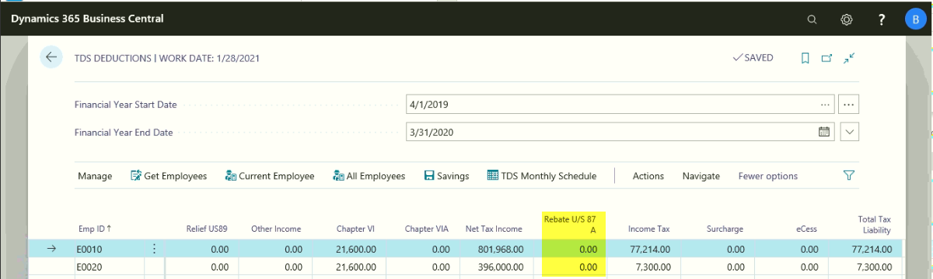
After computing the tax liability, the same can be schedule for the remaining months in that financial year.
Click ActionsCalculate TDS Monthly Schedule <Current Employee or All Employees>
With this Total tax liability amount will be divided equally for the remaining months, the same can be viewed by Click NavigateMonthly TDS Schedule
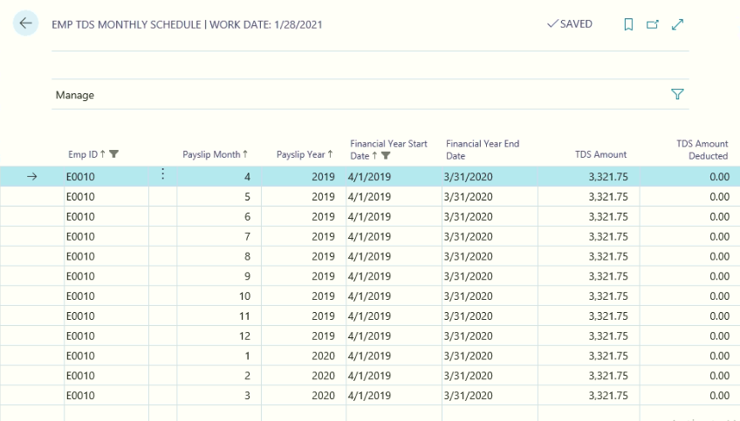
Once the salary has been processed for the month, system will deduct the TDS amount from the salary
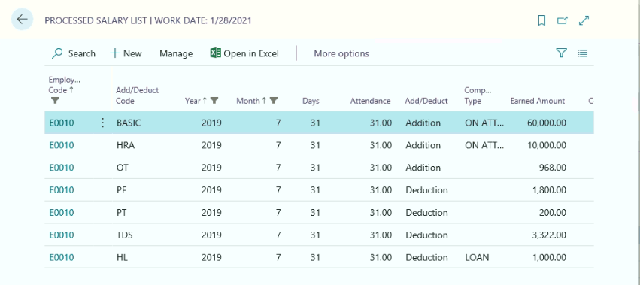
Recalculation of Tax Liability for the period:
Recalculation of Tax Liability will be accorded due to various reasons, they are likely due to change in Savings Plan (Modifications, Additions in Savings plan) or change in income etc.,
ClickActionsArchive TDS Details <Current Employee or All Employees>
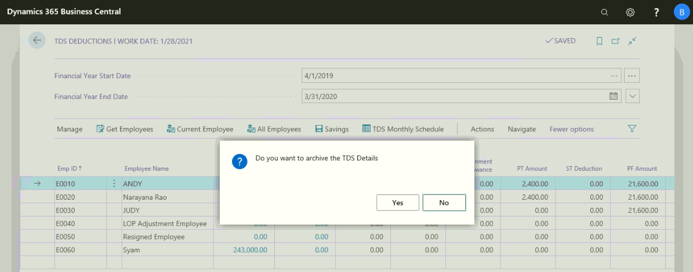
Click to Yes.
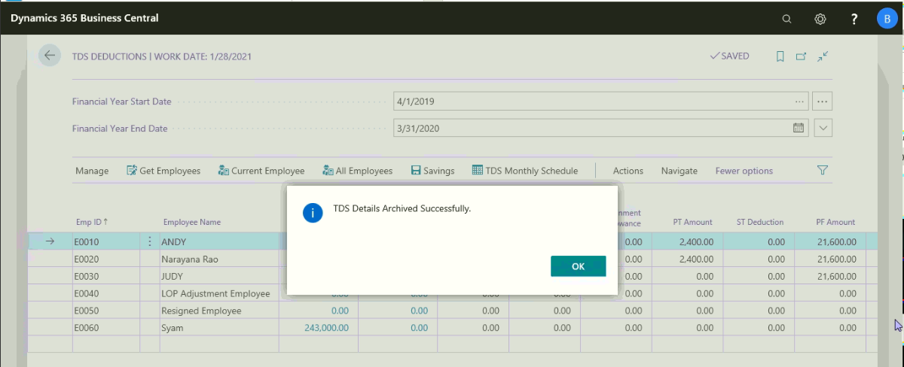
System will delete the previous TDS related information and Stored in Archive TDS information
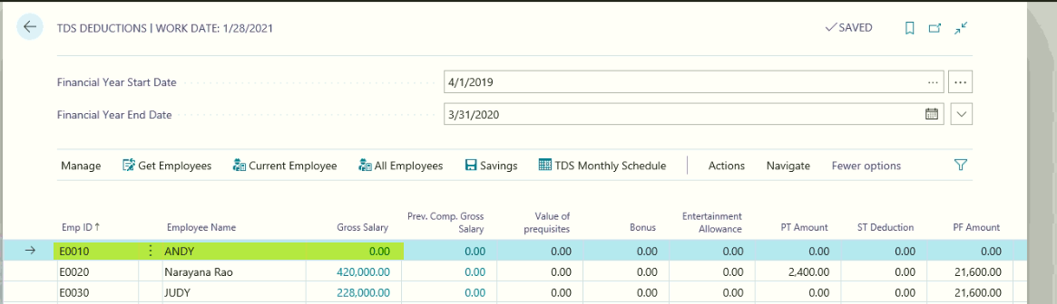
After archiving the document, user needs to recalculate the Gross Salary, PF amount. Update the Employee Savings once again if any change in Savings plan or No change in savings plan
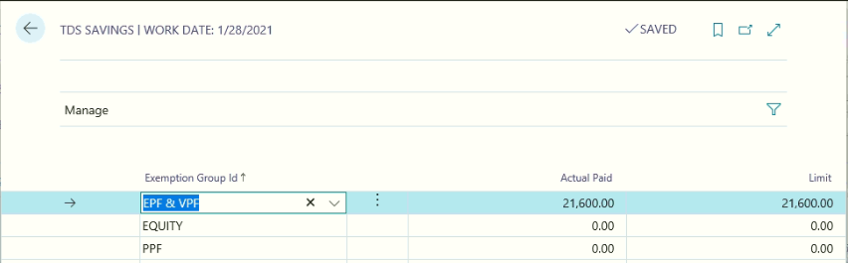
Click ActionsUpdate savings with this system will update the latest Savings information.
Click ActionsCalculate Tax Liability
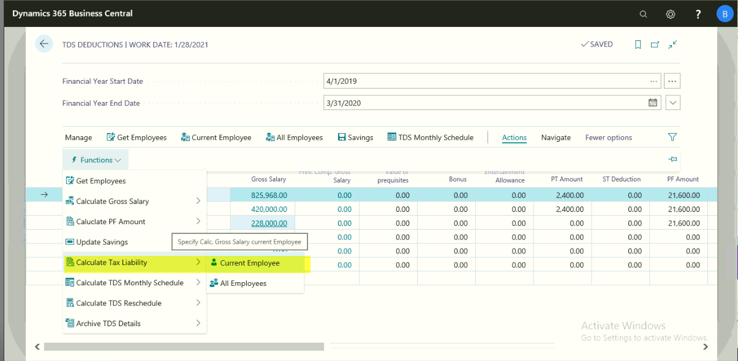

System is recalculated the tax liability for the financial year.
Click ActionsCalculate TDS Rescheduling
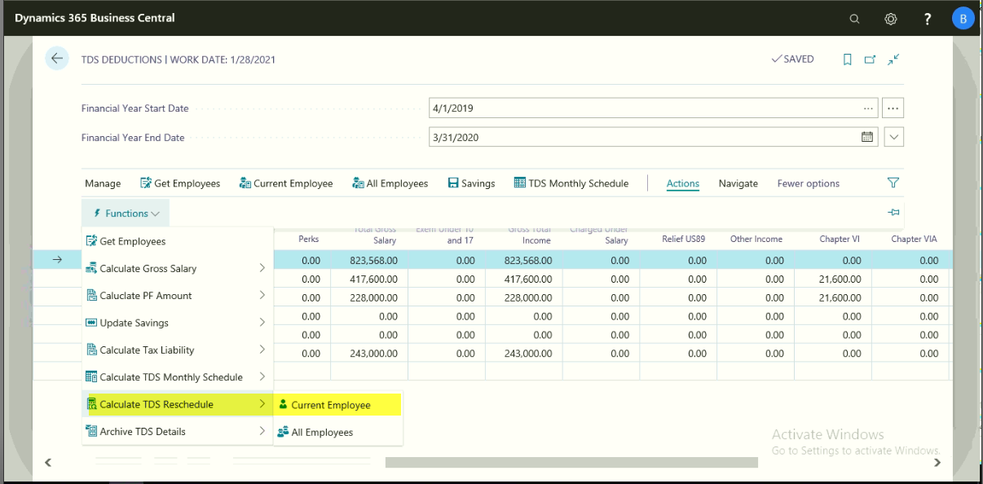
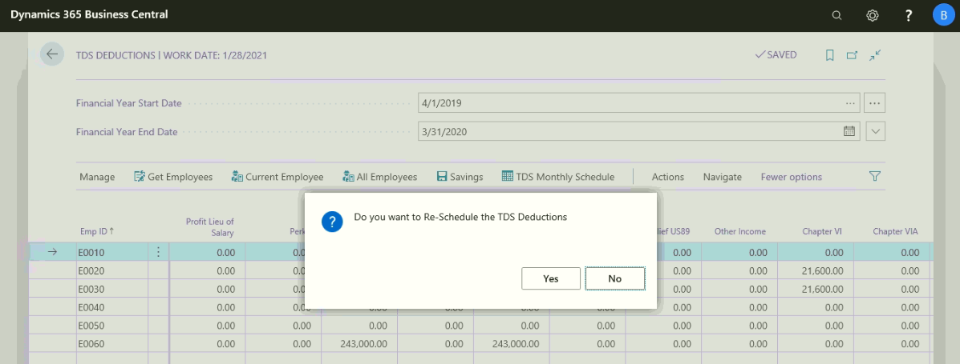
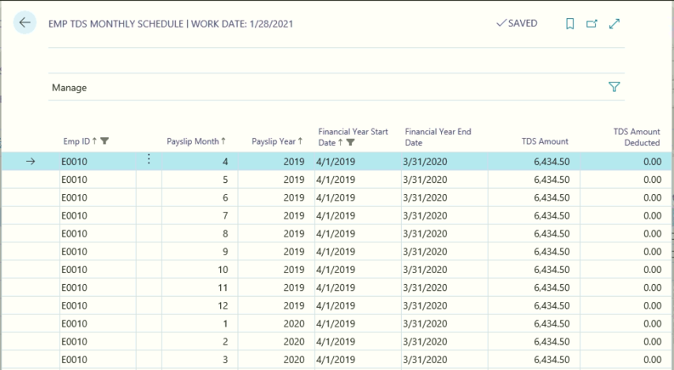
With this system will recalculate the TDS amount (Total Tax liability – TDS Deducted if any)/No of remaining months.
If user needs to view the Archive TDS information by using the following path
Path: DepartmentsHR and PayrollPayrollTDSHistoryArchived TDS Deductions
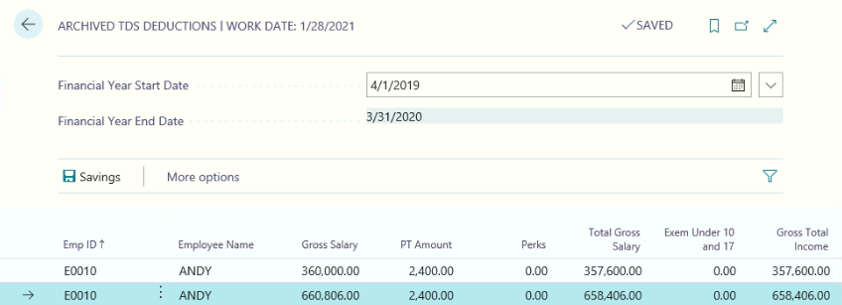

Click NavigateSavings
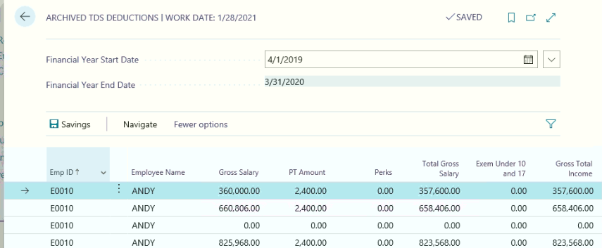

TDS Payment to Income tax Department:
Path: BussinescentralActions TDS Payment Journal
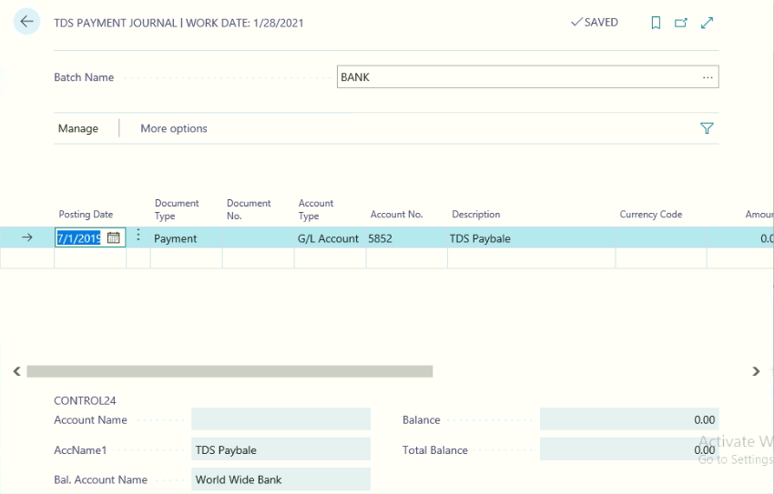
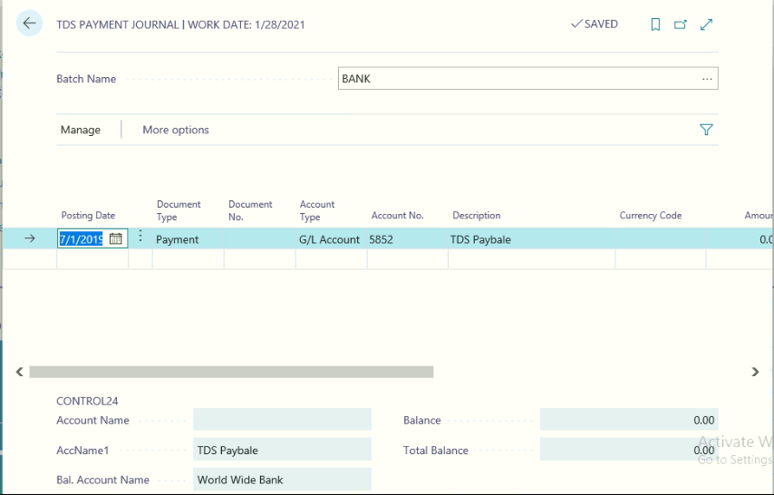
Define the following information form the TDS Payment journals
Posting Date
Check No and Cheque Date
Document type as Payment
Document Number
Account Type as G/L Account
Account No as TDS Salary Payable account
Balance Account type as Bank
Balance account no. Select applicable bank

After filling once post then system will post the TDS payment entry.

TDS Register:
Once the TDS payment made to Income tax department, user needs to update the TDS Challan Number, Date, BRS Code, Cheque date and Cheque numbers. The same will be displayed at the time of generating Employee form 16.
Path: Business centralActionsTDS Registers
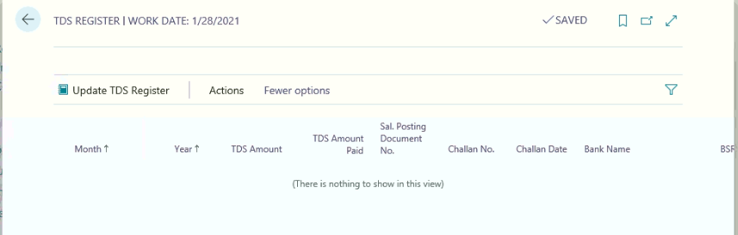
Click HomeUpdate TDS Register
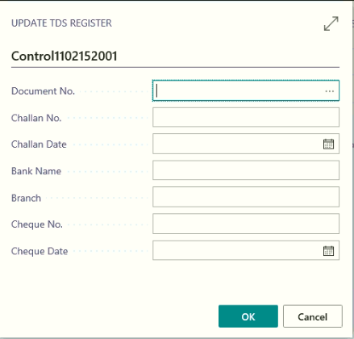
Select the document No
- Challan No
- Challan Date
- Bank Name and Branch
- Cheque No and Date

Final Settlement

Path: Business Central Final Settlement
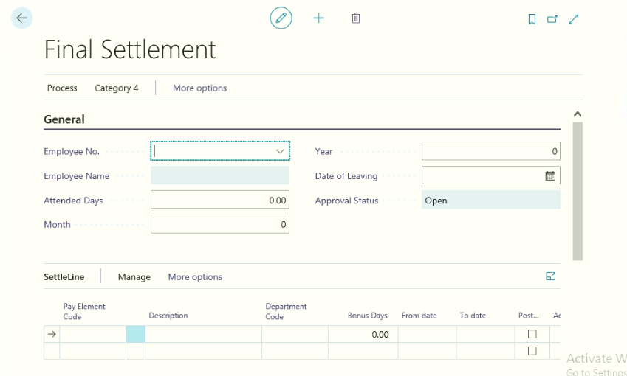
Click HomeNew.
Once the employee Resigned, Place a check mark on Employee Master “General Fast Tab” as resigned, in final settlement only resigned employee information will be viewed.
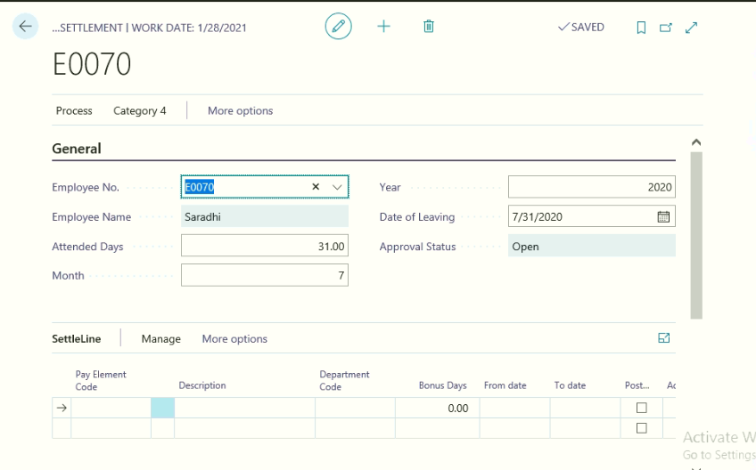
Select the employee and define the reliving month and year and last of leaving date with this system will update the no of days filed, if user needs to modify the same as per applicable they can modify.
Click HomeGet Pay elements
With this system update the applicable pay elements
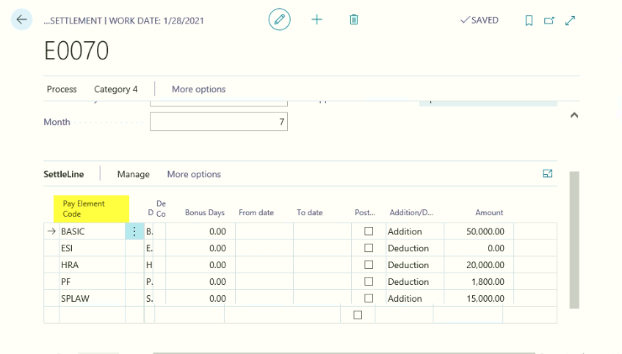
Click HomeCalculate Amount
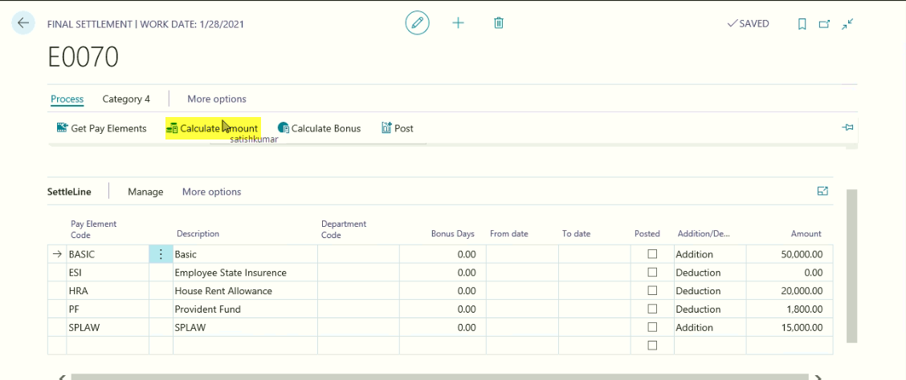
Click HomeCalculate Bonus Amount
Click Home Print to print the Final settlement of the employee
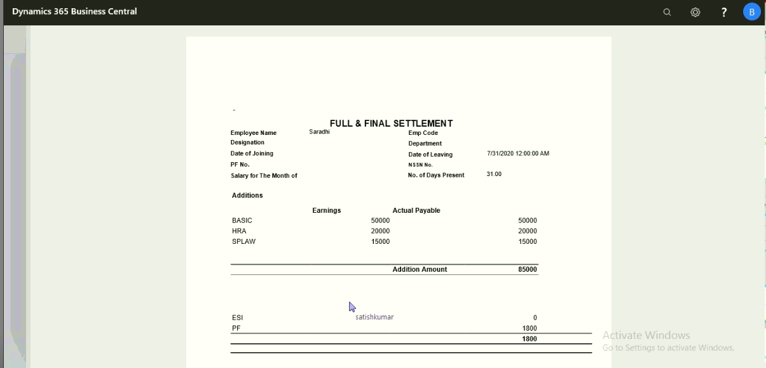

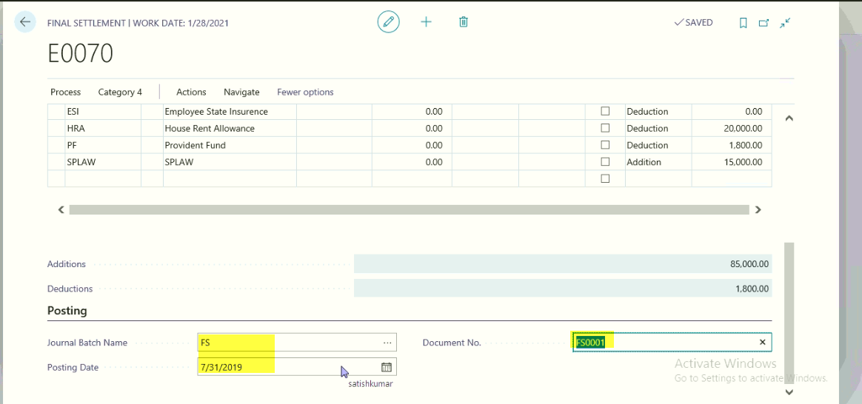
Posting Fast tab: Define the following information
- Journal Batch name
- Posting Date
- Document No
Click HomePost
With this final settlement will be calculated and posted to G/L accounts and Employee will be blocked automatically.
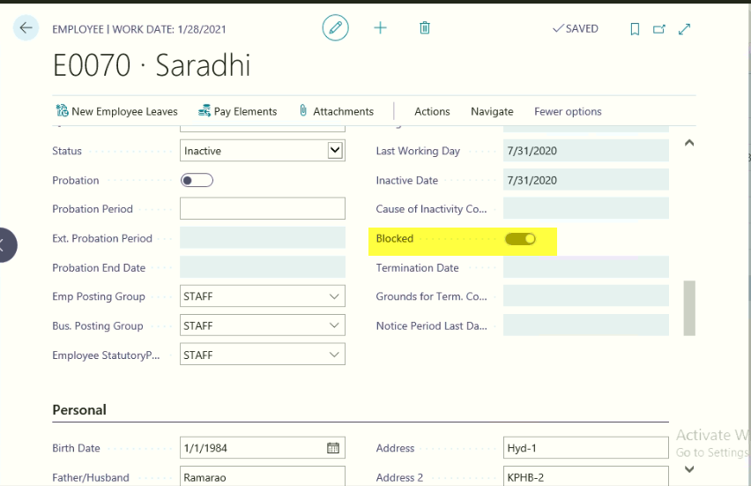
With this he will become the history of the organization only.

Final Settlement Payment to Employee:
Path: Business CentralActionsJournalsFinal Settlement payables
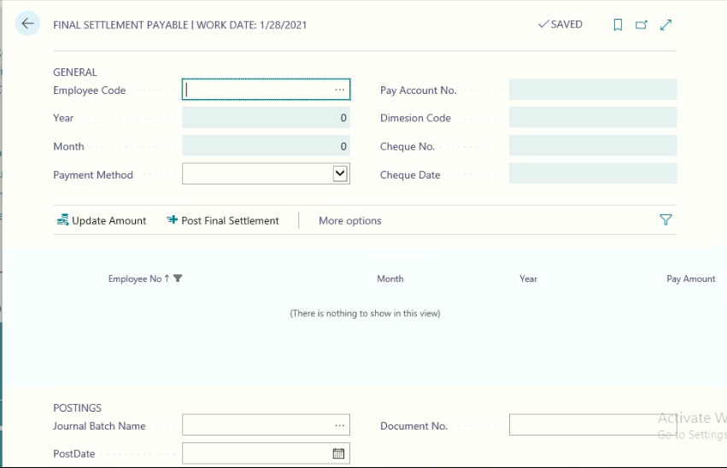
Select the employee code, Month and Year
Select the Payment Method and Pay Account No
Define the Cheque no and Cheque Date
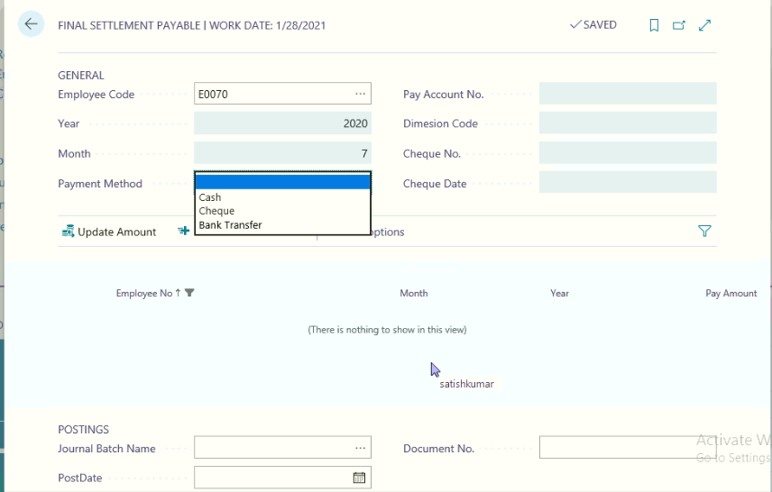
Click HomeUpdate Amount
Select the Journal Batch Name, Posting Date and Document from Posting Fast Tab
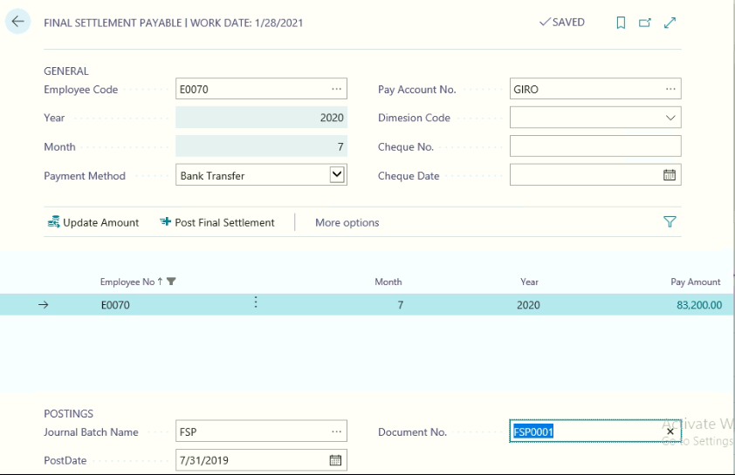
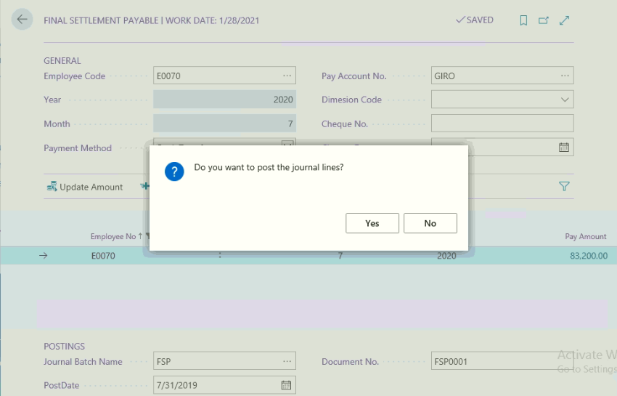
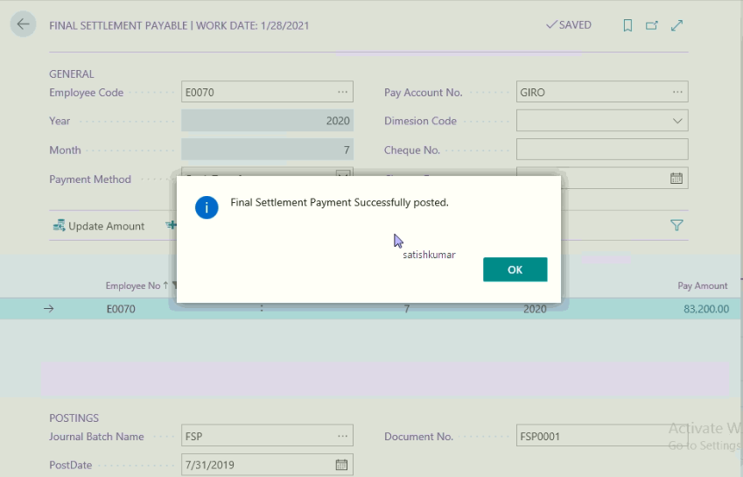

Monthly Attendance (Monthly Salary Processing)
Every month user needs to run this function for Computing Employee Salary, before running this functions, user needs to check the following activities have done or not, they are as under:-
- Updating of Daily Attendance
- Updating of Leave Information
- Updating of Overtime Approvals
- Updating of On duty Information
- Updating of Compensatory off if any
- Processing Pay Revision if any
- Processing of Loans (New Loans, No Deduction Requests and Partial Deduction Request for Old loans if any)
- Processing of Other pay elements if any
- Processing of Final Settlement if any
- Processing of TDS monthly scheduling (New Employee, change request for old employees if any etc.,)
Path: Business Central ActionsAttendanceMonthly Attendance
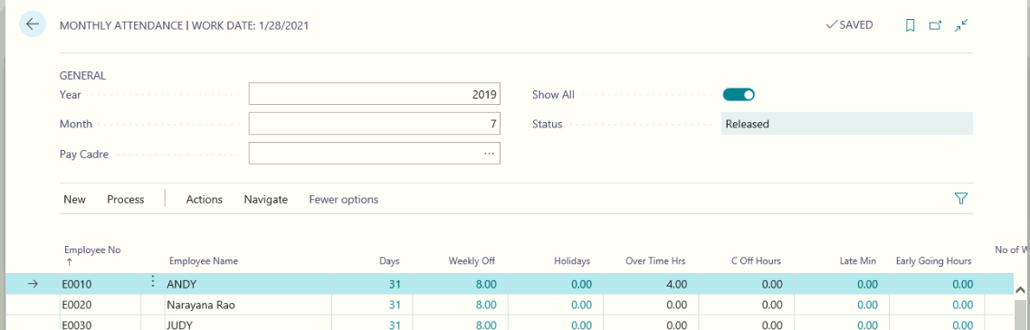
General Fast Tab:
Month and year information will automatically update based on the HR Setup General Tab, Salary processing month and year.
If user needs to process the salary based on the employee pay cadre wise, they can filter the data from pay carder field
Click ActionsRelease
Once the HR Department will update employee wise attendance information they can release the Monthly attendance to Finance and Accounts Department for Process salary for the month.
After releasing the document, if they need to update any information, they need to click ActionsReopen
Finance and Accounts Department will run the following process:
Click ActionsProcess Salary <Current Employee or All Employees>
Salary can be processed for current employee or all employees
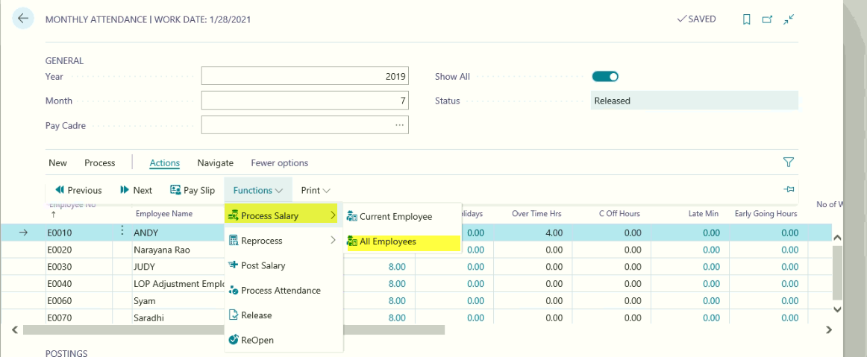

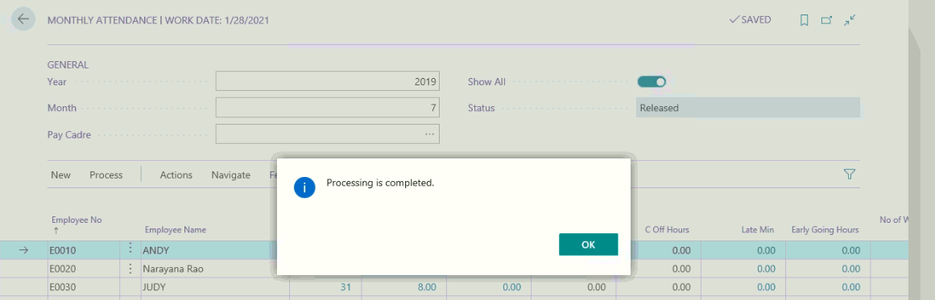
Click Ok
With this system will compute the employee salary with considering of the following information
- Attendance Days for the Month
- Leaves Taken During the Month
- Loss of Pay if any for the Month
- Weekly off days and Holidays for the Month
- Compensatory off if any for the Month
- Overtime Approved Hours for the Month
After processing the salary, if user received any of the above information against any employees, they can update and reprocess the salary
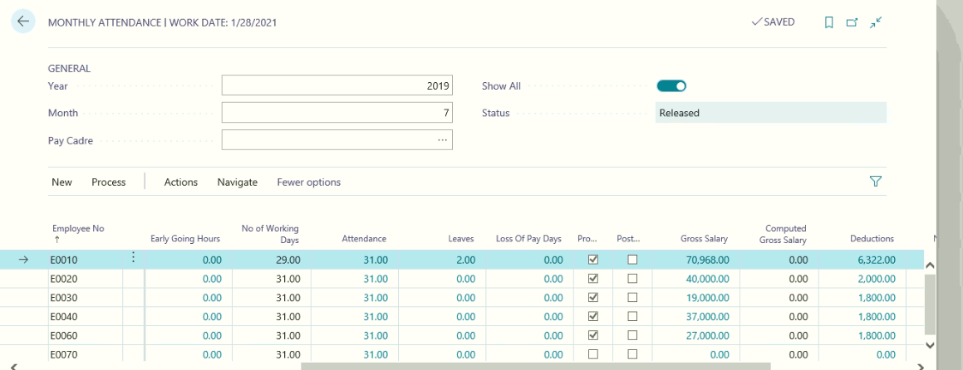
Click ActionsReprocess Salary
Note: This function can run as many times as HR and Finance Department needs to run before posting to General Ledger. Once the Salary has been posted to G/L Accounts, they cannot run this function for the month.
Click ActionsCalculate Gross Salary
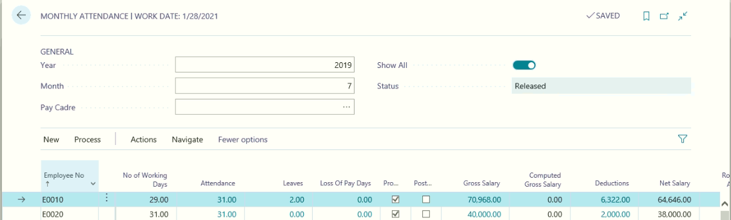
With this system will update the Gross Salary
Click ReportsPrint PDF Pay Slip
With this pay slips will be converted into PDF format
Click ReportsSent to Outlook Express
With this pay slips for the month will be sent to employee outlook express, for this mail id needs to be configuring in Employee master communication tab.
Click NavigateProcessed Salary
With this user can view the Employee processed salary with all additions and deductions for the month
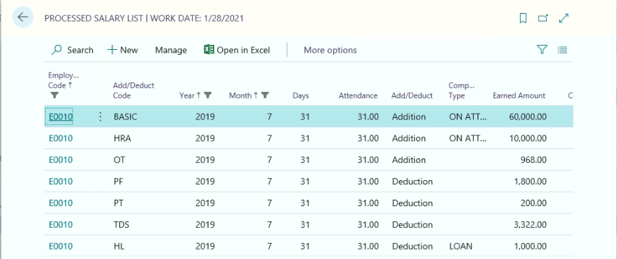
Click NavigateDimension
Form this Employee Dimension information can be attached or modified as per the requirements
Click ActionsPay Slip
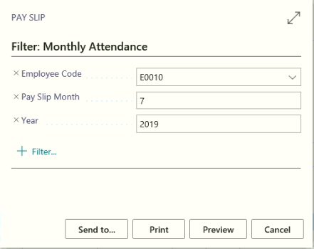
Click Print or Preview
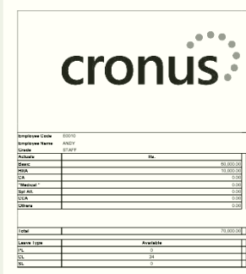

Posting tab:
- Select the Journal Batch Name
- Posting Date
- Document Number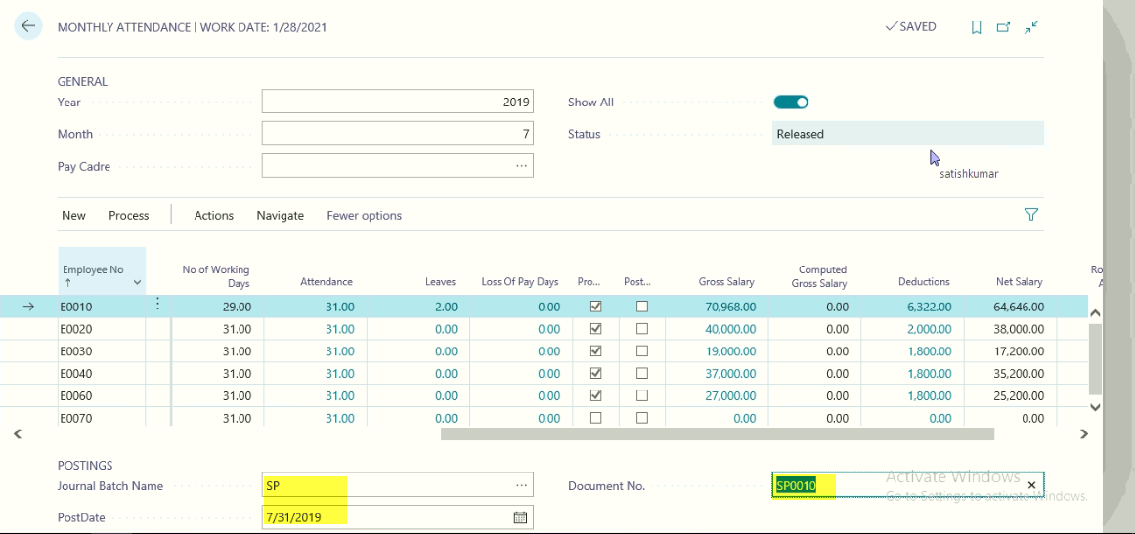
Click ActionsPost Salary
With this Salary for the month will be posted to General Ledger and in Monthly Attendance form System will update Posted Field as True.
Note: Once the Salary has been posted to G/L Accounts nothing can be done for the month.

Salary Adjustment (Perks)

This functionality will be used, if any employee is getting additional benefits apart from the Salary, this functionality can be used.
These expenses will be paid on monthly basis by submitting bills or as per the eligibility.
Path: Business Central Actionssetup Salary Adjustment setup
Click HomeGet Employees
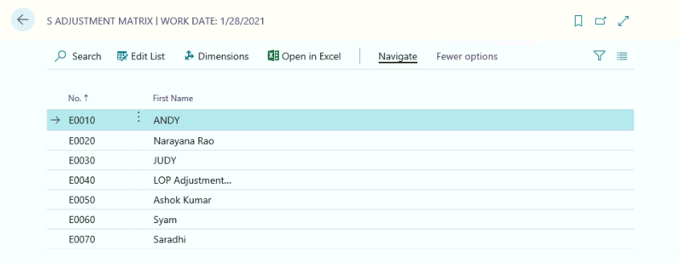
General Fast Tab:
Month and Year will be updated based on the HR Setup General Tab, Salary processing month and year information.
User needs to pay based on the location; they can use the required location from the location field.
Define the Amount for applicable each and every employee
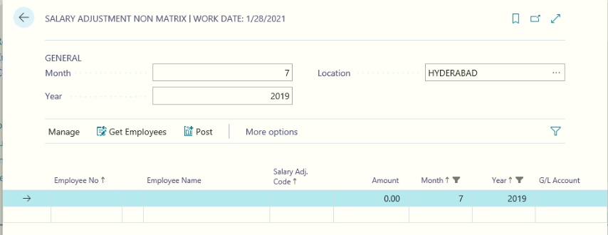

Posting Tab:
Select the Journal Batch Name, Posting Date and Document Number
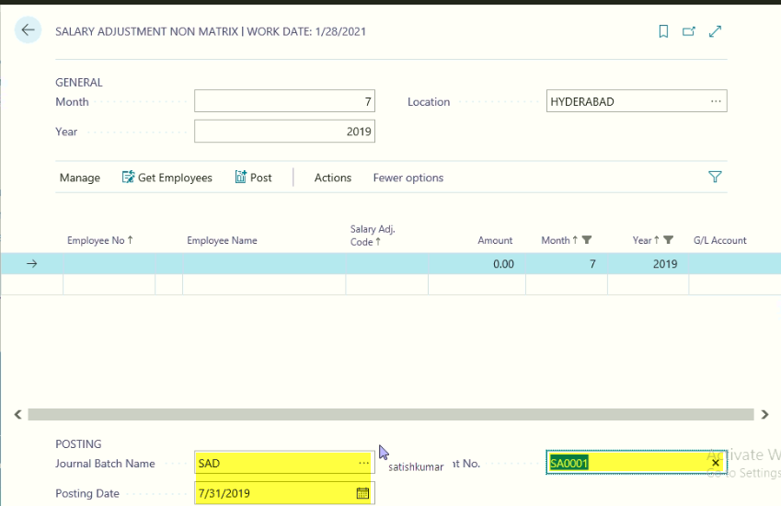
Click HomePost

Leave Encashment

Whenever employee surrenders Earned leaves, they will be paid leave encashment amount. For computing the Leave encashment the following information needs to be checked.
- Employee Earned Leave balance
- Leave Encashment applicable Pay elements (Refer Look Up No 16 Additions & Deductions)
- Leave Encashment Postings
Path: Business Central ActionLeave Enchment
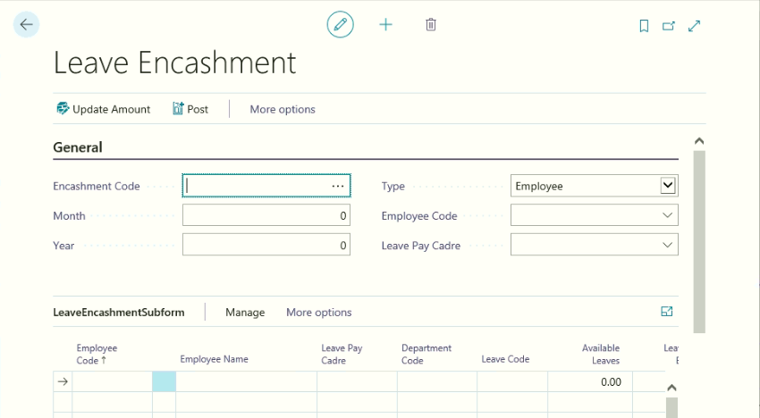
From Home tab Click “New” to create new Leave Encashment Page.
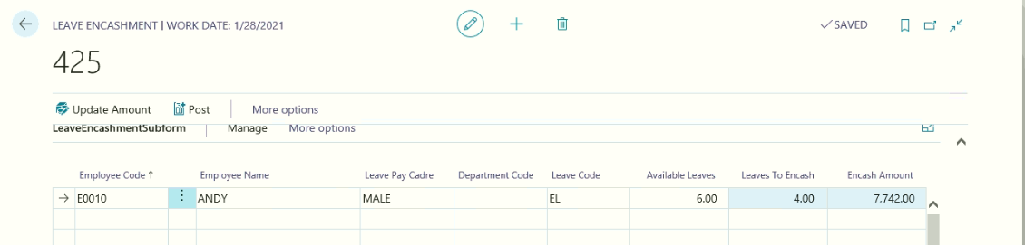
General Fast Tab:
Select the Employee Code
Month and year on which Leave Encashment need to be paid
Once the User Select the Employee Code, System will update the Pay Cadre and Leave encashment lines with following information
- Employee Code
- Employee name
- Pay Cadre
- Leave Code
- Available Leaves
User needs to enter No of Leaves needs to be encashed information

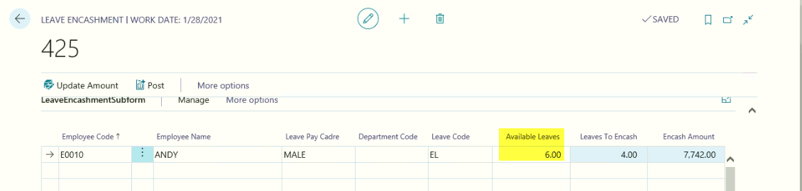
From the above page update, leaves to be enchased and click HomeUpdate Amount
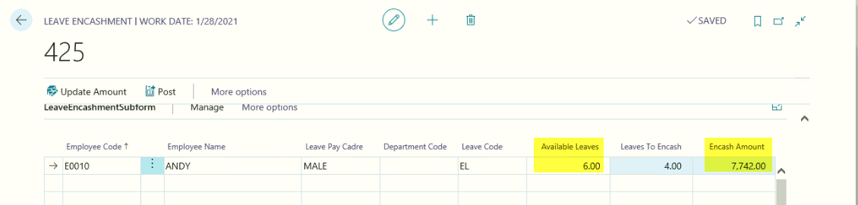
System will calculate and update the Encash amount
Posting Fast Tab:
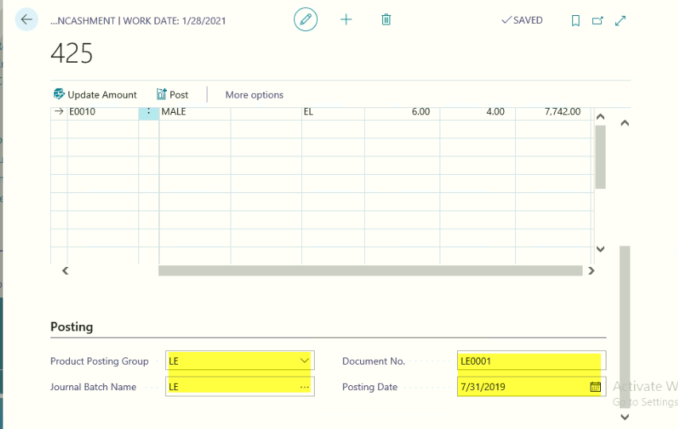
Select the Journal Batch name, Posting Date and Document Number
Product Posting Group
Click HomePost
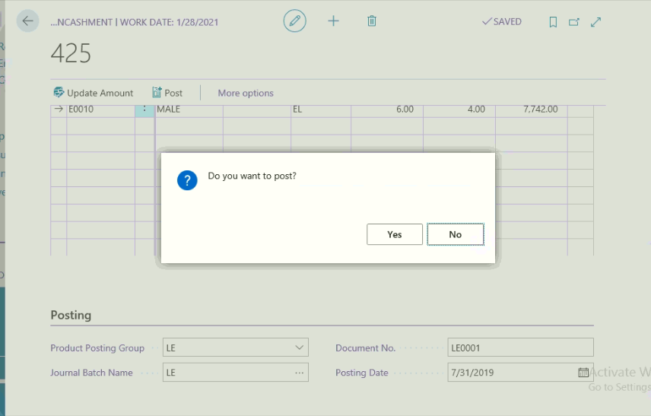

22.1 Leave Encashment payment
Path: Business Central ActionsJournalsLeave Encashment payment Journal
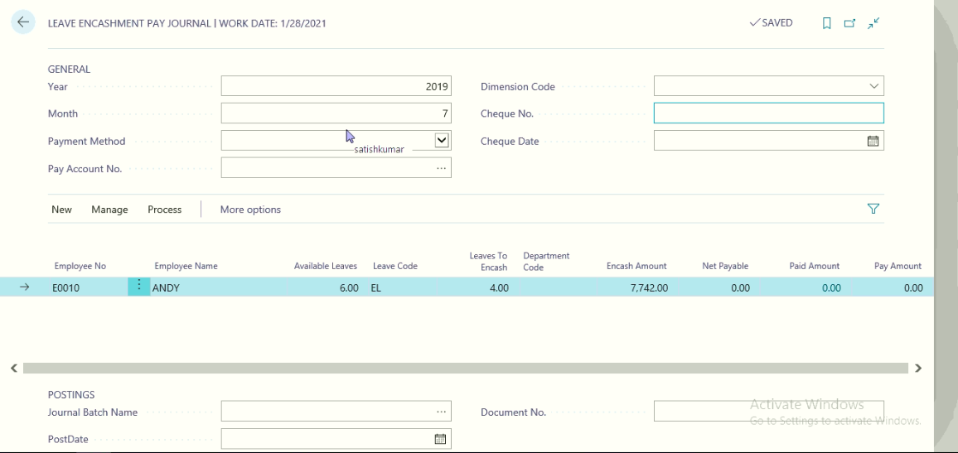
General Fast Tab:
Select the Payment Method
Pay Account No (in case of cash payment select cash account from General Ledger in case of Cheque or Bank Transfer select the Bank account)
Cheque Date and Number:
Posting Fast Tab: Select the Journal Batch name and Posting date and Document Numbers.
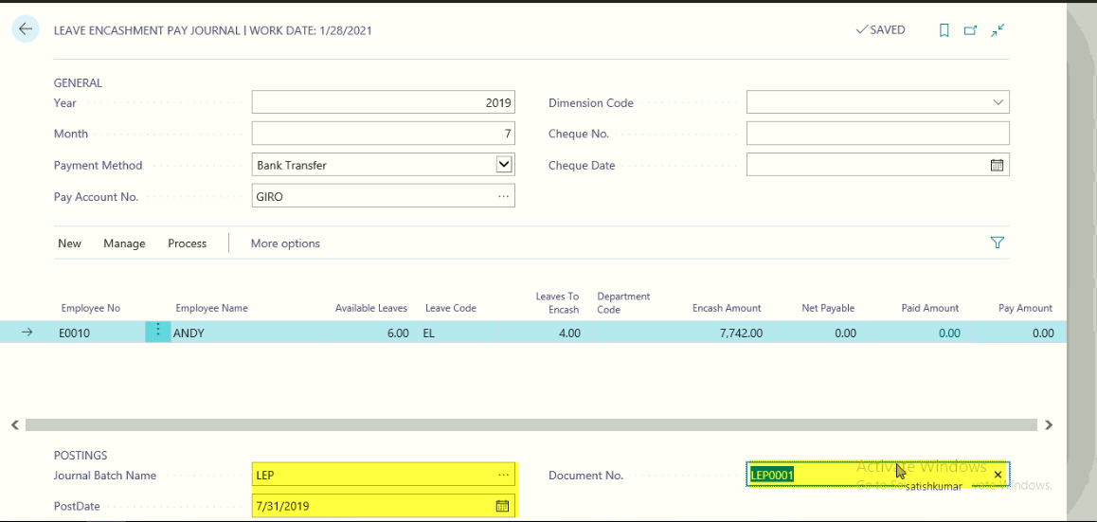
Click HomeUpdate Amounts, with this system will update Net Payable and Pay amounts.
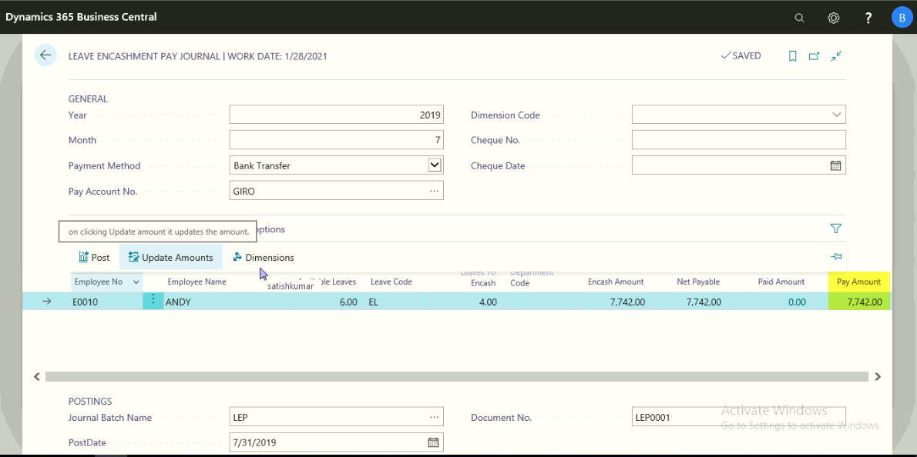
Click Home or NavigateDimensions
Click HomePost
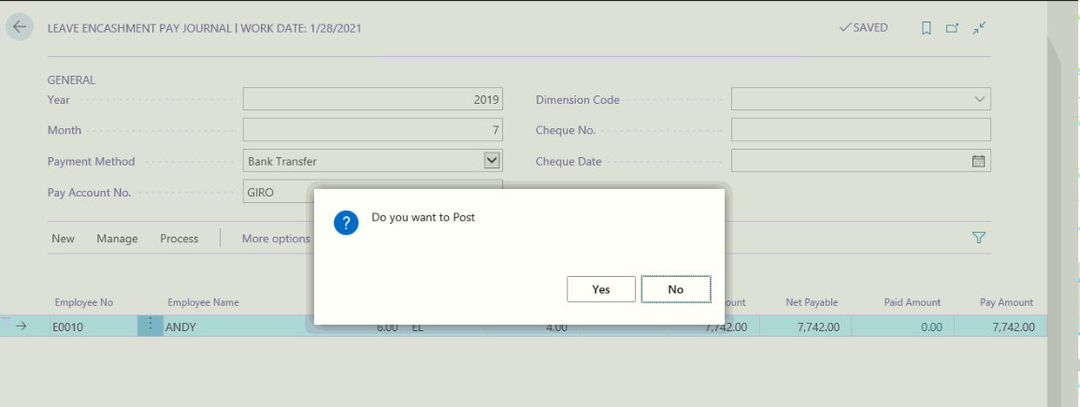
Click yes to post the transaction.
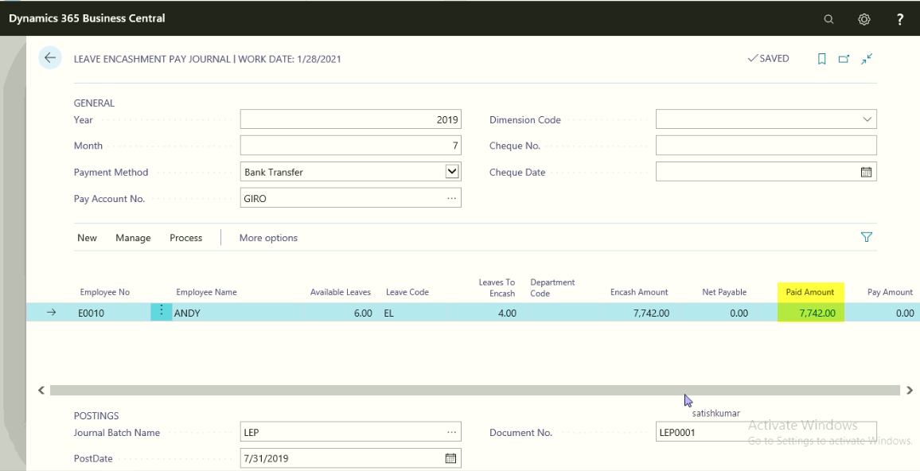

Bonus\Ex-gratia Adjustment

Bonus and Ex-gratia will be calculated once in a Year based on Previous Financial year Performance of the Organization. Bonus will be paid as per the Bonus Act. Ex-gratia will be paid as per the Management Decision.
Path: Business Central Actions Periodic ActivitiesBonus Adjust
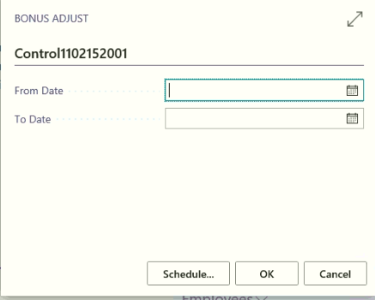

Define the from date and to date as Financial year Start Date and End Date and Click “OK”

With this system will compute the Bonus amount and update in Bonus\Ex-gratia Adjustment form for the period
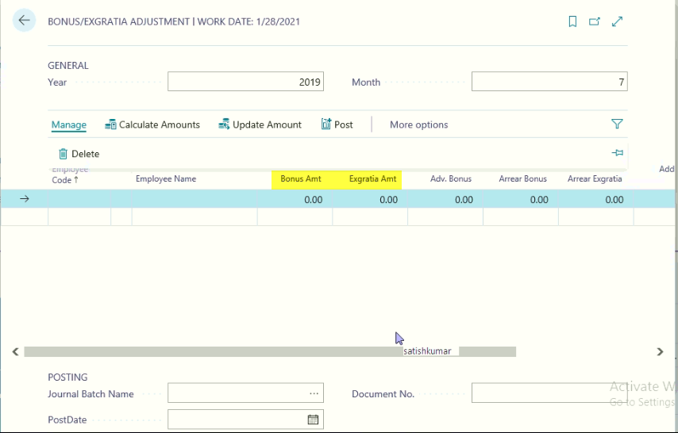
If management and Employee needs adjust, they can do adjustments.
In case of Management: if the management wants to give arrear bonus or addition Bonus they can enter the amount manually.
In case of Employee: they needs to adjust the partial Bonus amount towards loan they can give request to Finance and Accounts department to adjust the partial or Full Bonus amount towards Loan amount.
Click HomeUpdate Amount
With this system will update the Net payable amount
Click Print
From the Bonus Register can be printed
Bonus Slip
Click ReportsBonus Slip
Posting Fast Tab:
Select the Journal Batch Name, Posting Date and Document Number
Click HomePost
With this system will update the G/L Entries in Financial Management.

Salary Payment

Once the salary has been processed for the month, need to be paid to employee based on the Employee payment Method.
Path: Business Central Actions Journals Pay Salary
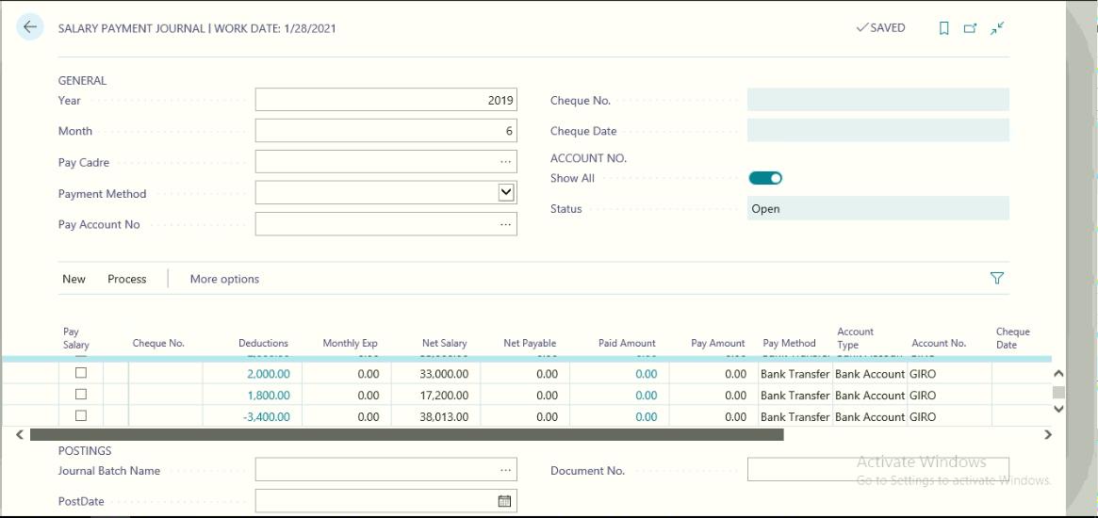
General Fast Tab:
System will update the Month and Year based on the HR Setup General Tab, Salary Processing month and Year Fields.
Select the Payment Method from the applicable options like (Cash, Cheque and Bank Transfer)
Select the Pay Account No: in case of Cash Pay Account should be linked to G/L Accounts to select the Cash Account, in case of Cheque or Bank Transfer user needs to select the bank account form which we are making Salary payment.
Posting Fast Tab:
Select journal Batch Name
Posting Date
Document Number
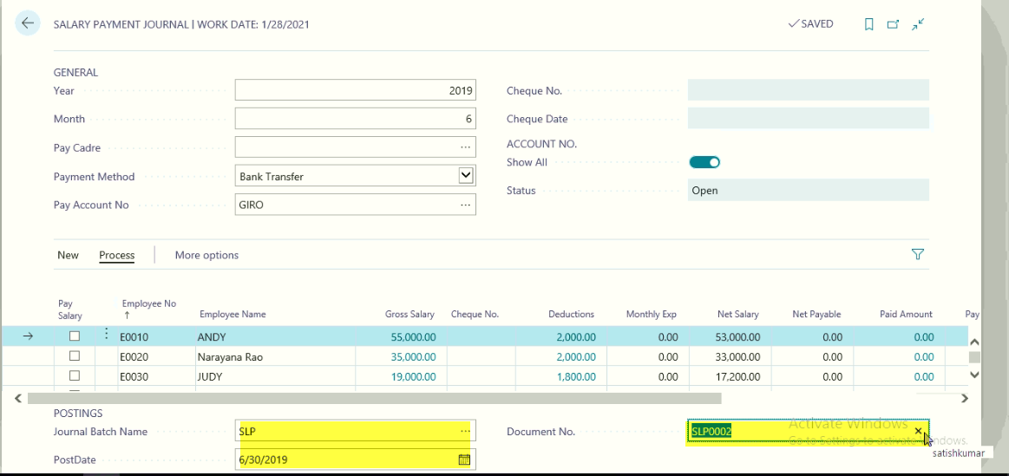
Click HomeUpdate Amount
With this system will update net payable field
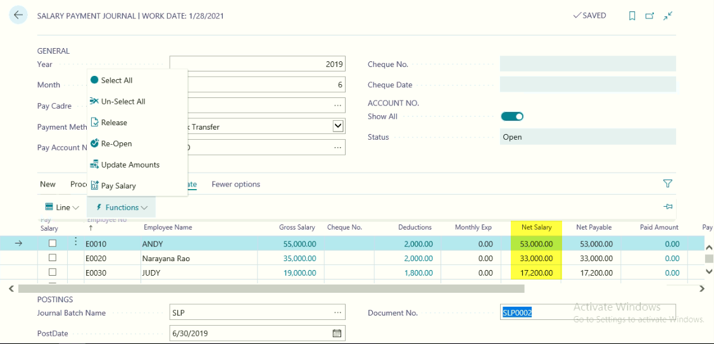
Click HomePay Salary
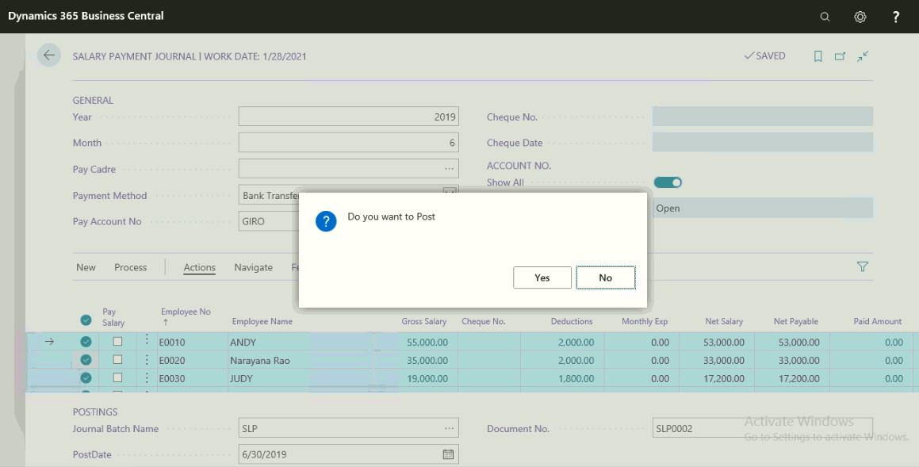
Click Yes to Pay Salary

Leave Management

Leave Creation
All the applicable leaves can be defined in the leave master. Leave master can be accessed from
Path: Business Central ActionLeave List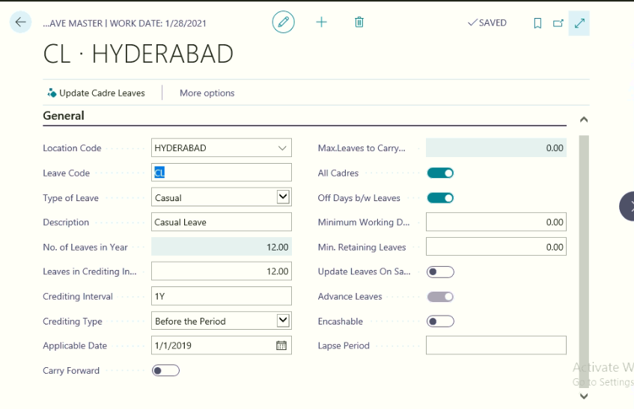
Refer Point No 8.4 for process of creating Leave Master

Pay Cadre – Leaves
Pay Cadre Leaves will be generated when Update Cadre Leaves function is run from Leave Master where the value of All Cadres field is set to “Yes / True”. The values updated can be changed by the user as per the requirement.
If All Cadres field in leave master is set to “No / False”, then the user has an option to define the pay cadre leaves manually. This can be done by running the Update Cadre Leaves from functions in the leave master and then picking the required Pay Cadre.
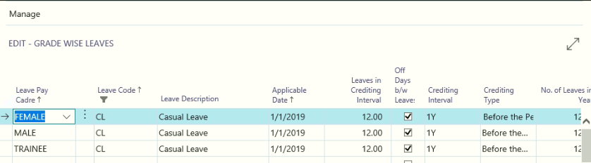

Leave Generation
Leaves for the Employees will be generated automatically when Attendance is generated from Periodic Activities Calendar Generation.
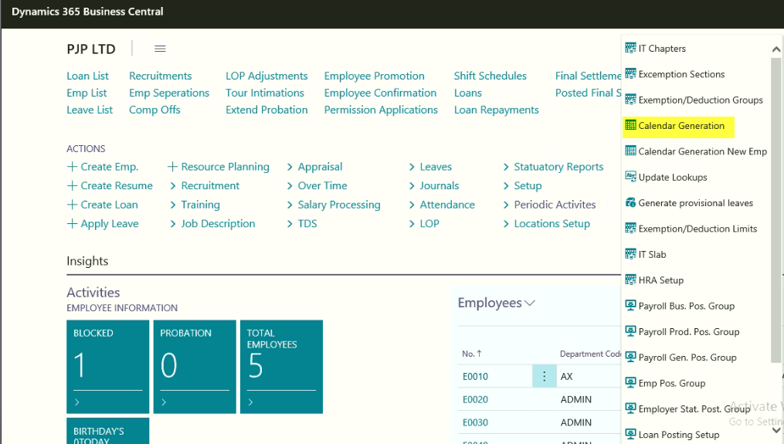

New Employee Leave Generation
Leaves for the new employees can be generated using the option available on Employee Card Home New Employee Leaves.
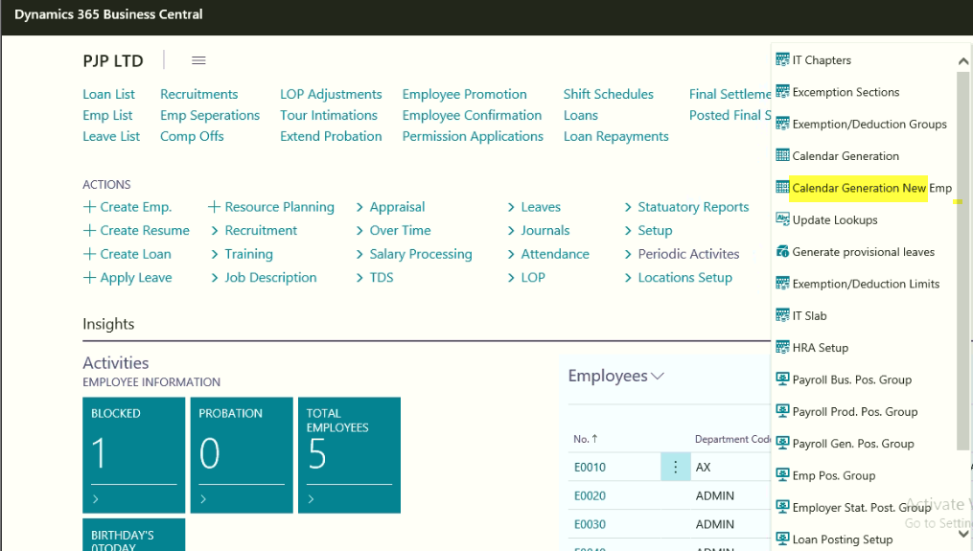
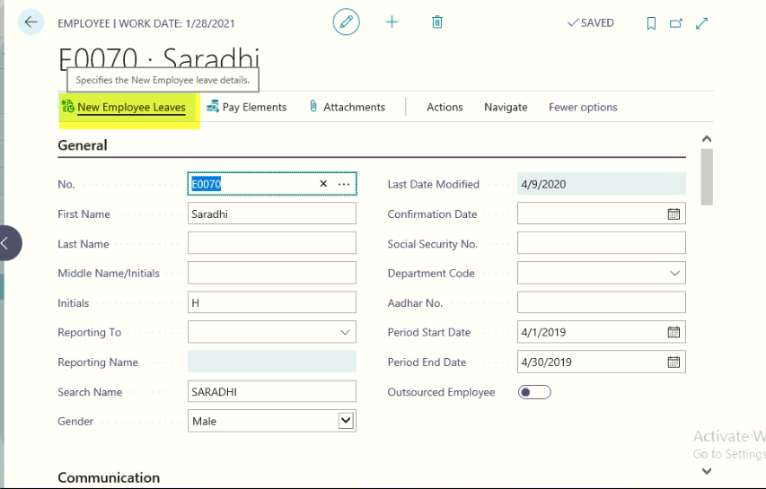

Leave Approval Setup
Refer Point No 8.6 for setting up of Leave Approval process for Leave application and Leave cancellation.
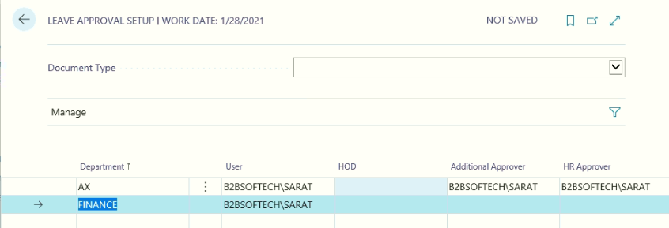

Leaves Applicability
Where an Employee can apply different Leave codes continuously, Leave Combination setup needs to be defined.
Path: Business CentralActionsLeave Applicability
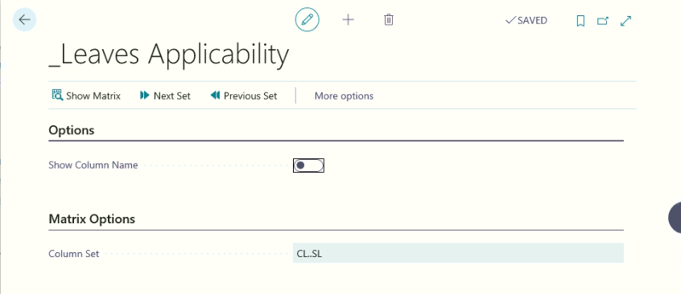
Click HomeShow Matrix
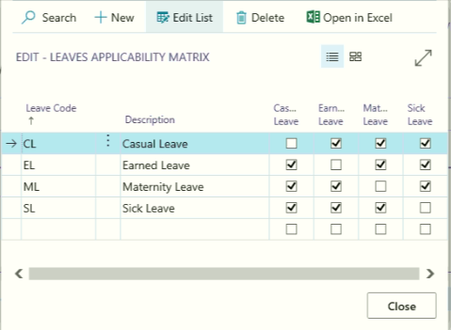
Where Leave combination need to be allowed, check mark need to be placed in the matrix form.

Opening Leave Balance
At the time of implementation of HR & Payroll, the previous balances / opening balances of employees can be updated using the Leave Opening Balance Journal functionality.
DepartmentsHR & Payroll Leaves DocumentsLeave Opening Balance
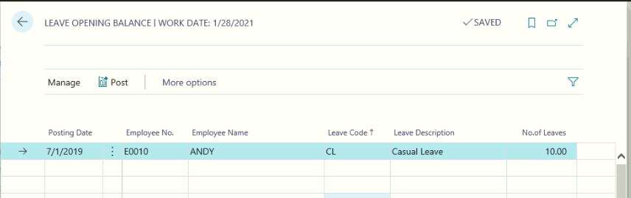
To update the Leave opening balances of an employee, key in the Posting Date, select the Entry Type as Opening Balance; pick the Employee No and Leave Code. Fill in the No. of Leaves field with the Leave Opening balance at the beginning of the Salary Processing Period Month and Year as defined in the HR & Payroll Setup.
Post the Journal for creation of opening balances.

Employee Leave and Detail Leave Records
Two types of leave records are generated when Calendar Generation / Generate Leaves periodic activity is run –
  - Employee Leaves
  - Detailed Leave Records
Employee Leaves:
Employee leaves display the number of leaves available against each Leave Code as on current date. Employee leaves are generated by the system when Calendar Generation / Generate Leaves periodic activities are run.
Detailed Leave Records
Detailed Leave Records will keep track of the complete history of leaves for every employee against each leave code.
Following are various entry types in Detailed Leave Records and the cases when they are generated –
- Opening Balance: When Opening Balances for a Leave Code are posted against an Employee through Leave Journal, system will create Detailed Leave Records with Opening Balance entry type.
- Entitlement: Entitlement entries are created when Monthly Attendance is processed “Process Attendance” function is run from Monthly Attendance Form.
Entitlement entries are created based on the Leave Crediting Interval and No. of Leaves in Crediting Interval fields defined in the Pay Cadre Leaves against each Leave Code and is for future period.
- Utilization: Entries of type “Utilization” are posted automatically when Process Attendance function is run based on the status of Leave Application. Only Leave Applications Posted and Authorized form the basis for Utilization entries.
- Lapse: Entries of “Lapse” type are posted by system when Process Attendance function is run for the closing month of Leave Year. No. of Leaves that lapse is based on setup defined in Pay Cadre Leaves in Carry Forward and Number of Leaves to be Carried Forward fields.
- Correction: When Leave Correction Journal is used for adjusting the leaves, system will post the Detailed Leave Entries with entry type “Correction”.
The summary of Detailed Leave Records will be displayed in the Employee Leaves in the Employee Card.
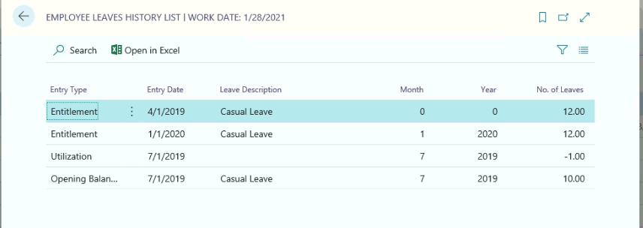

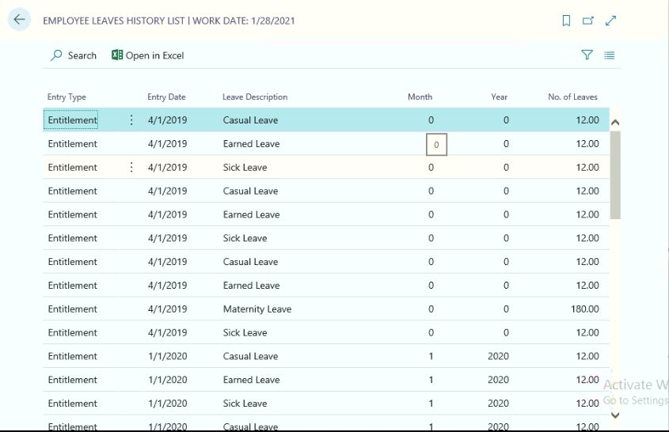
When drilldown on “No. of Available Leaves”, system will display the Employee Leaves History, which represents “Detailed Leave Records” information.

Provisional Leaves
Provisional leaves enable Employees in –
- Creation of Leave Plan in Leave Application (refer to Leave Application section)
- Facility to apply for Leaves covering multiple months (Ex: 04/30/2011 to 05/02/2011) or multiple leave years (03/31/12 to 04/02/12).
Provisional Leaves for a leave year are generated at the start of leave year as against monthly creation of Detailed Leave Records when Calendar Generation / Generate Leaves periodic activity is run. As the name indicates, these leaves are provisional, internally used by the system to help the users in the process of planning leaves.
Information from the Provisional leave records are used for creation of Detailed Leave Records when Process Attendance function is run for a Salary Processing period.

Leave Application Process
A Departmental employee who applies the leaves on behalf of all employees (fall under same department) can do the same by logging into the system with the user ID and Password and fill in the leave application form.
Path: Business Central ActionsLeave Application List

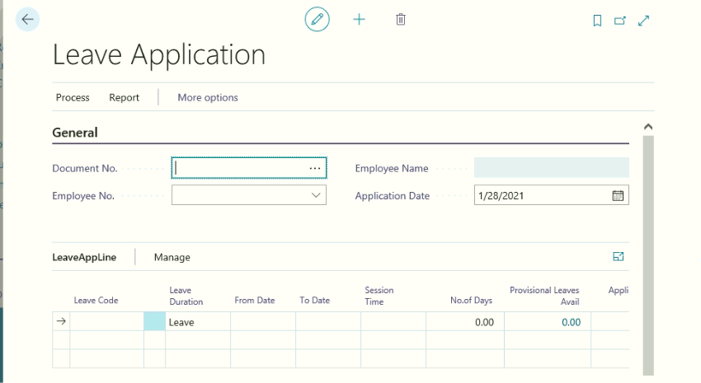
Click HomeNew to create New Leave Application page.
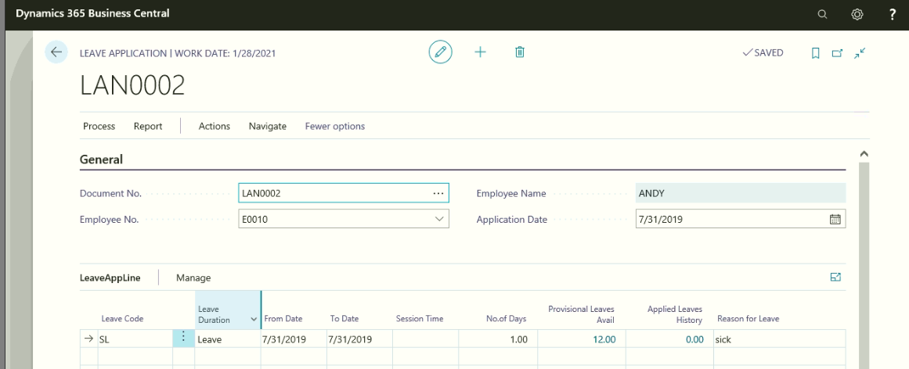
Leave Application Header:
Document No: Select the Leave Application Document number
Employee No: Select the Department Employee Number
Employee Name: on Selection of Employee number, system will update the Employee Name
Leave Application Date: define the data on which Leave is application has been created
Work Assign to: Select the Employee Number, to whom the work has been assigned at the time of leave
Work Assigned to name: on selection of Name, System will update the Employee Name
Leave Application sub form:
Leave Code: Select the Leave Code against which leave is being applied.
Leave Duration: Select “Leave” if Leave is being applied for 1 day or more than 1 day. Select Half Day if leave is applied for Half day.
From Date & To Date: Key in the form and to dates of leave application.
Session Time: Session time is applicable only for the cases where the Leave Type option is Half Day. Select the session for which Half Day leave is applied (First Half / Second Half).
This field has significance to determine whether continuous leave can be applied with different leaves codes based on Leave Combination setup.
No. of Days: This will be calculated by the system automatically based on from and To Dates.
Provisional Leaves Avail. This field will display the number of leaves an employee can avail against the leave application between the from and to dates.
Refer to Leave Application Creation Scenarios sections for detailed explanation about the Provision Leaves.
Applied Leaves: This field will display the number of applied leaves pending for authorization against the leave code.
Reason for Leave: Employee has to specify the reason for leave in this field.
Once all the required fields are filled in, a Leave Plan need to be created before posting the Leave Application for authorization.
Other information:
Create a Leave Plan:
Leave plan provides flexibility to an Employee to plan the leaves in an optimal manner. It has the following advantages –
- If required number of leaves are not available for an employee against a leave code, employee can decide which days should be considered as LOP (Loss of Pay) as per his choice. This will help employee to plan the leaves in an optimal manner where off days are considered as Leaves against the Leave Code.
- At the time of Authorization, sanctioning in charge has discretion to partially accept / reject the leave application and specify the dates of acceptance / rejection of leave.
To generate a leave plan, click on Home Create Leave Plan in Leave Application
To access the Leave Plan, go to Leave Application Menu Item and open Leave Plan. The Leave Type field can be changed by the Employee as per his requirement
Click, Leave applicationLeave Plan
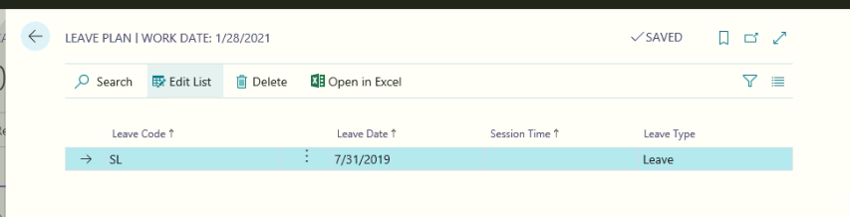
To print Leave application hard copy, Click Print Leave Application
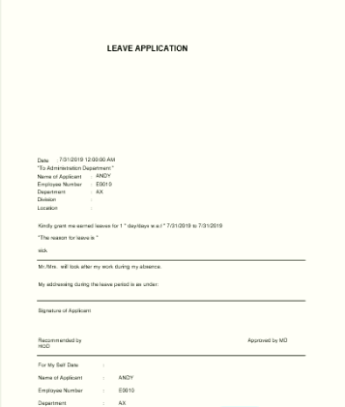
Once the Hardcopy of leave application has been printed out, click Post Post
On posting of leave application, this document will go to Department HOD for approval
Department HOD will open the leave application by using the following path
Path: DepartmentsHR and PayrollLeaveschoose by categoryTasksLeave Approvals
Once the Department HOD logging into the system, above leave application will displayed in Leave Approval HOD

From the leave approval HOD form, Department HOD will approve or reject the Leave applications.
Place Check mark on Approved filed in Leave Approval HOD lines and places a check mark in case of Approve all or rejects all along with Carry out check.
If the HOD can also approve day wise selecting Approved status field for approved or rejected as shown below.
Click Home Post, with this leave application will go for further approves.
Next approver will open the Leave application by using the same path as above.
Click HomePost to send for final approval to HR department.
Once the Leave application has been sent for Final Approver to HR department, HR will open the Leave application by using the same path.
Click HomePost
Note: Before Posting HR department needs to place a check mark in Approved field and carry out action field on leave approvals page.
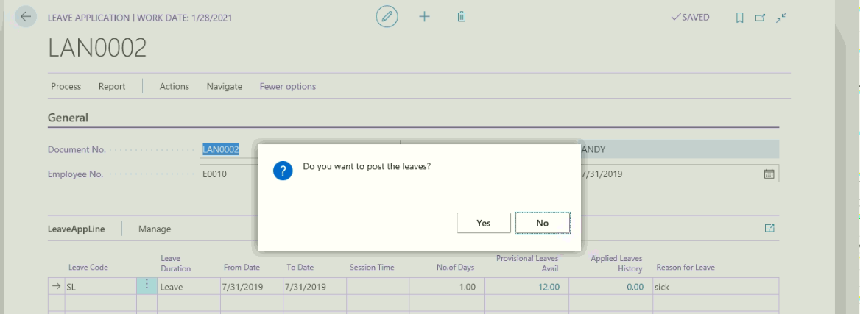
Click Yes to Approve the Leave application. Once the HR will approve, the leave information will be updated in Employee Daily attendance. The same can be viewed by using the following path.
Path: Business Central ActionsAttendanceDaily Attendance
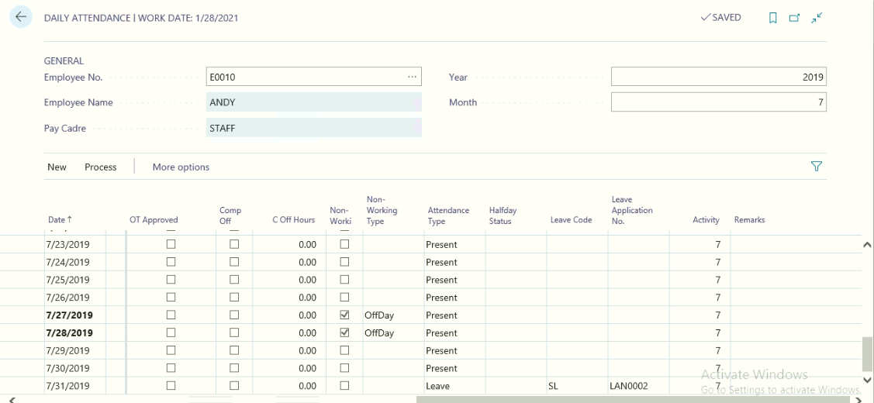
With this system will reduce the Employee leave balances, and the reduced leaves can be updated in the detailed leave records from the Employee Master.

Leave Cancellation Process
Employee applied leaves can be cancelled at any point of time before processing attendance for the month.
Employee Leave cancellation will be done based on the leave cancellation approval process
To perform above activity, user needs to perform the following activities
- Leave Approval Setup for Leave Cancellation
- Leave Cancellation Request
- Leave Cancellation MD Or HOD
- Leave Cancellation
Leave Approval Setup for Leave Cancellation
Path: Business CentralActionsLeavesDocument Leave cancellation
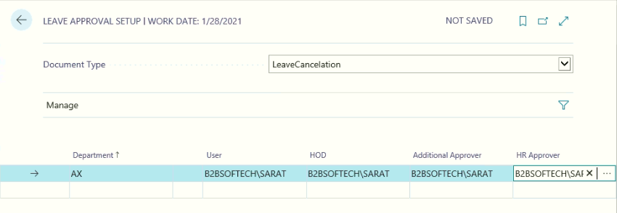
More details Please Refer Point No 6.07
Leave Cancellation Request
Path Business CentralActionsLeavesDocument Leave cancellation Request
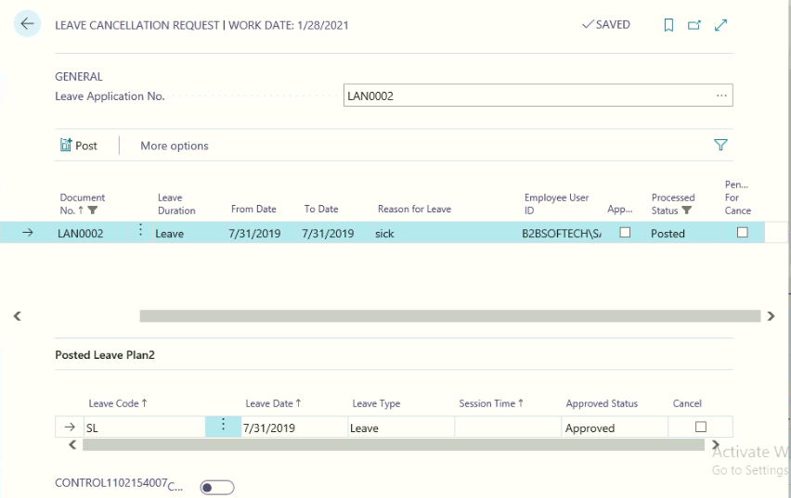
The above document is posted leave application; on which user can cancel all the leaves or partial leaves as per the department employee request.
After selecting cancellation request against posted leave application, click Post to post the leave application for leave cancellation approval to Department HOD
Leave Cancellation HOD or Additional Approver
Once the Department user has post the Leave cancellation request, the same document will be shown from leave cancellation HOD or Additional Approver page
From the above form, HOD will place a check mark in cancel field and post the transaction, with this cancellation request approved HOD will sent to Additional approver or HR department to cancel and updates the cancelled information in Daily attendance and employee leave history.
Daily Attendance before Cancelling Leaves
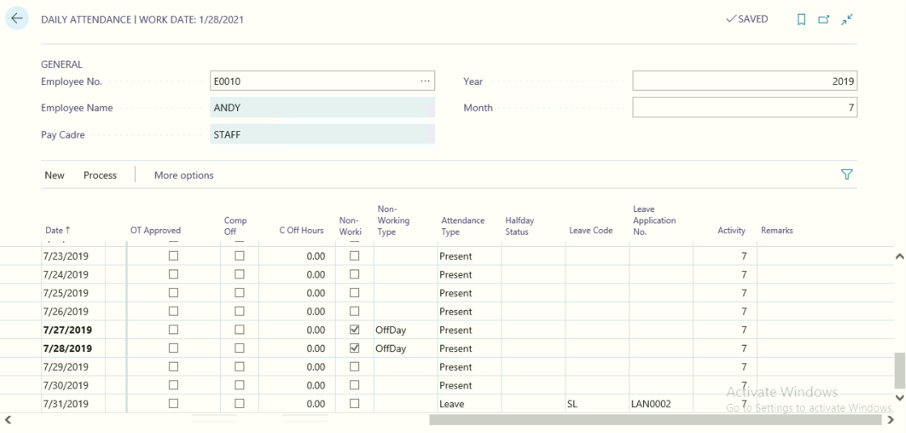

Employee Leave History before posting the Leave cancellation
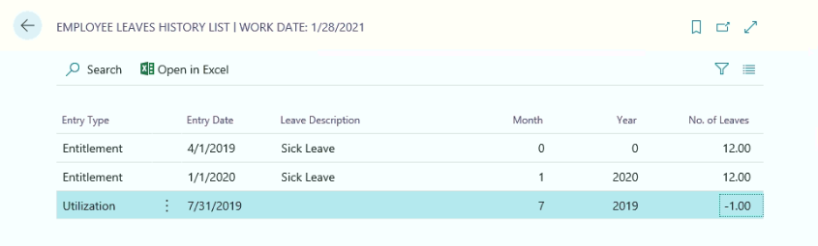
Leave Cancellation by HR and Admin Department
Once the Leave cancellation request received from Department HOD, HR & Admin department will cancel the leave and update the same in Daily attendance and Employee leave history.
If there is no Hierarchy levels are not defined for the leave cancellations then system consider the HOD Approver as HR Approver and will process the Leave Cancellation.

Cancel By HR:
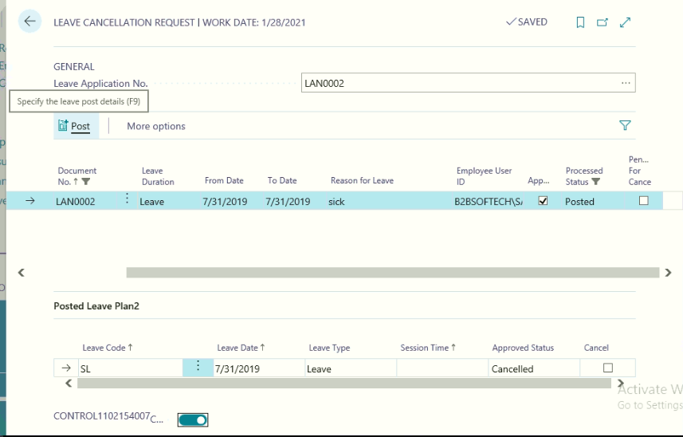
HR and Admin User will place a check mark in cancel field and post the Leave cancellation to update daily attendance and Employee History.

List of Reports – HRMS

HRMS reports are classified into two categories, they are as under
- Process Related Reports
- Non Process Reports
Process Related Reports are:
- Employee information Report
- Employee Probation Extension Report
- Employee Promotion
- Employee Confirmation
- Resource Indent
- Training Feedback
- Performance Appraisal Report
- Termination Letter
- Reliving Cum Experience Letter
- Appointment Letter
- On duty information
- Leave Application
- Pay Slip
- Pay Register
- Final settlement
- Bank Advice Report
- Form 16
- PF e returns
- Bonus Slip
- Bonus Register
- PF Challan
- PF Form 3-A
- PF Annual Returns 6A-I
- PF Form 10
- PF Form 5
- PF Form 12A
- ESI Form 7
- ESI Form 6
- Professional Tax Form 5
- Loan Installments
- Loan Details
- Payroll Reconciliation
- Gratuity Provision
- Monthly Salary Summary
- PF Monthly Statement
- ESI Monthly statement
- E-TDS month wise

Non Process Related reports
- Monthly Attendance Details
- Nomination & Declaration from
- Monthly Attendance Report
- Daily Attendance for Period
- Concise Report
- Employee Count Report
- Employee Details
- Leftover Employee Details
- Leave Register

